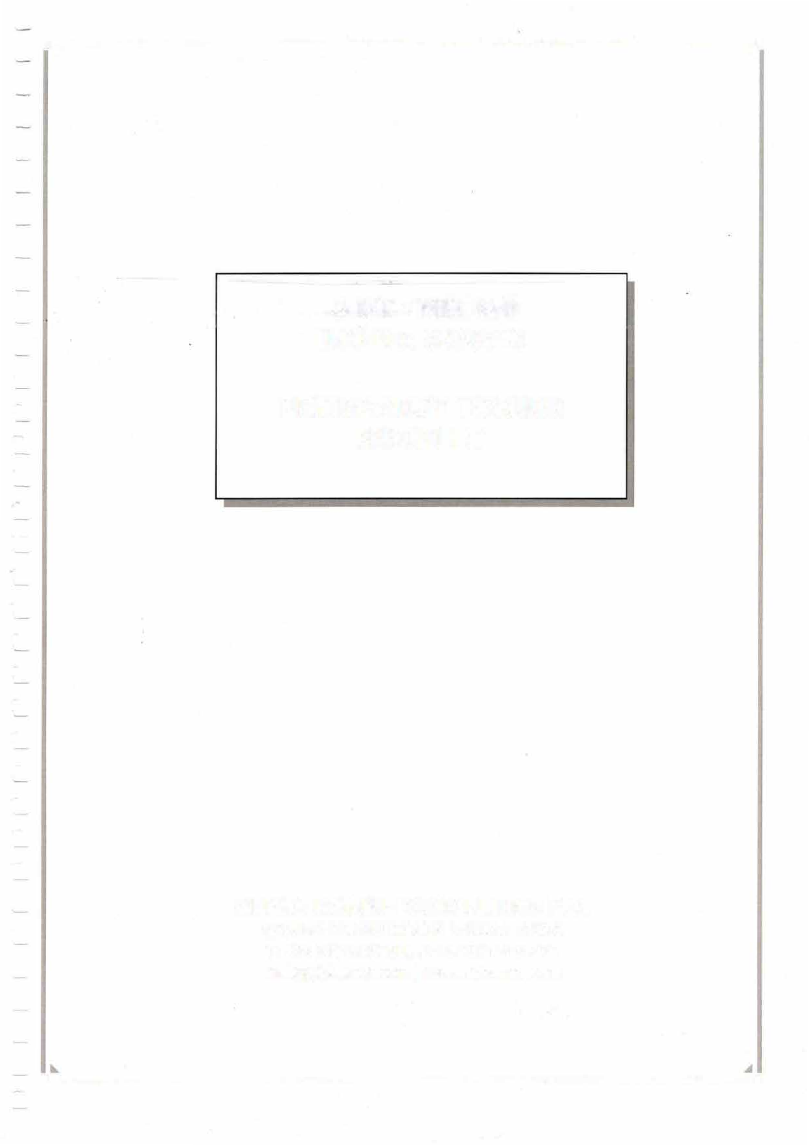■- ------�■
r

M/T
IMO No:

EMERGENCY TOWING BOOKLET

■-------------------------■

REV.
PLAN HISTORY DESCRIPTION

DATE

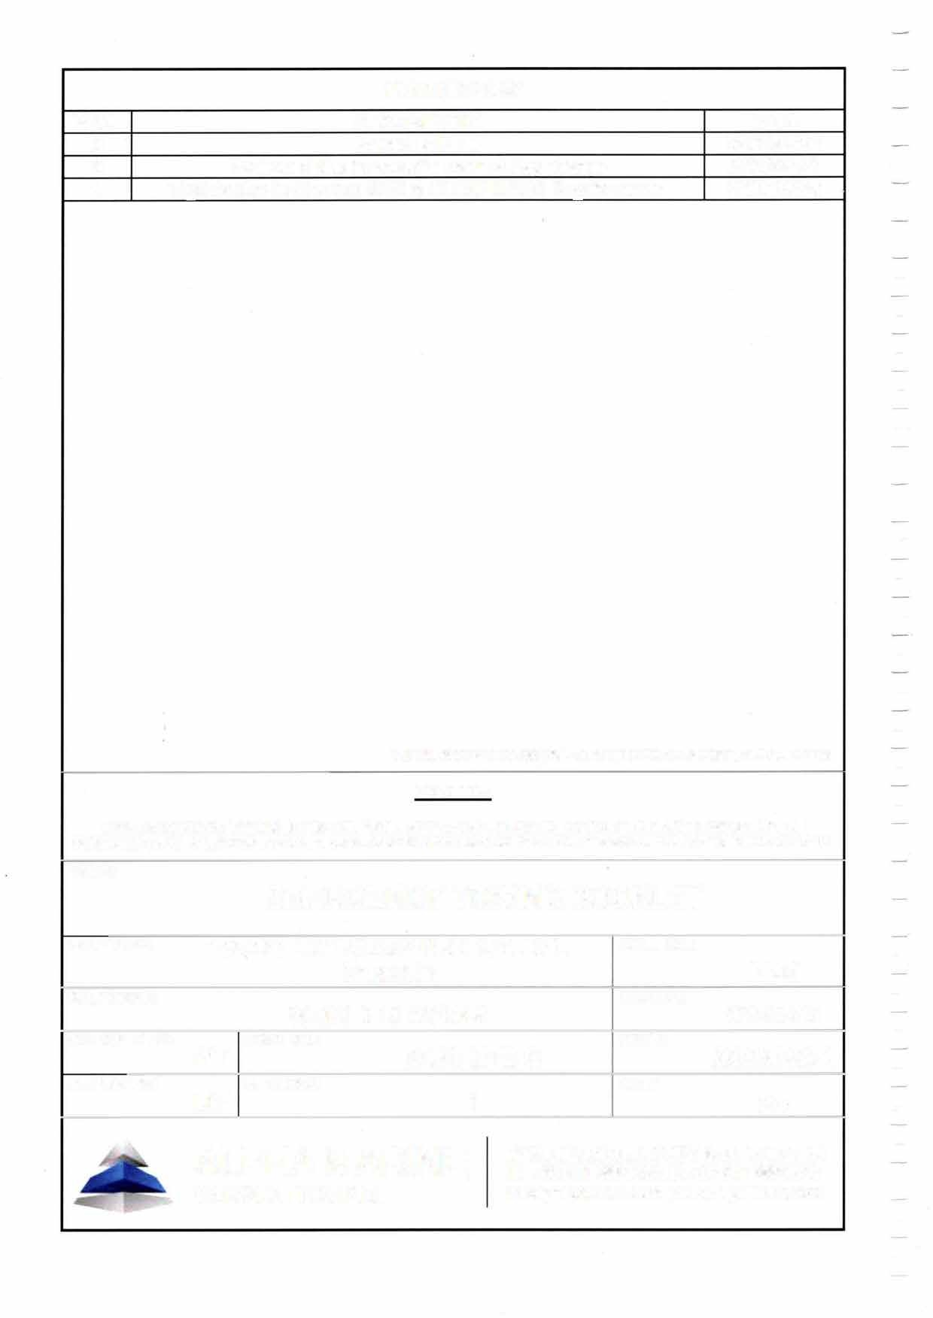

TOTAL SIXTY-TWO (62) SHEETS WITH COVER, EXCL APPENDICES

CAUTION
THIS DRAWING OR DOCUMENT IS THE PROPERTY OF ALPHA MARINE CONSULTING AND IT MUST NOT BE PARTIALLY OR WHOLLY COPIED OR USED FOR ANY OTHER PURPOSE WITHOUT PRIOR WRITTEN PERMISSION OF AMC.
TITLE:
EMERGENCY TOWING BOOKLET
SHIP TYPE: HULL NO.:

SHIP NAME: IMONO.:

CHECKED BY: DWG NO.: DATE:

DRAWN BY: REV. NO.: SIZE:


MIT
EMERGENCY TOWING BOOKLET PAGE 3 OF 62

TABLE OF CONTENTS

PAGE
- GENERAL 4
  - SCOPE 4
  - MAIN PARTICULARS 5
- EMERGENCY TOWING FACILITIES 6
  - COMMUNICATION EQUIPMENT 6
  - POWER SUPPLY EQUIPMENT 7
  - STEERING GEAR 7
  - ANCHORS, CHAIN CABLES AND MOORING ROPES 8
  - FWD MOORING ARRANGEMENT 9
  - AFT MOORING ARRANGEMENT 11
  - DECK TOOLS AND OTHER EQUIPMENT 13
- EMERGENCY TOWING PROCEDURES 14
  - GENERAL INSTRUCTIONS FOR EMERGENCY TOWING 14
  - COMMUNICATION PLAN 18
  - TOWING MODES 23
  - DECISION MATRIX FOR DETERMINING TOWING MODE 31
  - ORGANIZATION OF DECK CREW 32
  - EXAMPLES OF TOWING LINE CONNECTING PROCEDURES 34
- REFERENCE DRAWINGS 62

APPENDIX A Resolution MSC.256 (84)
APPENDIX B MSC.1/Circ.1255

.

MfT
EMERGENCY TOWING BOOKLET PAGE 4 OF 62

GENERAL

  - SCOPE

This booklet has been prepared in accordance with the requirements of the International Convention for the Safety of Life at Sea, 1974, Regulation 11-1/3-4, as amended by Resolution MSC.256 (84), adopted on 16 May 2008, as well as with the requirements of MSC.1/Circ.1255, adopted on 27 May, 2008 (see Appendices A & B).
The purpose of this booklet is to establish ship-specific emergency towing procedures based on arrangements and equipment available onboard the vessel. This booklet is to be carried onboard the vessel for use in emergency situations.
The procedures developed in this booklet aim at supporting the crew in establishing the safest and most efficient course of action to be taken when confronted with an emergency that requires towing. The steps described herein should be considered as part of the emergency preparedness required by paragraph 8 of part A of the ISM Code.
It is the responsibility of the Company and the Master to regularly review this booklet and ensure that the information contained herein is accurate and updated.
The booklet is written in English, which is the working language of the crew.

A minimum of three copies of this booklet should be maintained onboard the ship for ready use by the ship's crew during emergency towage. One should be kept in the bridge, one in a forecastle space or appropriate space where easy entry is available at the ship's fore part, and one at the ship's office or Cargo Control Room.

Furthermore, one copy should be kept by the Company in order to facilitate the passing on of information to the towage company in the event of an emergency. Finally, the booklet should be kept in common electronic format, which will allow faster distribution to the concerned parties.

MIT
EMERGENCY TOWING BOOKLET PAGE 5 OF 62

  - MAIN PARTICULARS

Ship's Name: Ship's Type: Flag:
Port of Registry: Call Sign:
IMO Number: Classification:
Gross Tonnage: Net Tonnage: Built by:
Year Built:

Length O.A.:
Length B.P.:
Breadth (mid.):
Depth (mid.):
Draught at Full Load Condition: Draught at Light Ballast Condition : Displacement at Full Load Condition: Displacement at Light Ballast:

Height of Mooring Deck abv. BL at Bow: Height of Mooring Deck abv. BL at Stern:

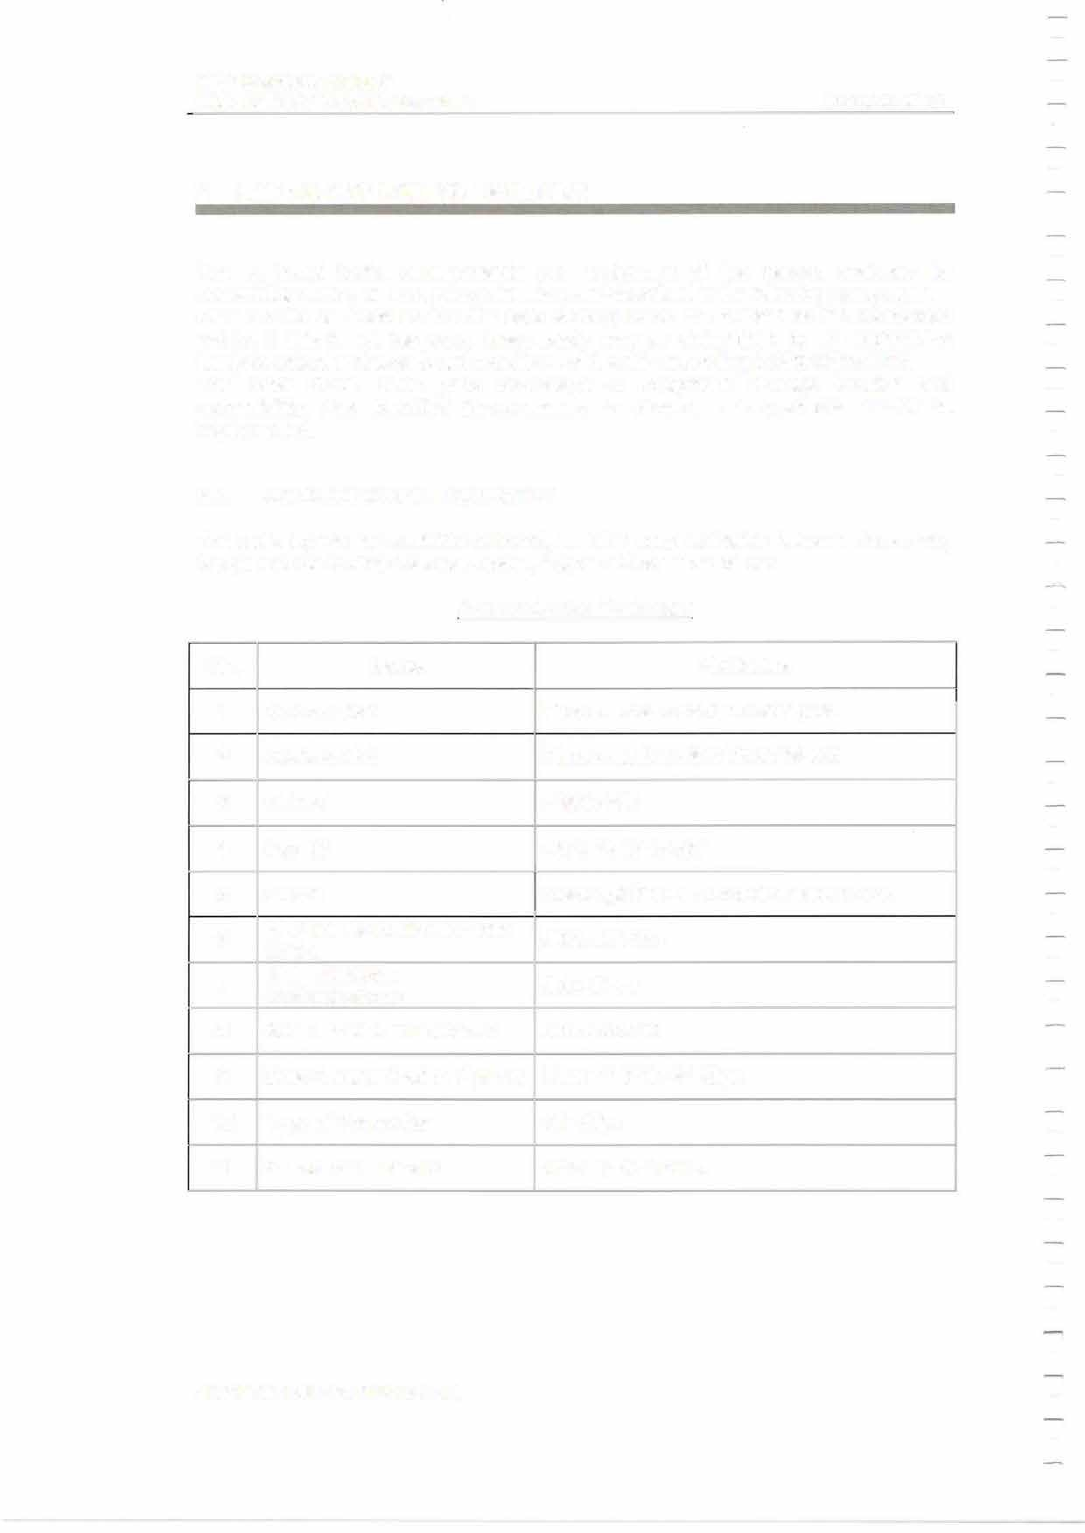MIT
EMERGENCY TOWING BOOKLET PAGE 6 OF 62

EMERGENCY TOWING FACILITIES

The on-board tools, arrangements and equipment of the vessel, available for assembling during an emergency situation, are described in the following paragraphs. Care should be taken so that the safe working loads are marked on the connection points. If this is not the case, these loads may be determined by an engineering analysis reflecting the on-board conditions of the ship according to MSC/Circ.1175.
The crew should have good knowledge of equipment stowage location and accessibility. Any identified improvements to stowage arrangements should be implemented.

  - COMMUNICATION EQUIPMENT

The radio equipment available onboard, enabling communication between deck crew, bridge and the towing / salvage vessel, is given in the Table below:
Communication Equipment

No. | Name | Particulars
1 | SatCom No1
2 | SatCom No2
3 | M.M.S.I
4 | Fax ID
5  6  7  8  9  10  11 | E-Mail  VHF Marine Radiotelephone Equip.  VHF FM 2-Way  Radiotelephone  400 MHz UHF Transceiver Data Communication System Type of Connection  Standard C Telex ID

MIT
EMERGENCY TOWING BOOKLET

PAGE 7 OF 62

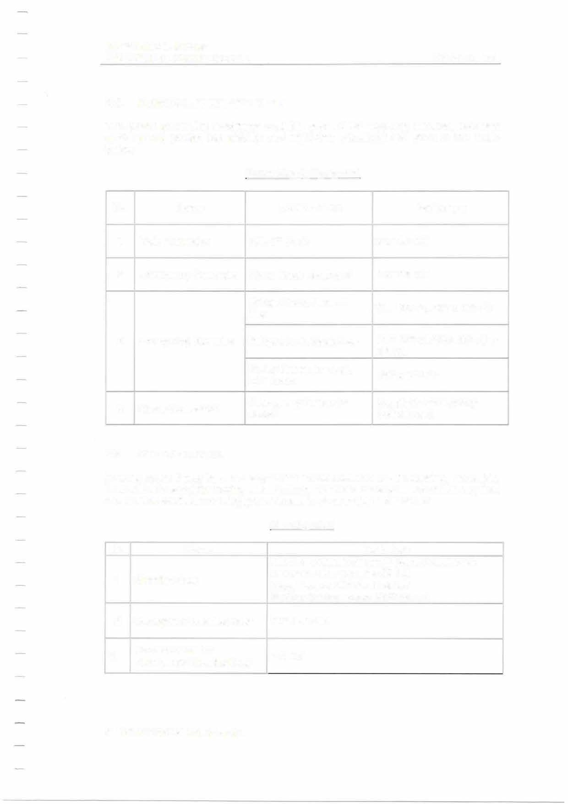

  - POWER SUPPLY EQUIPMENT
The power generating machinery available onboard for supplying winches, tools and deck lighting (during low visibility and night-time situations) are given in the Table below:

Power Supply Equipment

No. | Name | Location / Use | Particulars
1 | Main Generator
2 | Emergency Generator
3 | Emergency Batteries
4 | Shore Connection

  - STEERING GEAR
In some cases it may be necessary for the towed vessel to use its steering, if possible, in an effort to assist the towing vessel with manoeuvres or keep steady on the required course. The available steering gear onboard is given in the Table below:

Steering Gear

No. | Name | Particulars
1 | Steering Gear
2 | Emergency Steering Gear
3 | Power Source for Emergency Steering Gear

.

MIT
EMERGENCY TOWING BOOKLET PAGE 8 OF 62

  - ANCHORS, CHAIN CABLES AND MOORING ROPES
The anchors, chain cables & mooring ropes available onboard are given in the Table below:
Anchors, Chain Cables & Mooring Ropes

Particulars SWL
(MT)
No. | Name
1 | Bower Anchor
2 | Chain Cables
3 | Chain cable stopper
4 | Mooring Ropes

Mooring Ropes (Polypropylene 60% - Polyester 40%)

No. 1
2

Location Forecastle
Poop Deck
Size (dia.xlength - mmxm)
Breaking Strength (MT)

Quan.

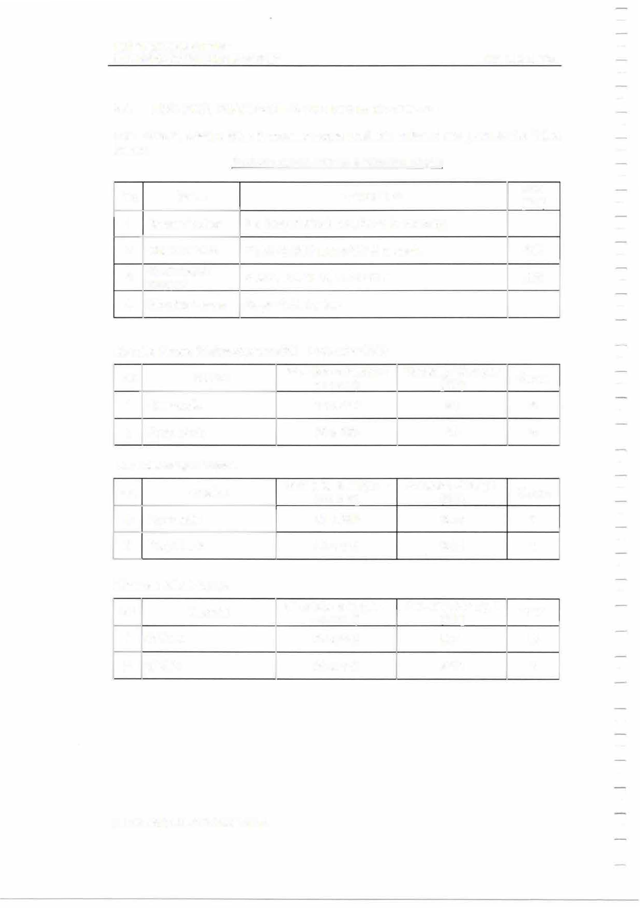STS Messenger Ropes
No. Location
1 Forecastle
2 | Poop Deck

Wires on Winch Drums
No.
1
2

Material

GSWR GSWR

Size (dia.xlength - mmxm)

Size (dia.xlength - mmxm)

Breaking Strength (MT)

Breaking Strength (MT)

Quan.

Quan.

MIT
EMERGENCY TOWING BOOKLET PAGE 9 OF 62

  - FWD MOORING ARRANGEMENT
According to the vessel's "Mooring Arra ngement Pla n",

Fwd Mooring Arrangement

.

MIT
EMERGENCY TOWING BOOKLET PAGE 10 OF 62

Fwd Mooring Equipment

Mark
Name
Particulars

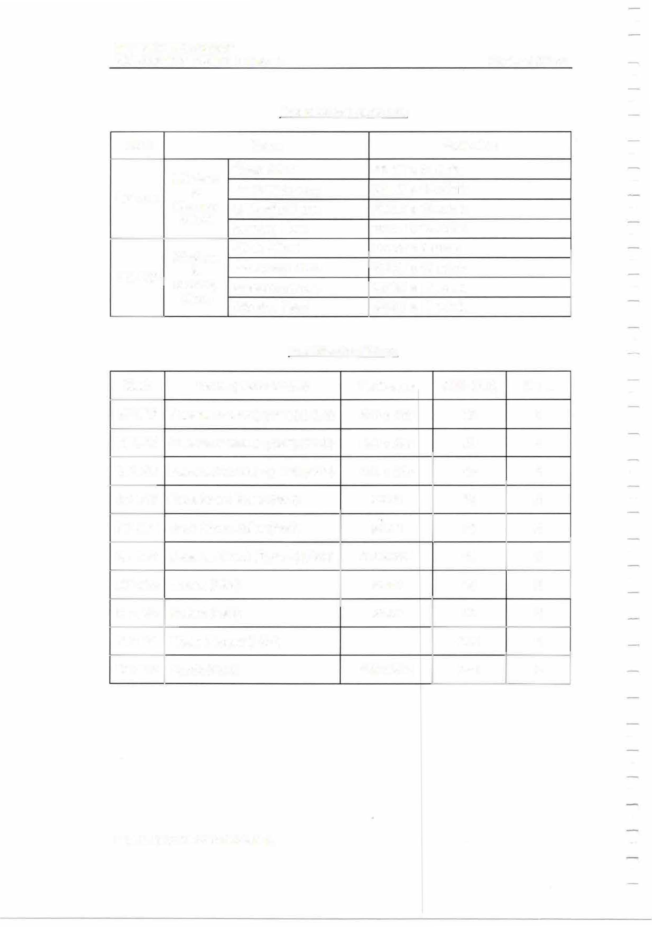
Windlass & Mooring Winch

Windlass & Mooring Winch

Fwd Mooring Fittings

Mark Name (Deck Fittings) Particulars SWL (MT) Quan.

.

MIT
EMERGENCY TOWING BOOKLET PAGE 11 OF 62

  - AFT MOORING ARRANGEMENT

According to the vessel's "Mooring Arrangement Plan",

Aft Mooring Arrangement

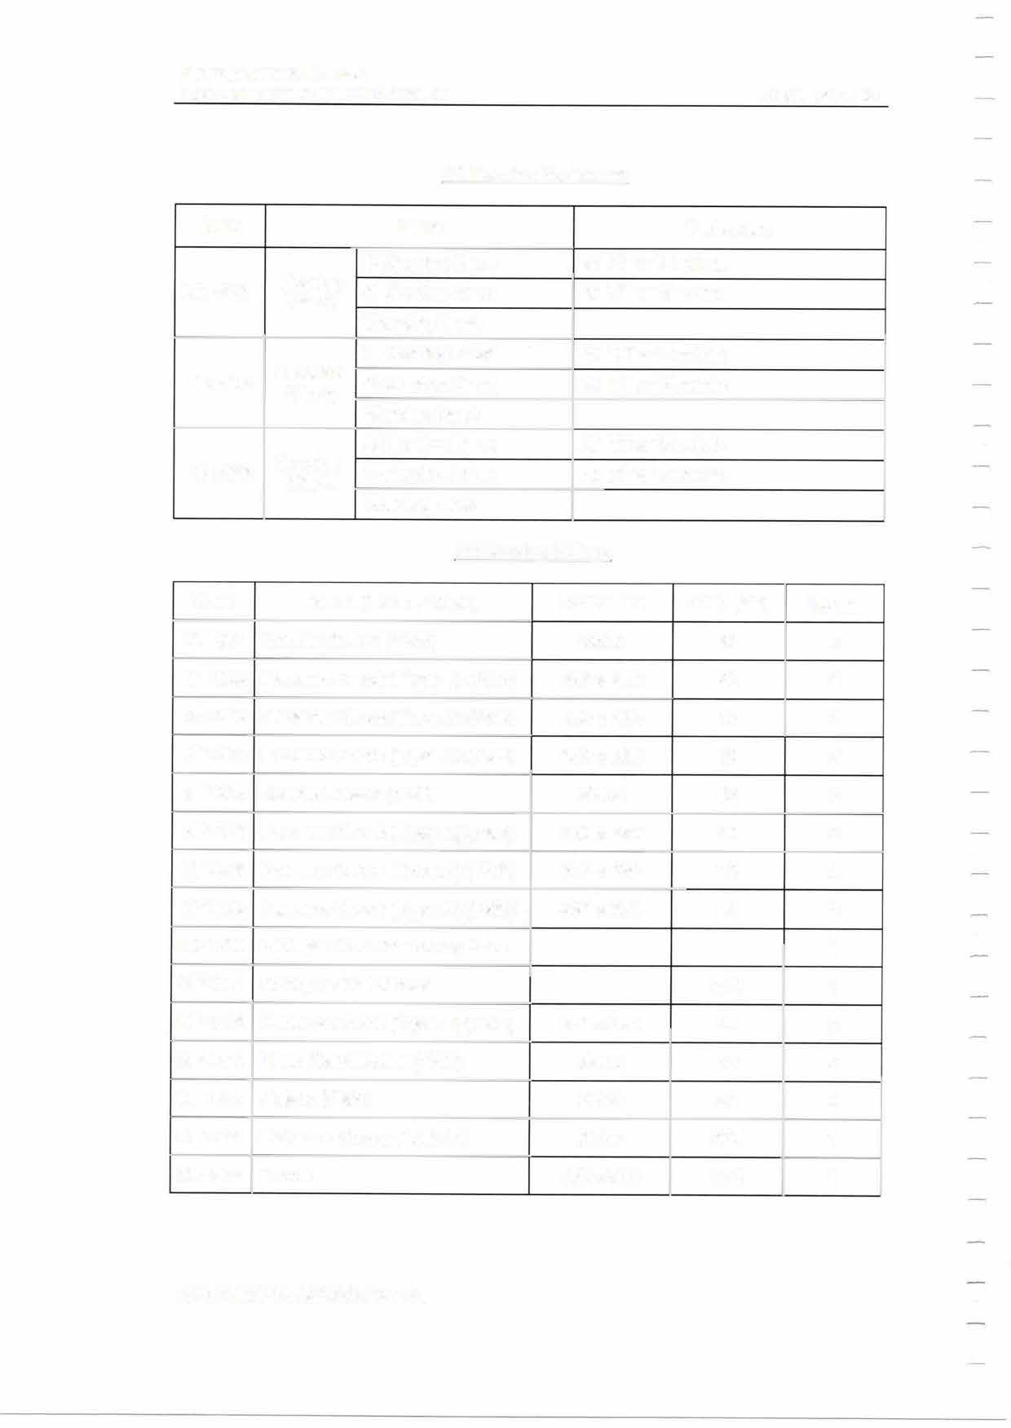MIT "WONDER AVIOR"
EMERGENCY TOWING BOOKLET PAGE 12 OF 62

Aft Mooring Equipment

Mark Name Particulars

Aft Mooring Fittings

Mark Name (Deck Fittings) Particulars SWL (MT) Quan.

MfT
EMERGENCY TOWING BOOKLET PAGE 13 OF 62

  - DECK TOOLS AND OTHER EQUIPMENT
Deck tools and other equipment that may be used to improve the "towability" of the vessel are given in the Tables below:

Deck Tools

No. 1
2
3
4
5
Name
Remarks

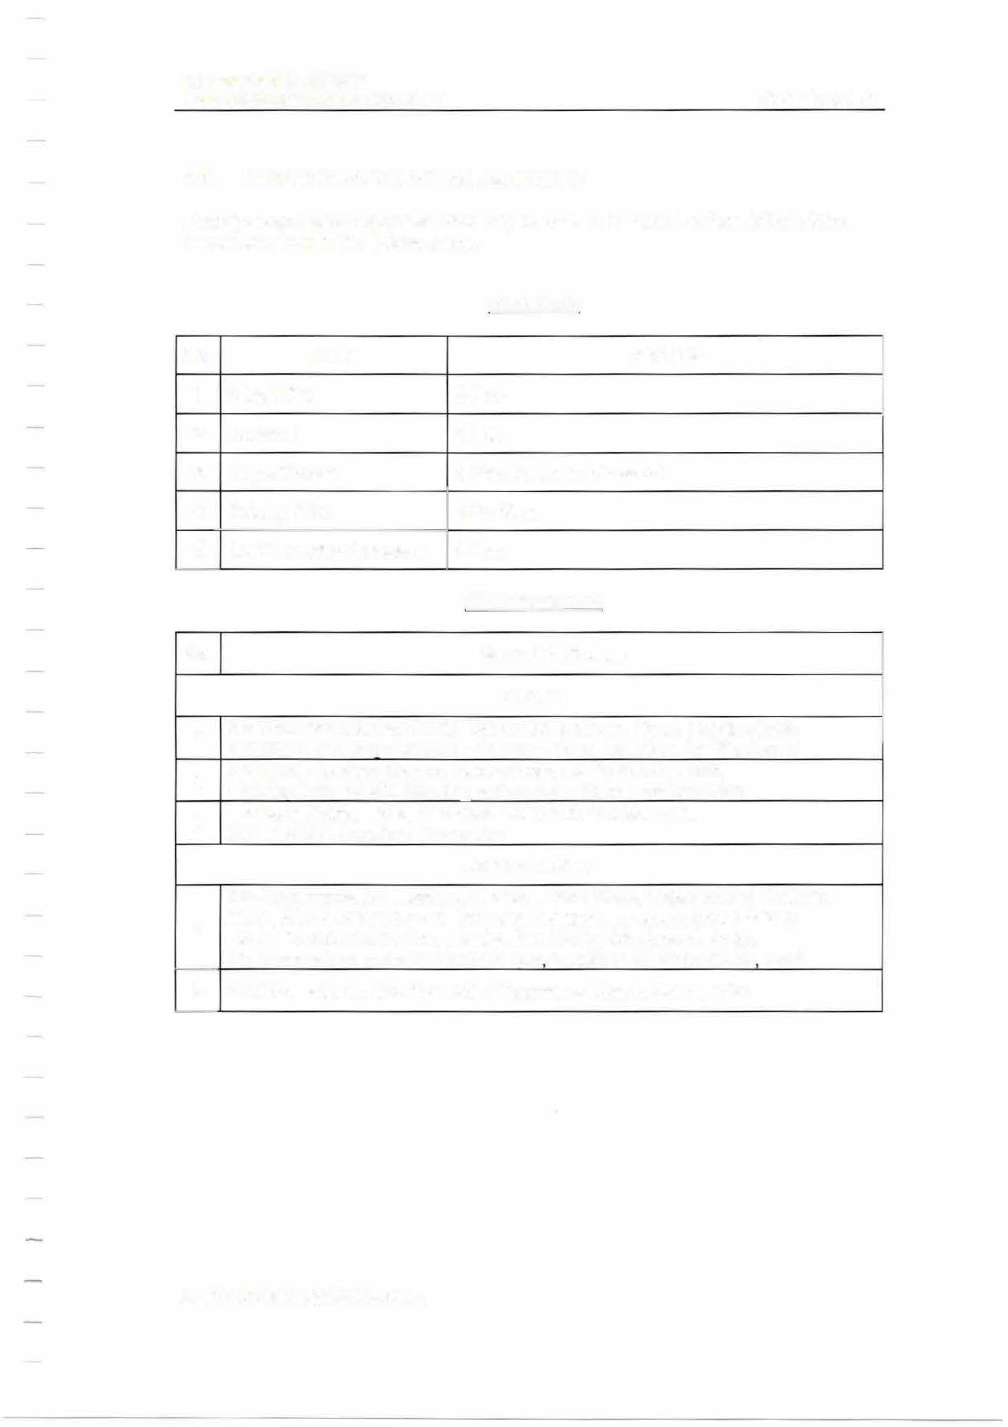
Other Equipment

No. Name / Particulars
Cranes

1
2

3
Access Ladders
,
4

5

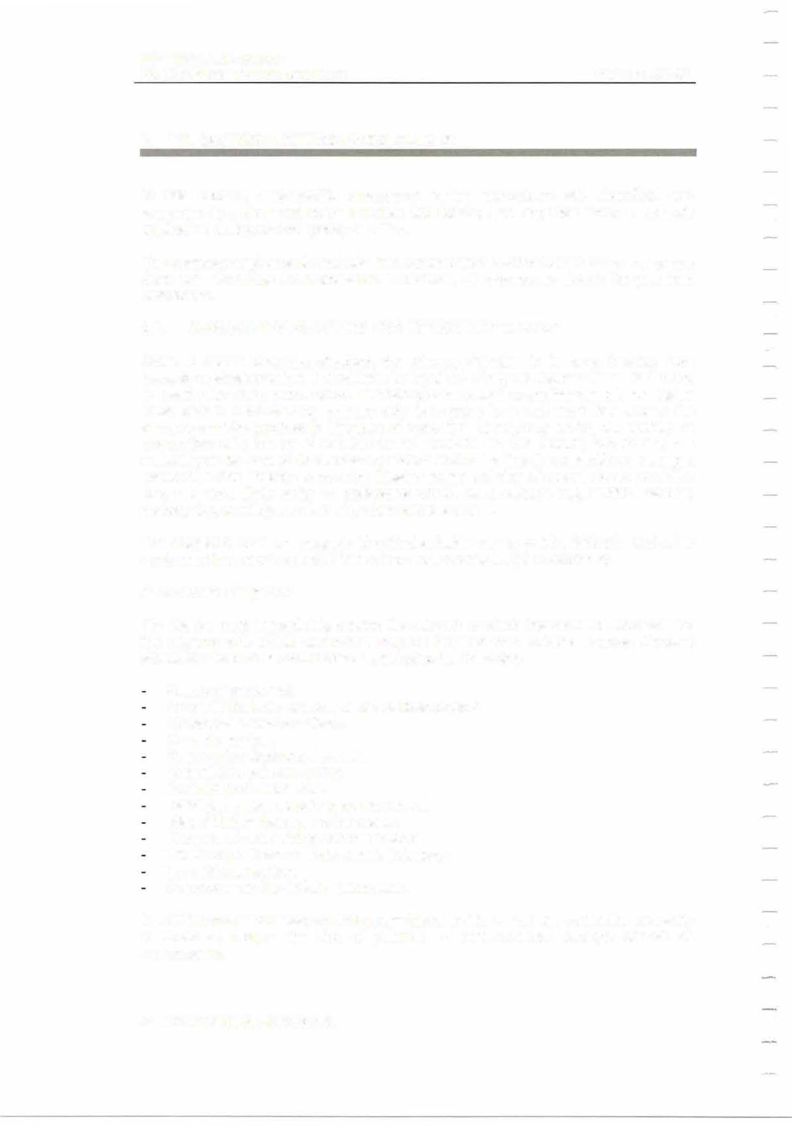
MfT
EMERGENCY TOWING BOOKLET PAGE 14 OF 62

EMERGENCY TOWING PROCEDURES

In this section, ship-specific emergency towing procedures are described and presented in a clear and easy to understand format, ensuring their smooth and swift application during an emergency situation.
The Company and crew should take into consideration that the nature of an emergency does not allow time for deliberation. Therefore, all procedures should be practiced beforehand.
  - GENERAL INSTRUCTIONS FOR EMERGENCY TOWING
When a vessel becomes disabled, the primary objective is to keep it away from hazards or shallow water. It must then be repaired or rely on another vessel for towing to a safe place for repairs. Before attempting to be towed by another vessel, the Master must bear in mind that his primary duty is to save lives and must first assess the dangers or risks involved in this type of operation. Emergency towing will usually be undertaken with the most suitable vessel available in the vicinity, considering the suitability of own vessel for such an operation and assessing the possibility of damage. However, in the unlikely event of the Master having a choice of vessel able to provide a tow, the most likely order of preference would be a salvage tug, anchor handler, harbour tug, warship and then any other suitable vessel.
The subject vessel has properly identified suitable strong points, fairleads and other equipment that may be used if towing becomes necessary (see Section 2).
Assessment of urgency
The Master must immediately assess the dangers to which the vessel is exposed and the urgency with which assistance may be required from outside sources. Account should be taken of all circumstances, including the following:
Safety of personnel.
Proximity to shore or shoal water, or fixed objects. Weather and sea conditions.
Current and tide.
Nature of seabed and shoreline. Potential for safe anchoring.
Availability of assistance.
Damage already sustained by the vessel. Risk of further damage to the vessel.
Prospect of maintaining communications. Threat of pollution or environmental damage. Threat to navigation.
Manpower and material requirements.
In addition to the necessity of limiting any threat to life, vessel and cargo, the necessity to avoid or reduce the risk of pollution or environmental damage cannot be overstressed.

MIT "
EMERGENCY TOWING BOOKLET

PAGE 15 OF 62



Readiness of emergency towing arrangements
To ensure rapid deployment of the emergency towing arrangements, the Master must ensure that:

Aft emergency towing arrangements are pre-rigged and capable of being deployed in a controlled manner in harbour conditions in not more than fifteen (15) minutes. Forward emergency towing arrangements are capable of being deployed in harbour conditions in not more than one (1) hour.

Because these systems are intended for use in emergency situations, it is important that they are readily available for use at all times. The components of the system should be located permanently at or near to the strong point site and kept free of obstructions so they are always ready for immediate deployment. The emergency towing arrangements fitted on the vessel may not be suitable for a long distance tow, but are more than adequate for a limited duration of tow, to pull the ship away from or restrict her drifting towards immediate danger.
Preparations for towing

Once the Master has decided that he requires the assistance of a towing vessel, he should immediately begin to plan the possible methods of making the towing connection. The nature and extent of the vessel's damage will be relevant in deciding whether it should be towed from the bow or the stern to minimise further damage while under tow. Early communications should be established with the towing vessel to exchange information and determine the equipment available on the vessel to be towed and the proposed towing method (see Section 3.2). It should be noted that during towing, the greatest stresses on the towing system occur when the inertia of the disabled vessel is being overcome and, later, during its tendency to yaw. In order to minimise the risk of parting the tow line, the highest possible resilience should be incorporated. One possible means of achieving this is by lowering the vessel's anchor and cable a little way and connecting the tow line directly to the cable with the anchor still attached.
All crewmembers should be well informed on emergency towing procedures and relevant allocation of personnel.
Connecting the tow
Prior to commencing the towing operation, communication procedures should be established between the vessels. No action should be taken with regard to navigation or engine manoeuvres by any Master without first informing the other.

MIT
EMERGENCY TOWING BOOKLET PAGE 16 OF 62

Adequate manpower should be standing by to make the connection. If the vessel is to be towed by a dedicated towing vessel, the tug will use its own wire and chain combination. In the event of the assisting vessel not being a dedicated towing vessel, the vessel's own towing system will be utilized. Initially, a light line will be used to take on board a messenger, which in turn will pass a tow line between the vessels. When the towing wire is passed to the vessel to be towed, the messenger connection to the towing wire may be rigged as shown in the Figure below:

Man Made Fibre Messenger Line

,,
t
;,.J

Wire Pennant Line

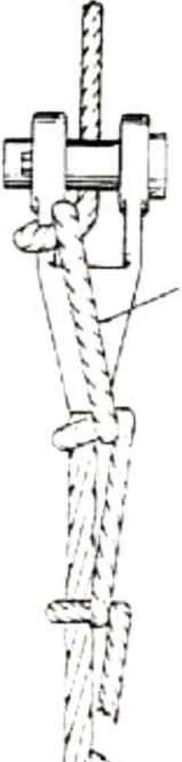
Should it prove impossible to lift the tug's gear onboard, then the method shown in the Figure below should be used. According to this method, a light line followed by a heavy messenger are passed back to the tug, after which the chafe chain and towing line are heaved up to the towing point on the disabled vessel, using the tug's own power. If this is impracticable, an alternative may be to lower an anchor into the water to enable the tug to connect a line directly to the anchor cable. Once the tug line is secure, several shackles of cable chain may then be paid out, provided that the agreement of the tug Master has been obtained.

-...

MIT
EMERGENCY TOWING BOOKLET PAGE 17 OF 62

Winch Rocket fine followed
by messengers up to appropriate sizes
-
7 +--

Wire I rope Joining Shackle 7
Side fair1ead!i

Rollers

�

Main Tow Wire
Chafe chain shackled to wire pennant · /
Bow fairleads

Towing Fittings

The tow line may be secured onboard the disabled vessel in several ways, for example by either turning up on two or more sets of bitts or securing the chafe chain in a towing bracket or in a chain stopper, as shown in the Figure below:

ai-,w
-----�-

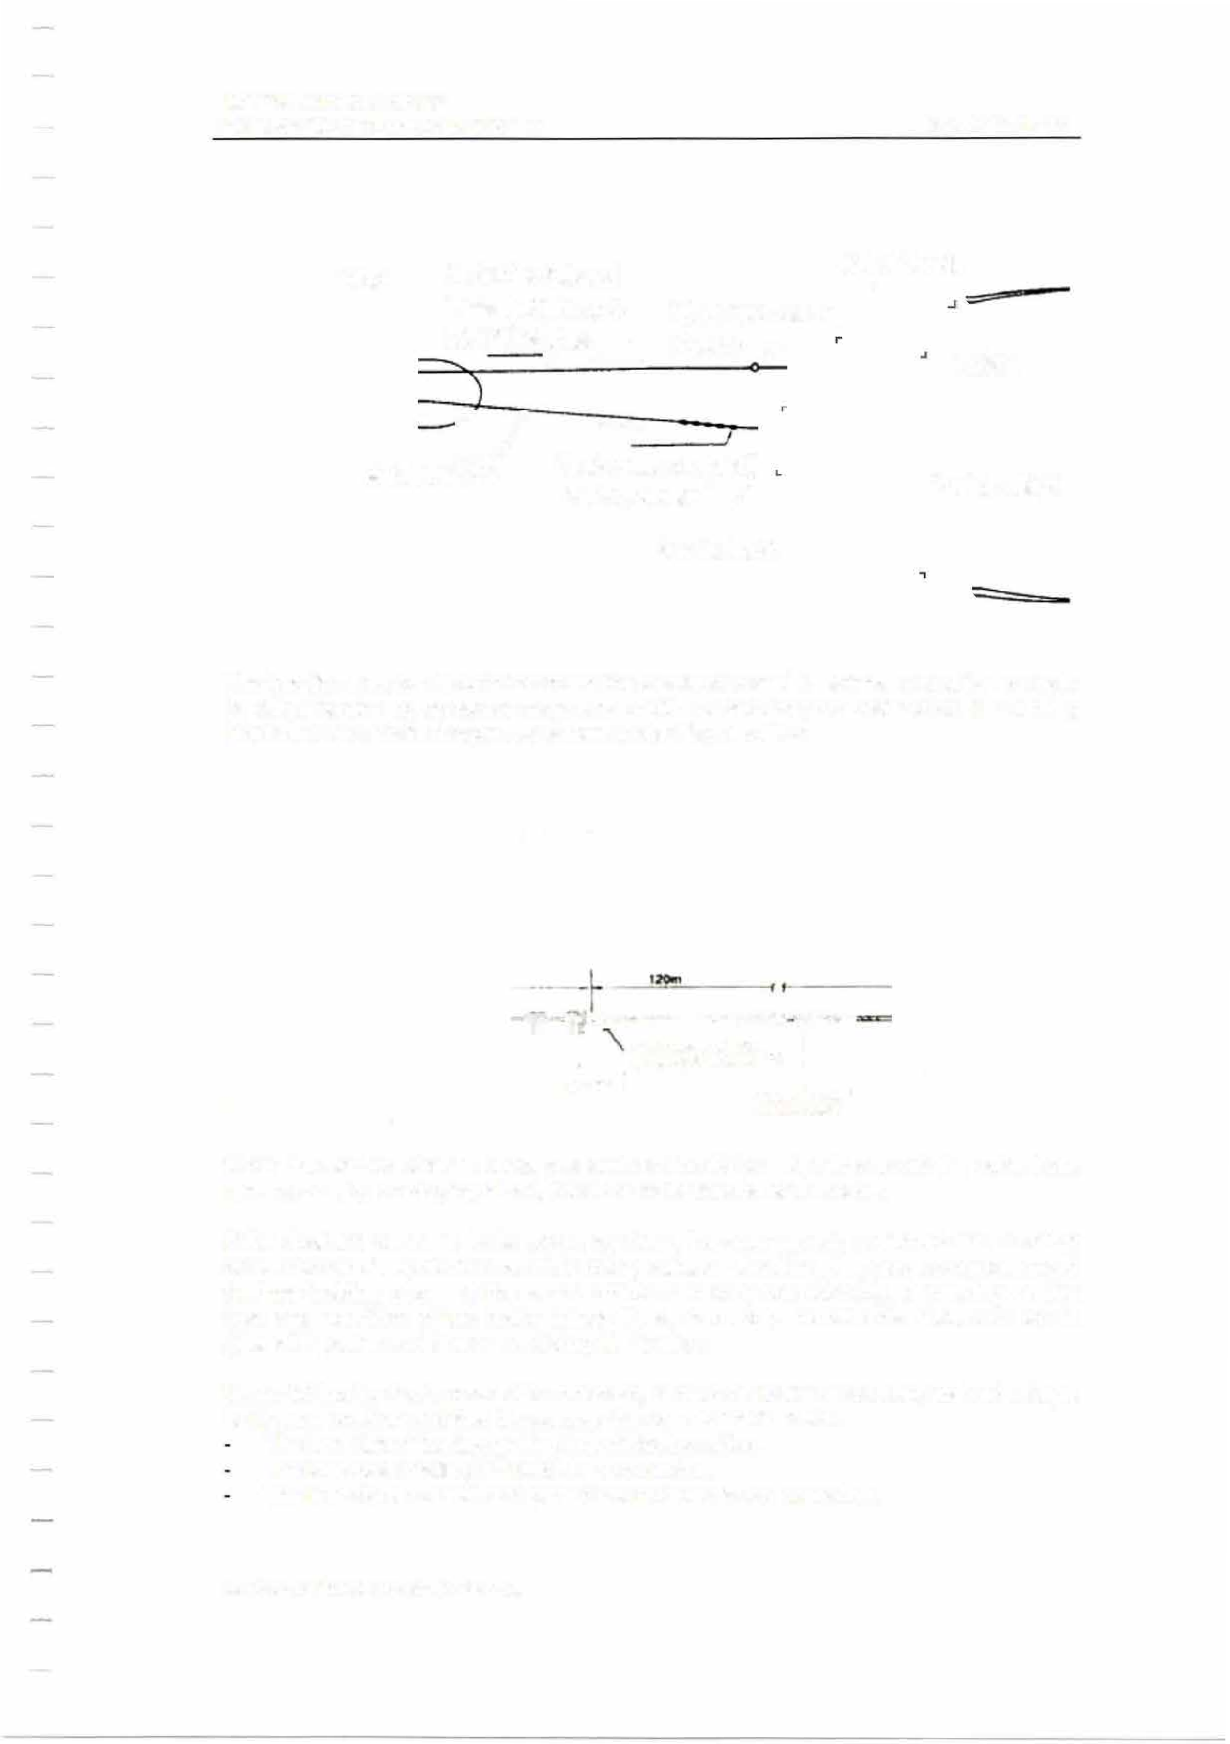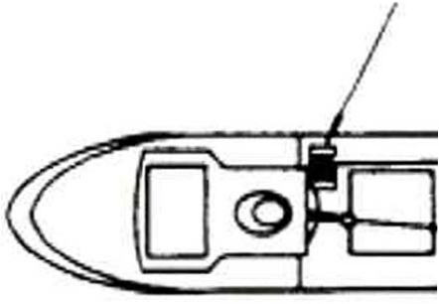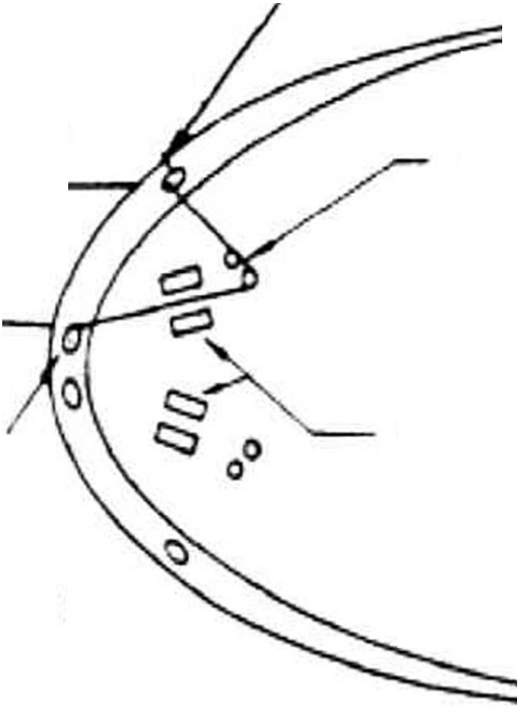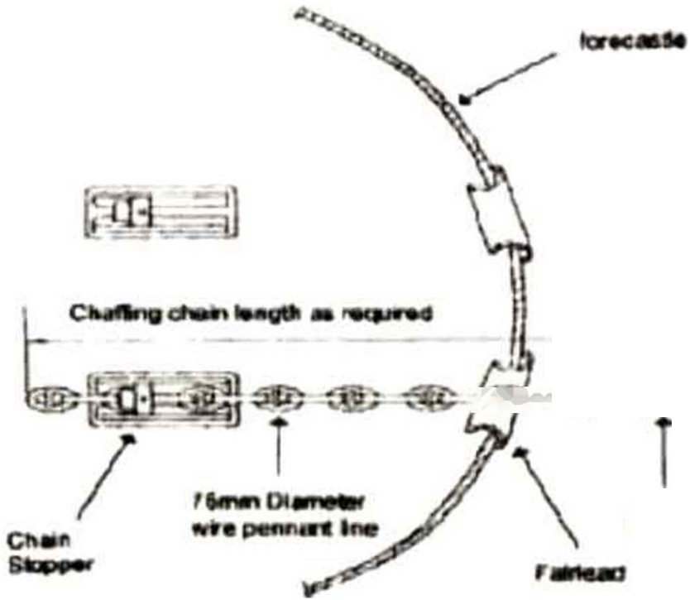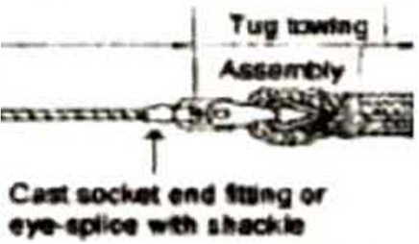When the anchor cable is used, precautions should be taken to prevent the cable from running out, by employing claws, pawls or other mechanical means.
;;;[)f,�����-••»•r=
g.-.;::::.� 1
If the disabled vessel is to be towed by stern, the after mooring winches and mooring wires can be set up to form a bridle using suitable shackles. It should be remembered that the holding power of the winch brakes can vary considerably, depending on the type and condition of the brake linings fitted, therefore, the winches should be left in gear with power and brakes on during the towing.
When taking the tug's connection onboard, remember that it is not easy to hold a large tug in one position and that the qu icker the connection is made:
The less risk of the tug getting in a difficult position. The less risk of failing to make the connection.
The less risk to vessel and personnel involved in the operation.


MfT
EMERGENCY TOWING BOOKLET PAGE 18 OF 62

The person in charge of the emergency towing operation should monitor the movement of the towing vessel carefully.

Towing
Occasionally it may be necessary for the towed vessel to use its steering, if it can be used, in an effort to assist the towing vessel with any manoeuvres and assist in keeping the tow steady on the required course. If the disabled vessel's steering cannot be used, the rudder should, where possible, be secured in the amidships position. Where it is advisable to secure the propeller to avoid engine damage, this can usually be done by engaging the turning gear although this may be more successful on a motor ship than a turbine ship. Alterations to the trim of the disabled vessel within permissible stress limits may help to improve manoeuvrability under tow.
In some cases it may also be necessary to grease the wire ropes continuously in order to prevent their wear when used as towing lines. The condition of chocks should also be frequently checked.

While under tow, warnings to other ships will be transmitted by the tug and at night a keen watch should be maintained from the tow, with visual signals being made to approaching vessels. The daylight signal lamp is very useful by day or night to give warning signals to vessels on a closing course.

  - COMMUNICATION PLAN
The purpose of the following communication plan is to provide a ready-to-use template used for contacting the salvage / towing vessel. This plan lists all information required to be communicated from the vessel's Master to the salvage / towing vessel. An example is also provided in order to assist the Master in properly preparing the plan.

MIT
EMERGENCY TOWING BOOKLET PAGE 19 OF 62

Communication Plan

No.

1

2

Present time Current position
Item
Current status Day/Month/Year

Time
I

    - Cause of requesting towage

    - Weather conditions

    - Wind velocity and direction

    - Wave height

Velocity (m/s) Direction

(m)

    - Weather forecast

    - Drifting speed and direction

Imminent danger (e.g. grounding) (if any, describe the expected danger)

Speed (kn) Direction

□Yes □No

- Flooding (if any, describe the status) □Yes 0No
- Carao (if any, describe the tvoe) I IYes I INo
- Fore draught
- Aft draught
Status:

(m)
(m)

- Can be towed from the bow?

- Can use power on board?
□Yes 0No Status:
□Yes □No Status:

- 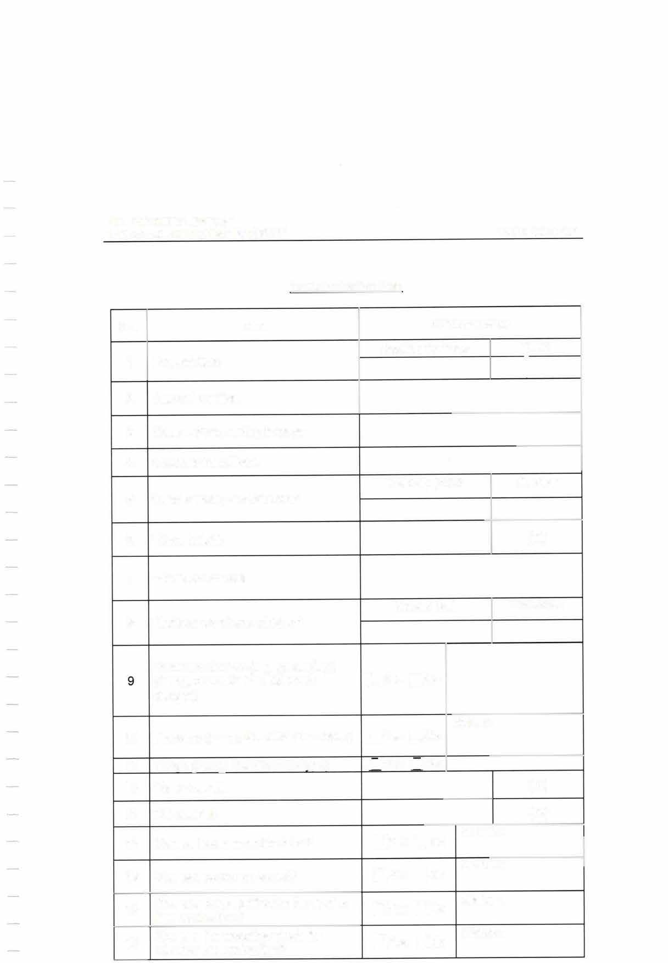Can use deck lighting for the towing □Yes □No Status:
line connection?
□Yes □No
Can use the mooring winch for Status: winding the towing line?
17

MIT
EMERGENCY TOWING BOOKLET

No. Item
Can use the mooring equipment on
18 the deck for the towing line
connection?
Can use towing lights (side lights, stern lights)?
19
20 Ready to display the black diamond? □Yes □No Status:
21 Can use the rudder (describe the □Yes □No Status: status)?
22 current rudder angle and is it □Yes □No
If the rudder is damaged, what is the Status:
 | possible to return to midship?
 |  | □Yes □No  □Yes □No | Status:  Status:
23 Can use the main engine? |  | □Yes □No  □Yes □No | Status:  Status:
24 Can control the trim? |  | □Yes □No  □Yes □No | Status:  Status:
25 Is there heeling? |  | □Yes □No | Status:
26 How to prevent free propeller rotation? |  | □Yes □No Status:
27 Oil leakage from the stern tube (if any, describe the status)

PAGE 20 OF 62

Current status
□Yes 0No Status:
□Yes □No Status:

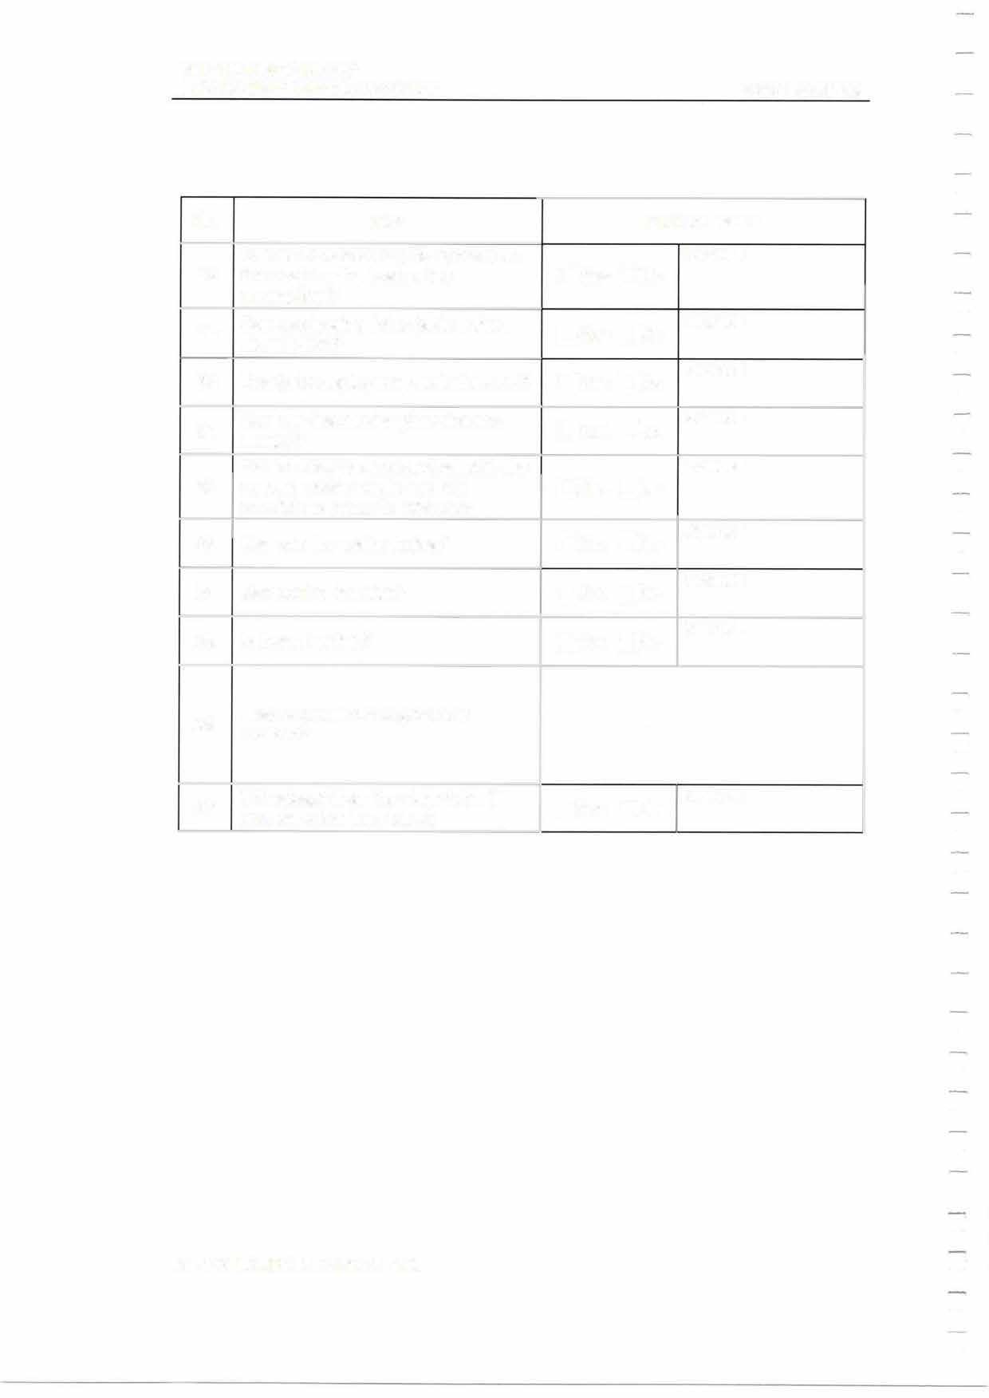

MIT
EMERGENCY TOWING BOOKLET PAGE 21 OF 62

Communication Plan (Example}

No. Item
Current status
Day/Month/Year

Time

- Present time

10/10/08
JST l 12:30

- Current position

- Cause of requesting towage
- Weather conditions
- Wind velocity and direction

- Wave height

- Weather forecast

- Drifting speed and direction

Imminent danger (e.g. grounding)
- (if any, describe the expected danger)
200km off Choshi 36 '59'48"N 142'25'31"E
Loss of power due to the breakage of the crankshaft of main engine
Cloudy
Velocity (m/s) Direction
About 10 Northeast
About 1.5 (m)

Typhoon is approaching and wind is expected to become stronger.
Speed (kn) Direction
About 1.0 Southwest
Note: There is no grounding risk now, but there is a possibility to approach land in 4 days at the current
[g!Yes □No
driftina rate.

- Flooding (if any, describe the status) □Yes [g!No
Status:

- Carao (if anv describe the tvoe) rxlYes I INo Crude Oil
- Fore draught 14.92 (m)
- Aft draught 14.92 (m)
[8]Yes □No

- Can be towed from the bow?
- Can use power on board?
[g!Yes □No Status: [8]Yes □No Status:

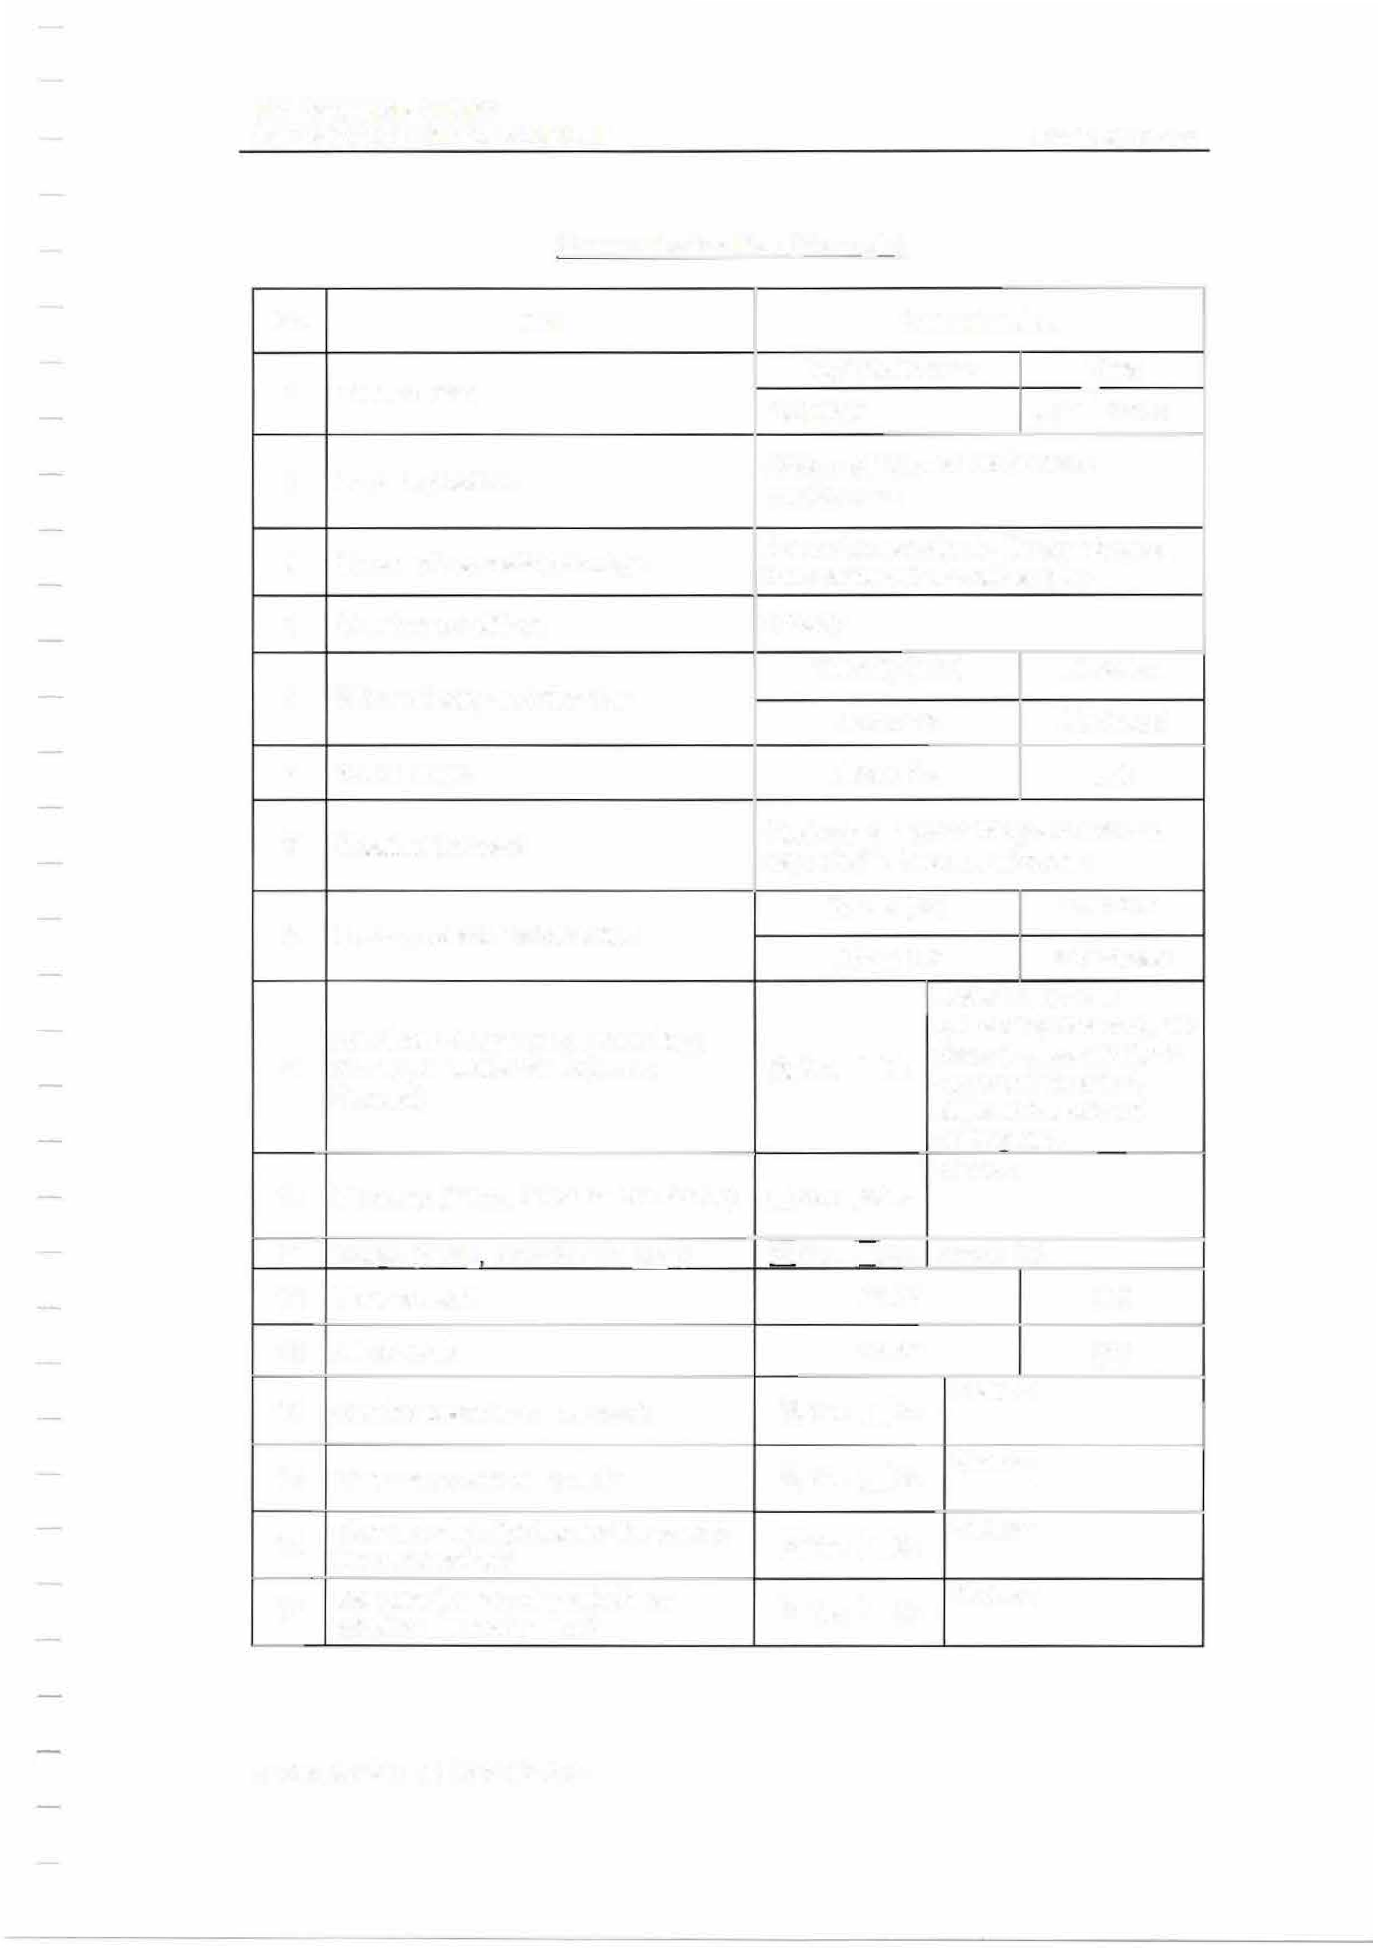Can use deck lighting for the towing Status: line connection?
16
- Can use the mooring winch for [g!Yes □No Status:
winding the towing line?

MIT
EMERGENCY TOWING BOOKLET

No. Item
Can use the mooring equipment on
- the deck for the towing line
connection?
- Can use towing lights (side lights, stern lights)?
20 Ready to display the black diamond?
Can use the rudder (describe the status)?
21
If the rudder is damaged, what is the
- current rudder angle and is it
possible to return to midship?
- Can use the main engine?

- Can control the trim?

25 Is there heeling?

How to prevent free propeller rotation?
26

PAGE 22 OF 62

Current status
Status:
[8]Yes ONo
[8]Yes □No Status:
Status:
OYes [8]No
Under preparation
[8]Yes ONo Status:
Status: Yes [8]No No problem
□

OYes [8]No Status:
Status:
□
[8]Yes No No trim at present
□Yes [8]No Status:
We are currently working to connect the coupling bolts of the intermediate shaft bearing. Will be finished within two hours.

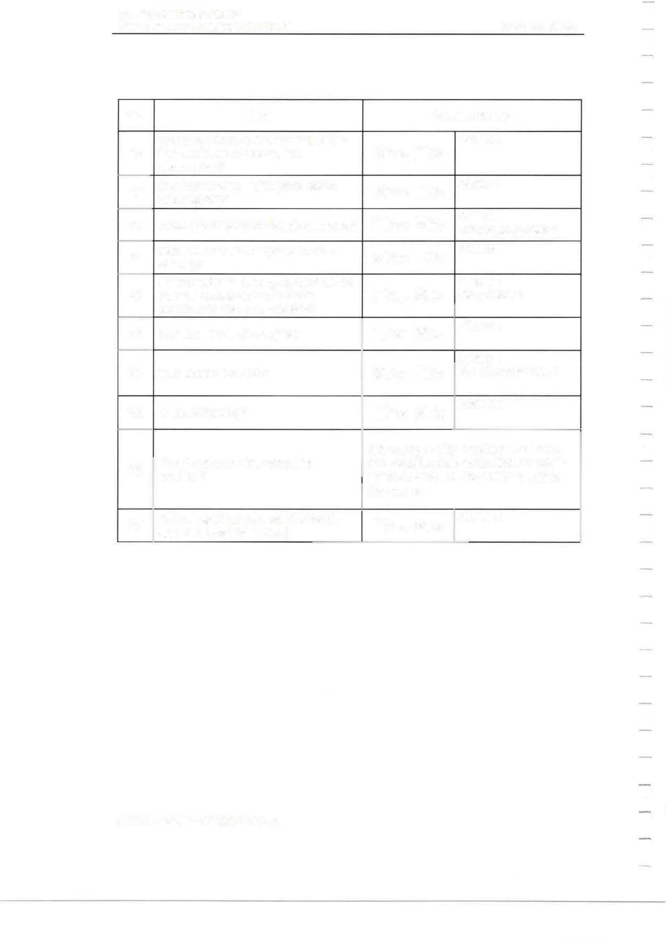Oil leakage from the stern tube (if any, describe the status)
27

OYes [8]No
Status:

MIT
EMERGENCY TOWING BOOKLET

PAGE 23 OF 62

  - TOWING MODES
The towing modes for this ship are the following 8 modes in principle. The pattern is determined by the vessel's Master in consultation with the towing company, taking into account the vessel's status and the surrounding conditions.
    - Mode1-F (Towing from the Bow) Use ship's chain.

.,.

{L

\

ICHAINi
TUG

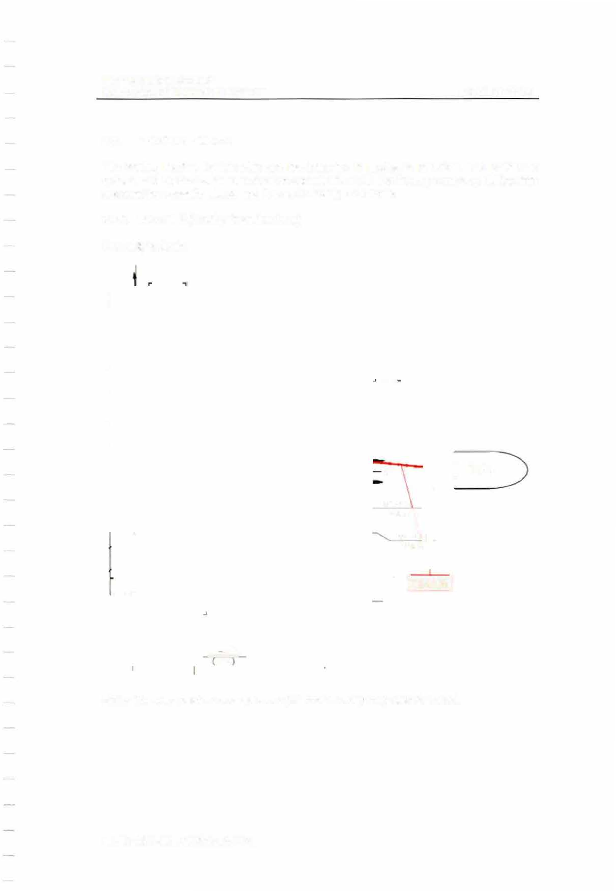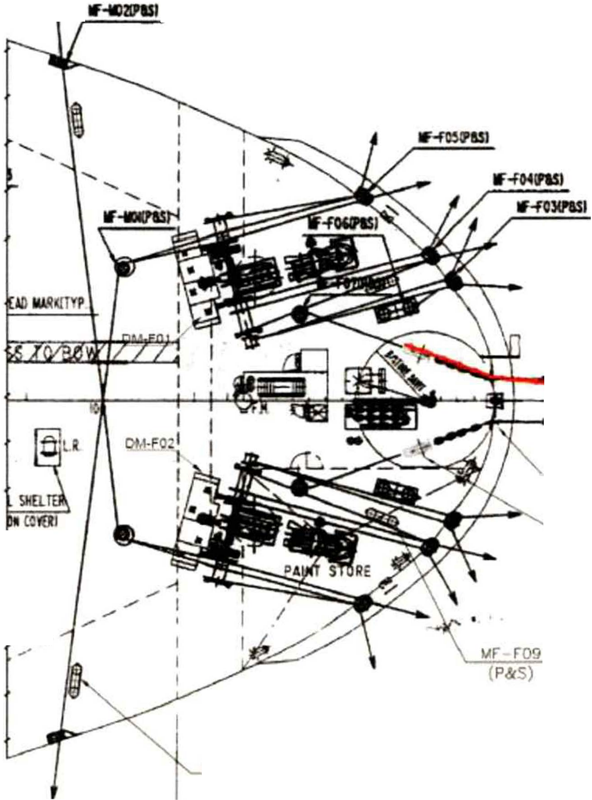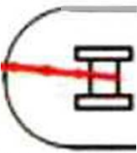

MF " IAJ2
P&S

Note: The symmetrical arrangement (starboard side) may also be used.

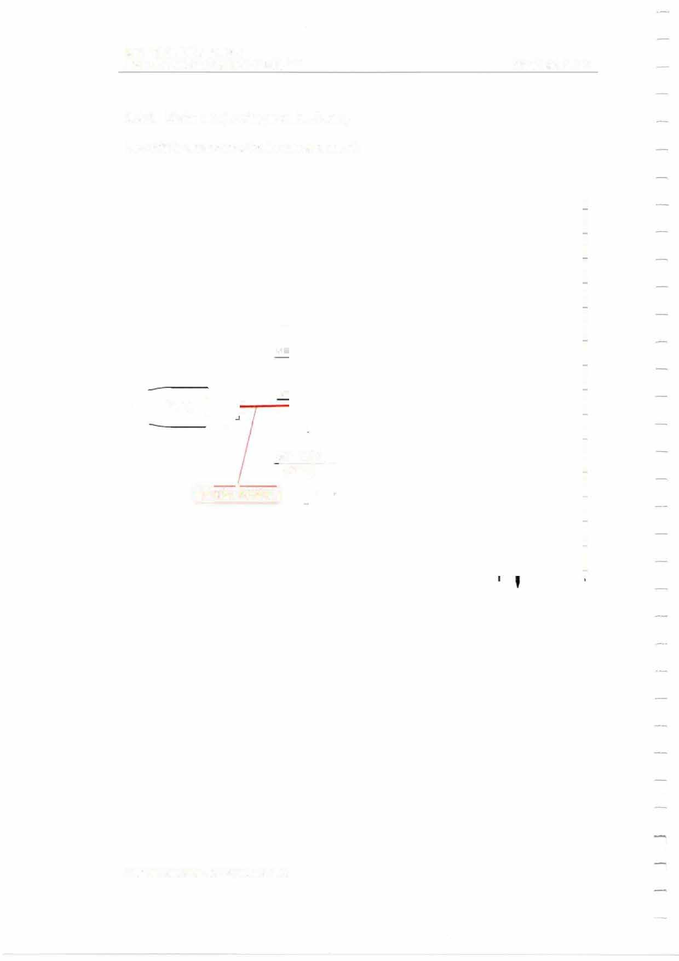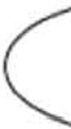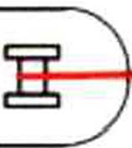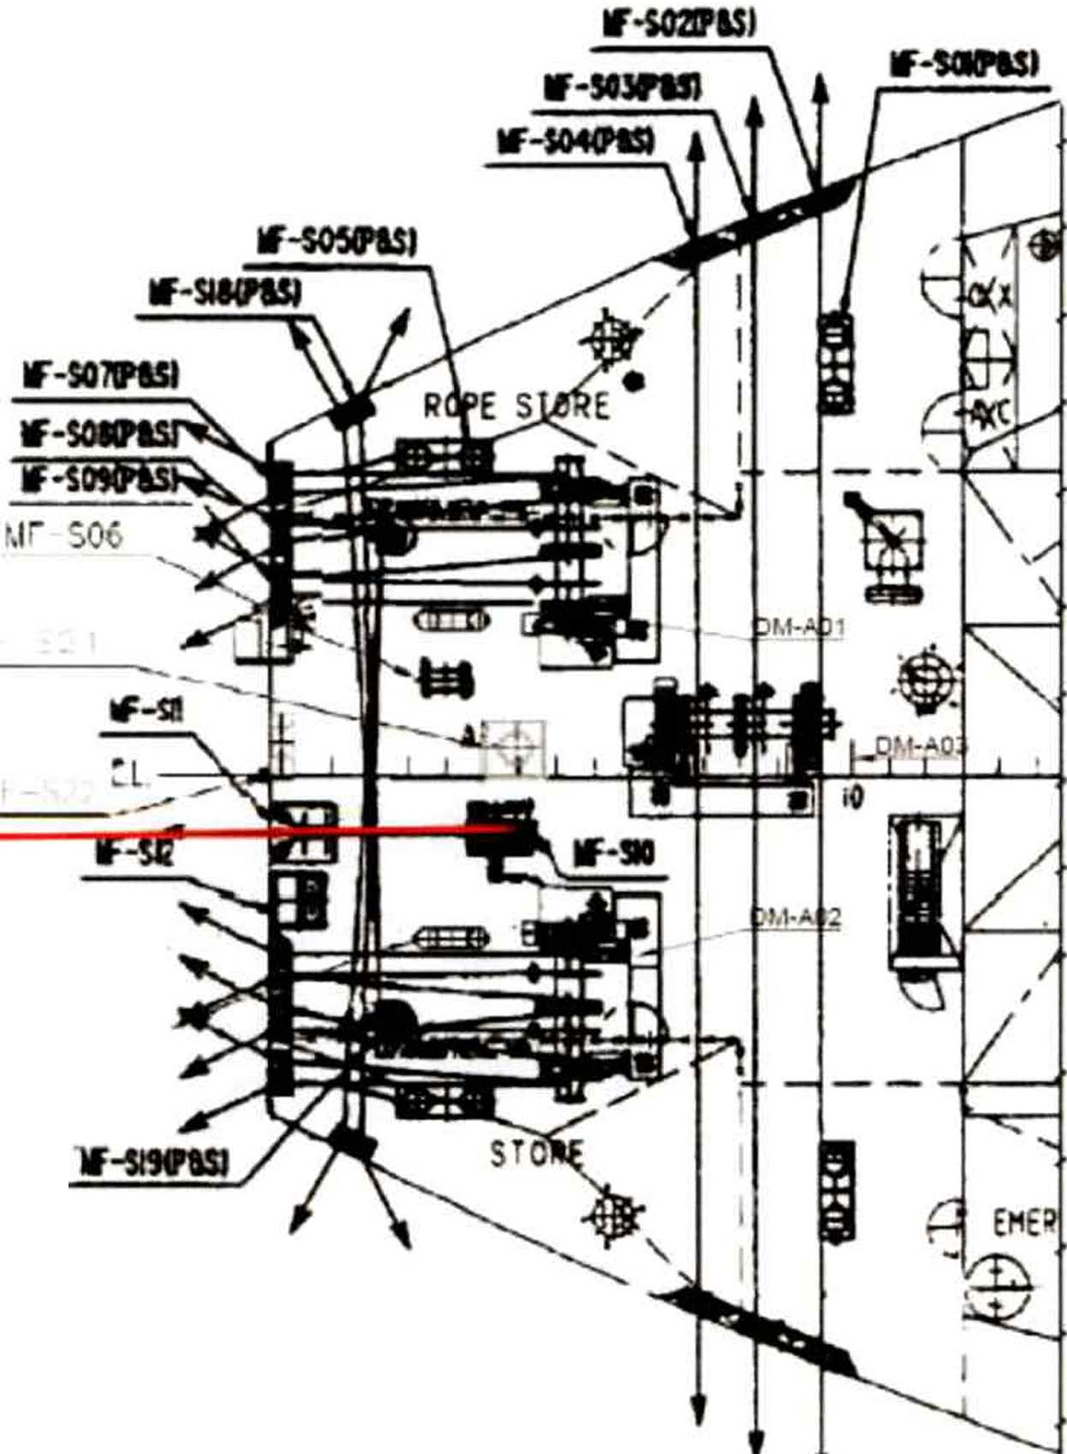MIT
EMERGENCY TOWING BOOKLET PAGE 24 OF 62

    - Mode 1-A (Towing from the Stern) Use ship's emergency towing arrangement.

TUG

MF-S20 ,/ (P&S}
1
[wlRE ROPE I

MIT
EMERGENCY TOWING BOOKLET

    - Mode 2-F (Towing from the Bow) Use ship's wire rope and a bollard.

1,r-M32
P&S

PAGE 25 OF 62

TUG

lwtRE ROPE I

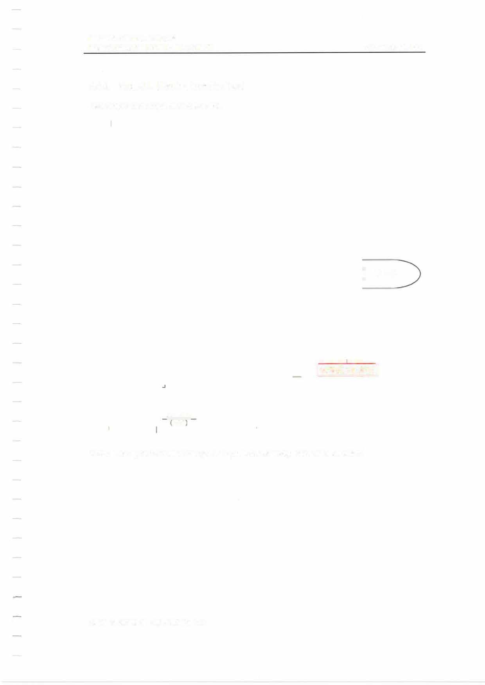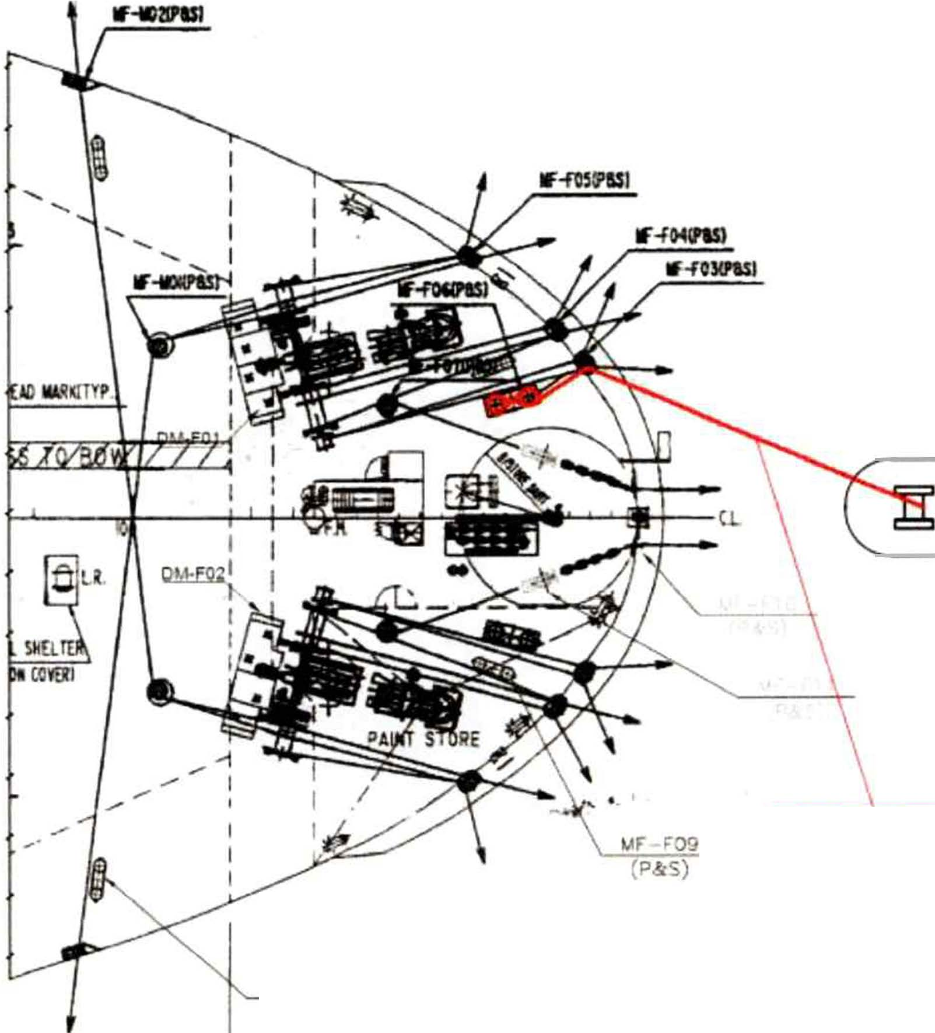

Note: The symmetrical arrangement (starboard side) may also be used.

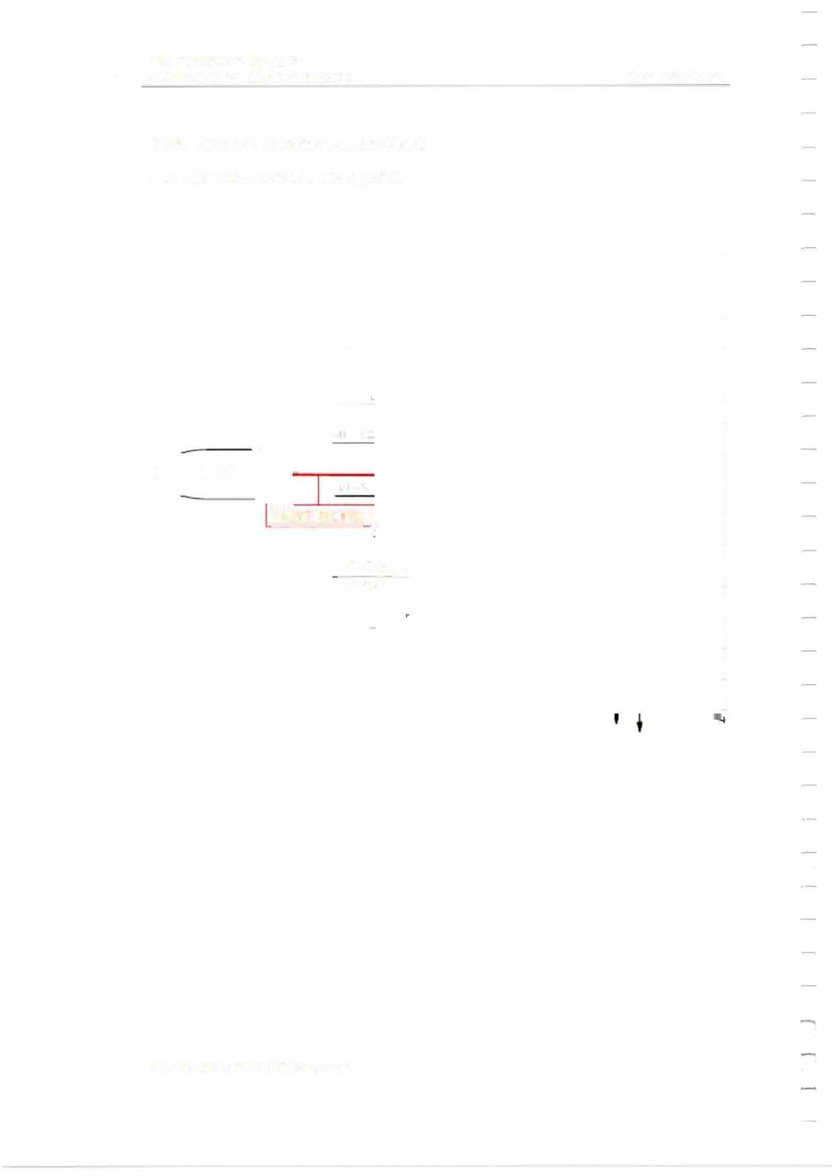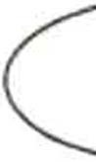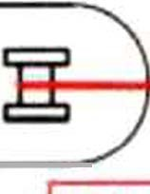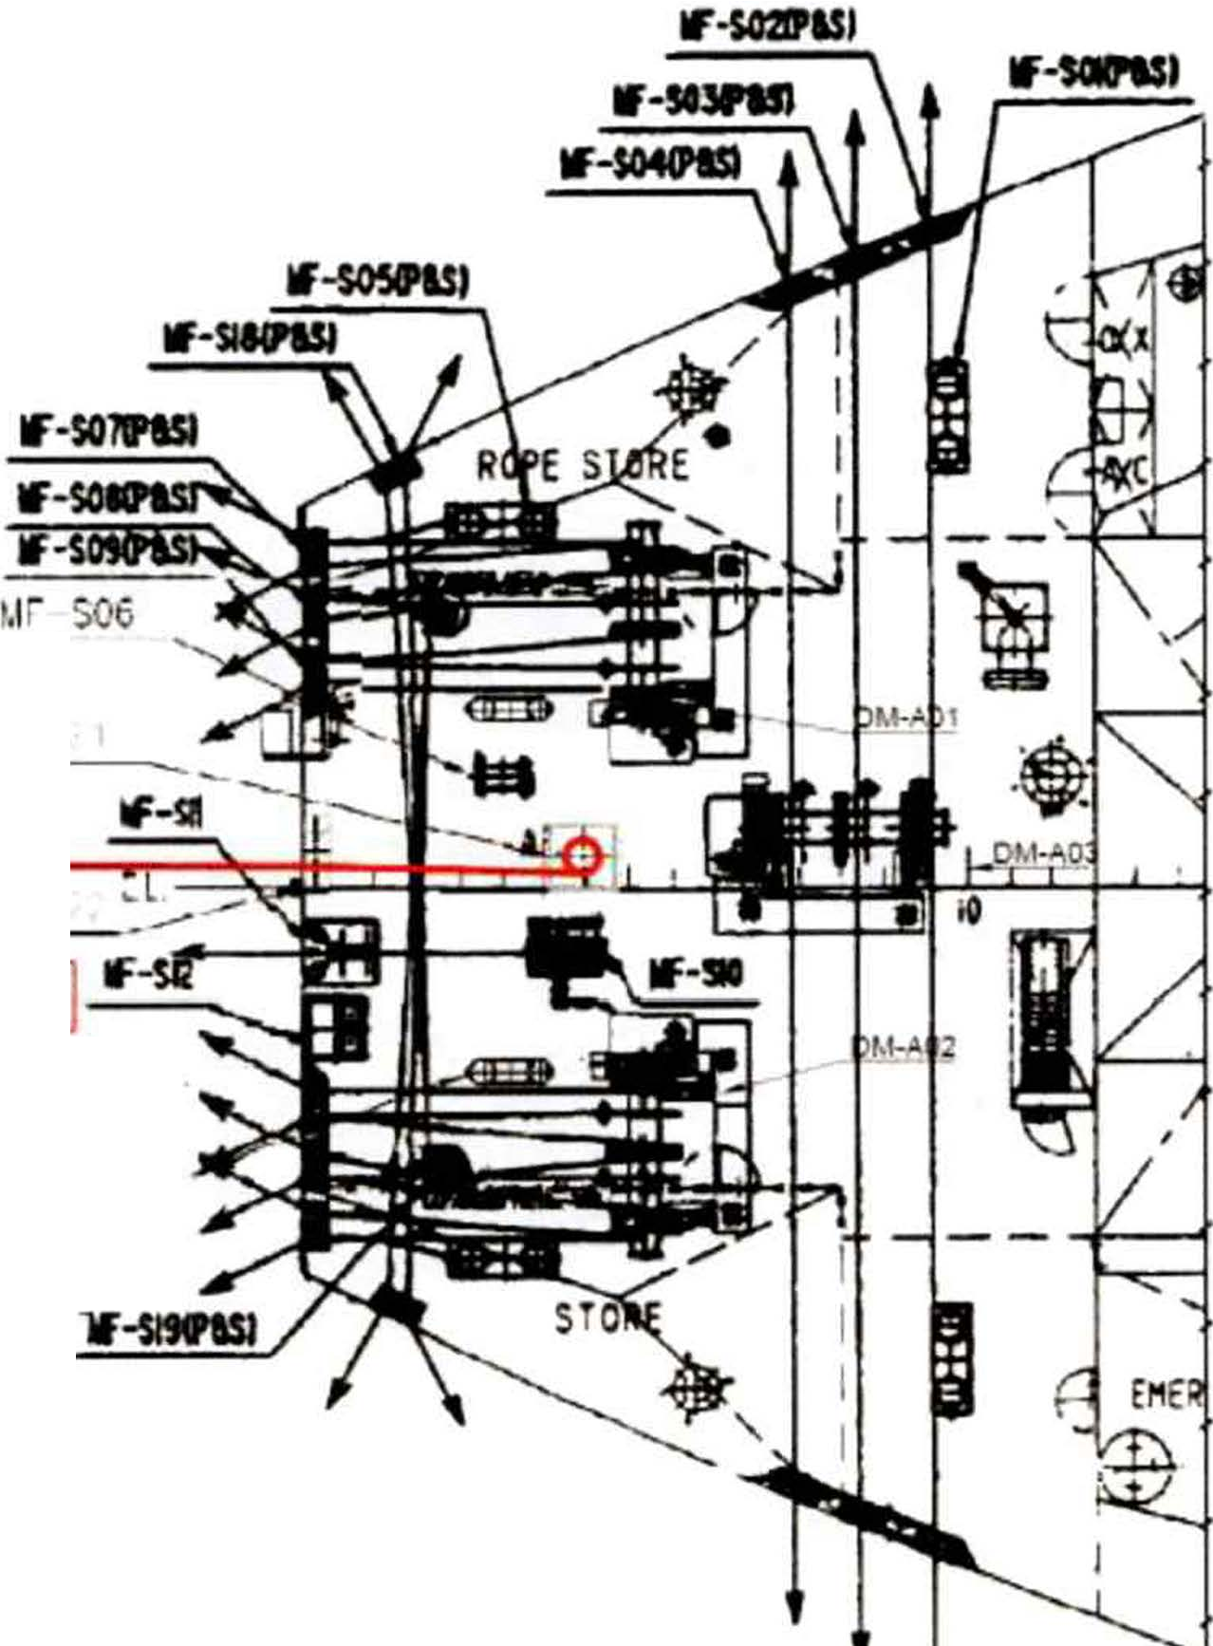MIT
EMERGENCY TOWING BOOKLET

    - Mode 2-A (Towing from the Stern) Use ship's wire rope and strong point.

TUG

WIRE ROPE

MF-S20 _,, (P&S)

PAGE 26 OF 62

MIT
EMERGENCY TOWING BOOKLET

    - Mode 3-F (Towing from the Bow) Use the ship's hawsers.

PAGE 27 OF 62

TUG

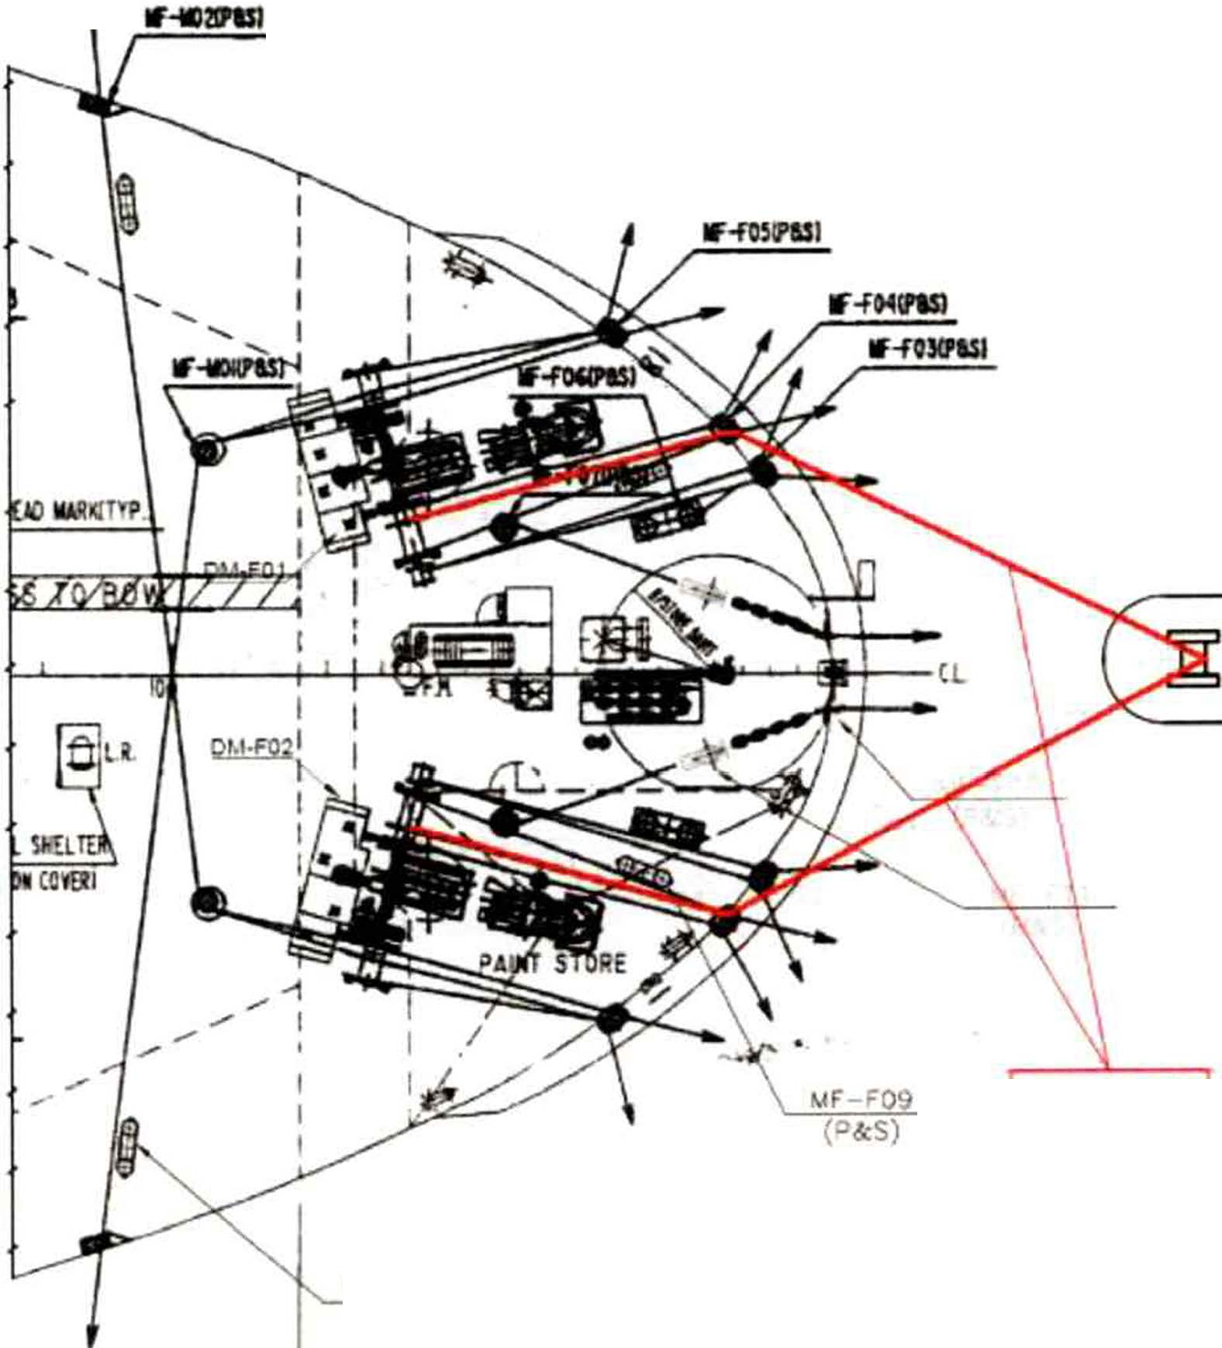

HAWSER

t.lF 1132
P&S

MIT
EMERGENCY TOWING BOOKLET

    - Mode 3-A (Towing from the Stern) Use the ship's hawsers.

lf-sGZIPISI

PAGE 28 OF 62

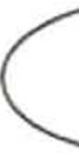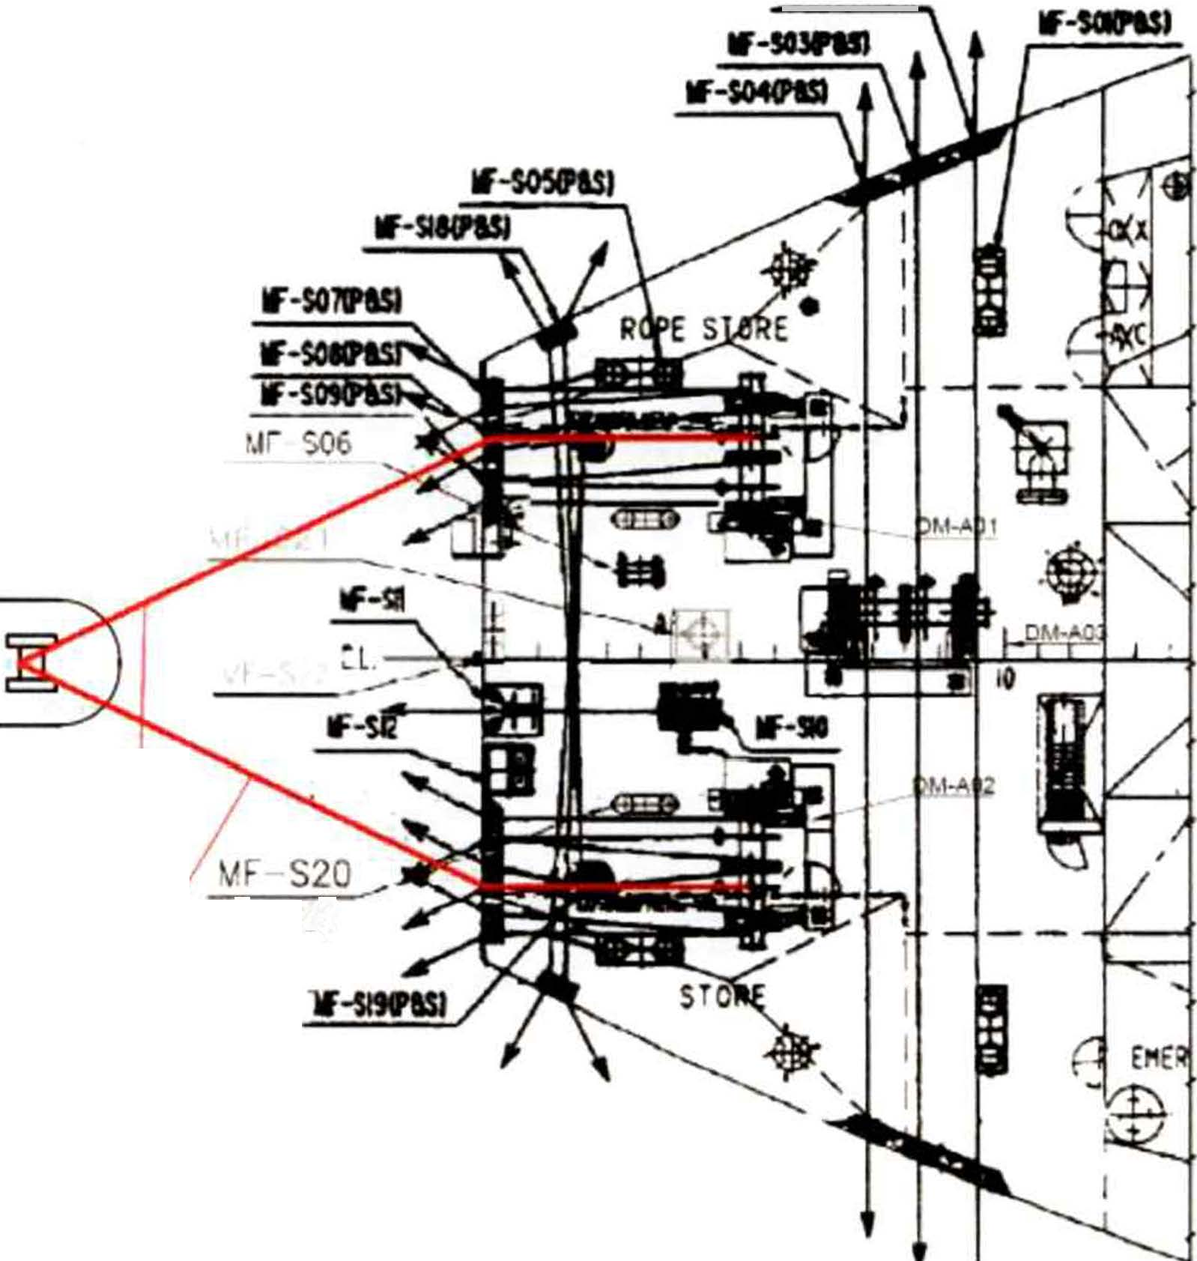TUG

(P&S) IHAWSERI
t

MfT
EMERGENCY TOWING BOOKLET

    - Mode 4-F (Towing from the Bow) Use tug's wire rope and a bollard.

\
\
/
/

PAGE 29 OF 62

TUG

_,,,. Mf"-F':)9
(P&S)
IWIRERQfi]

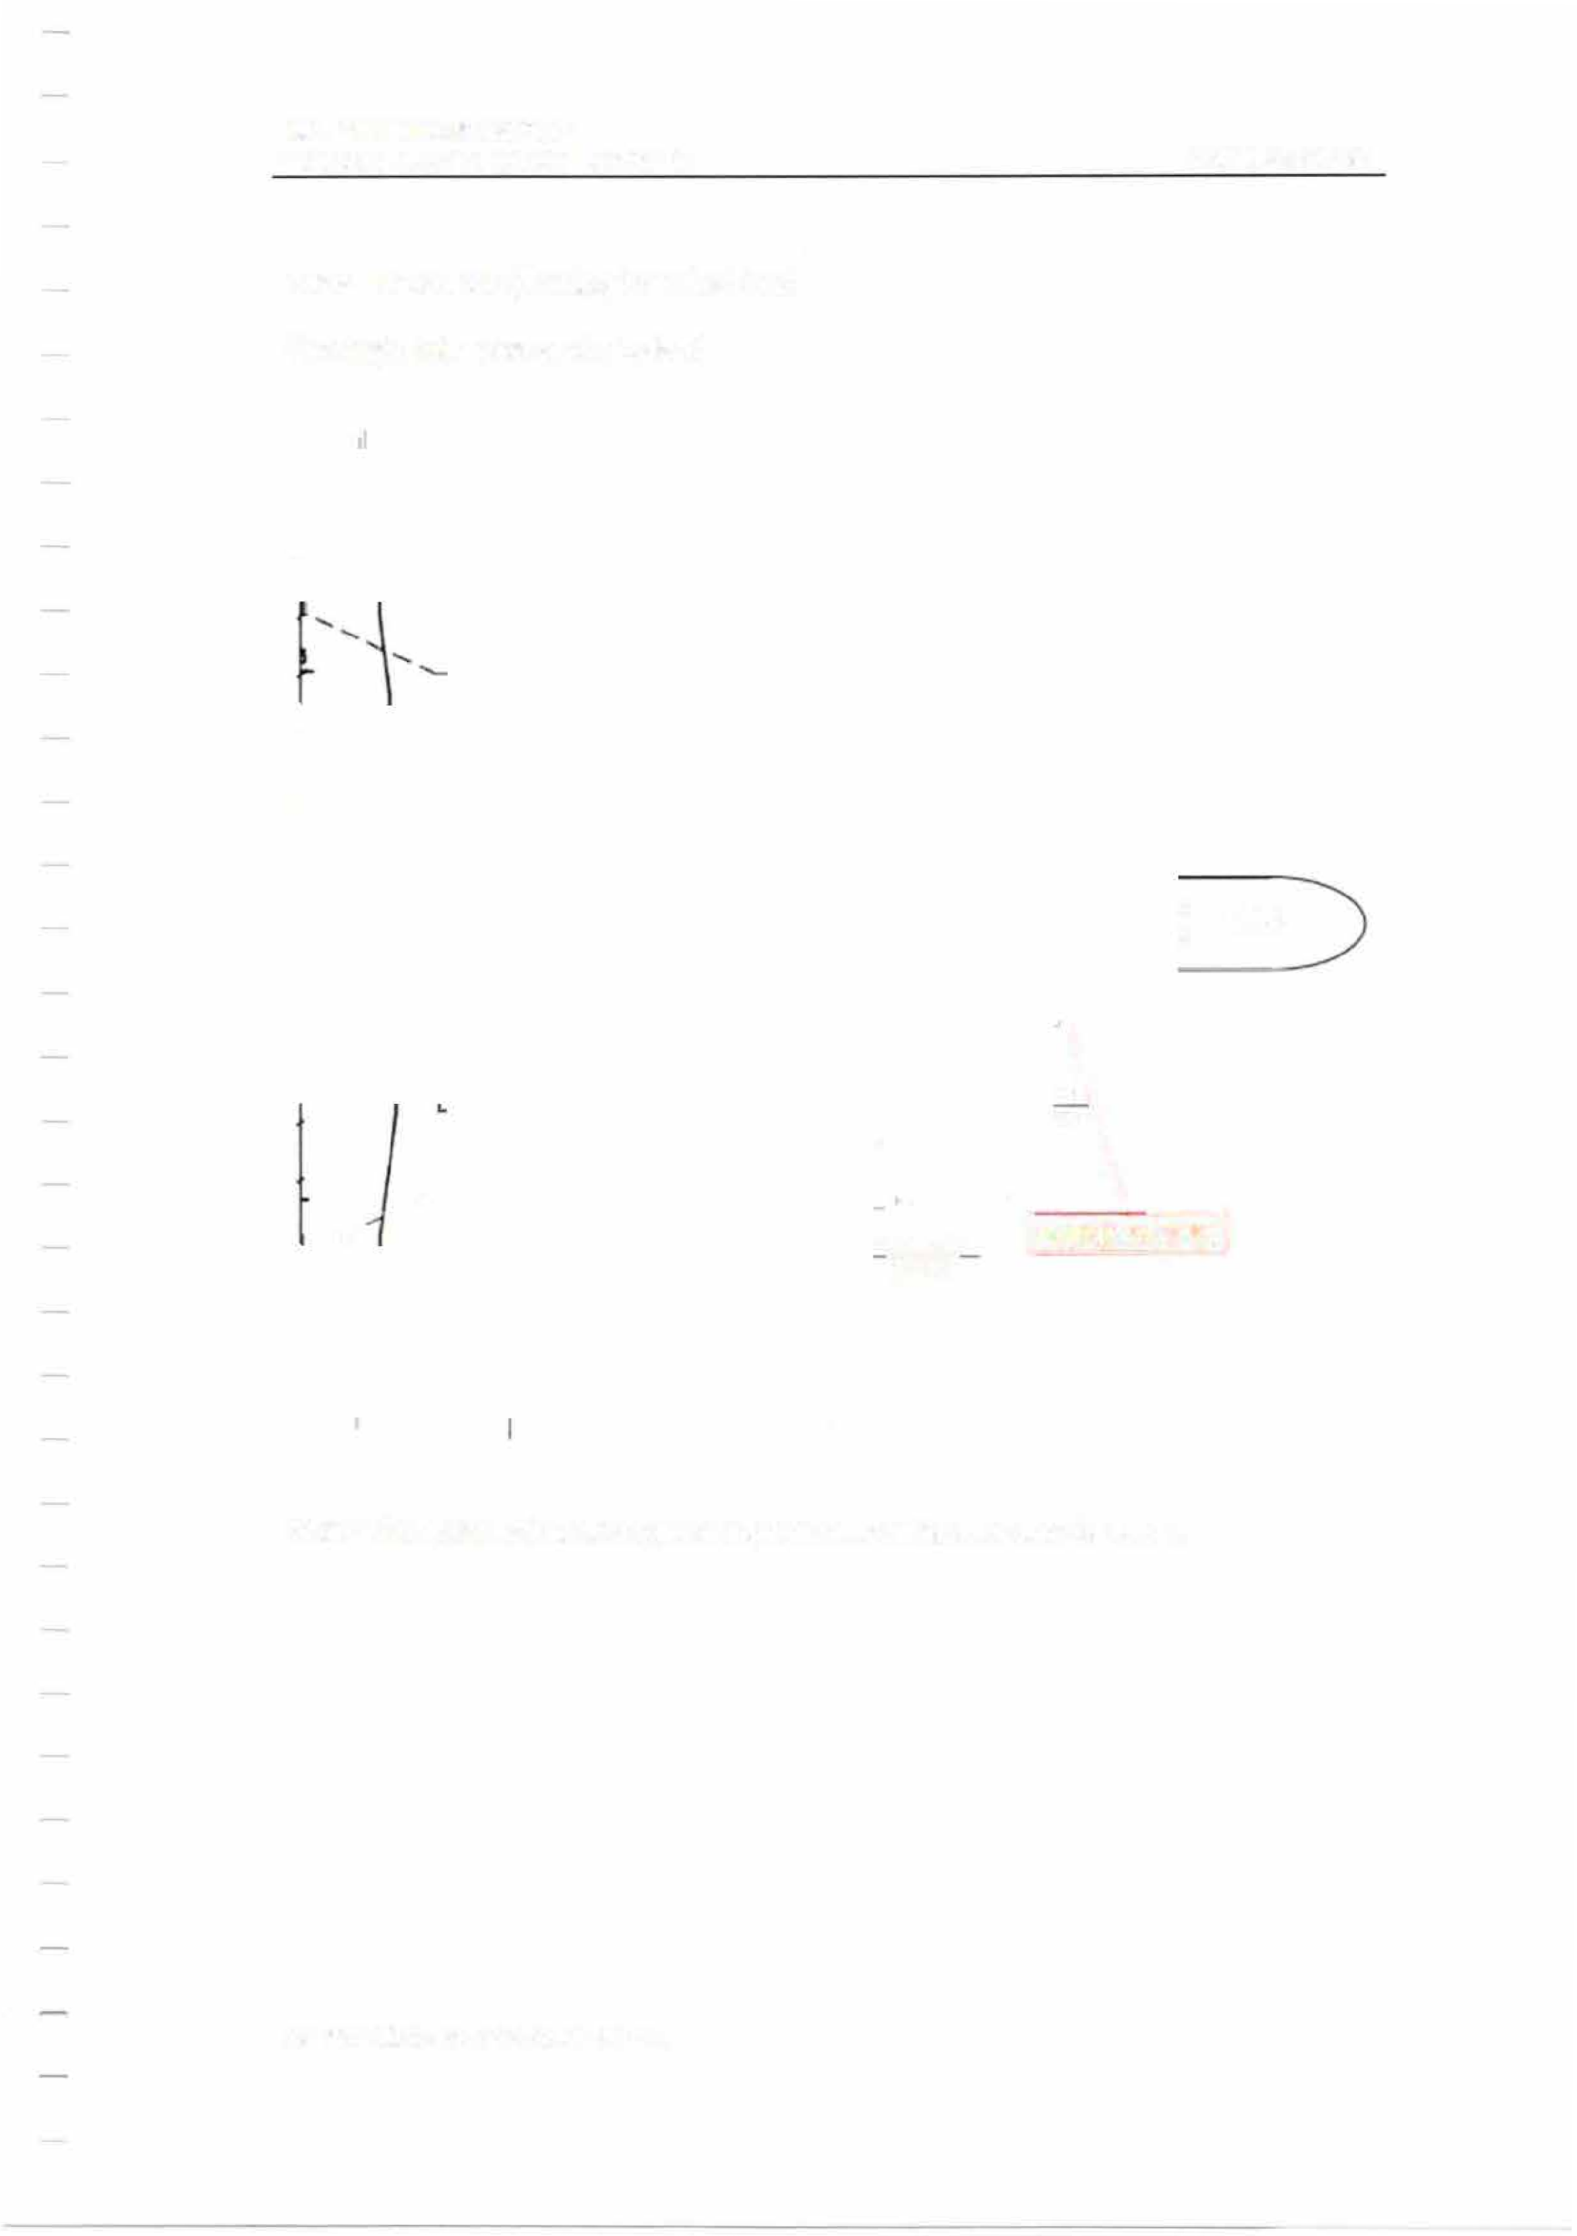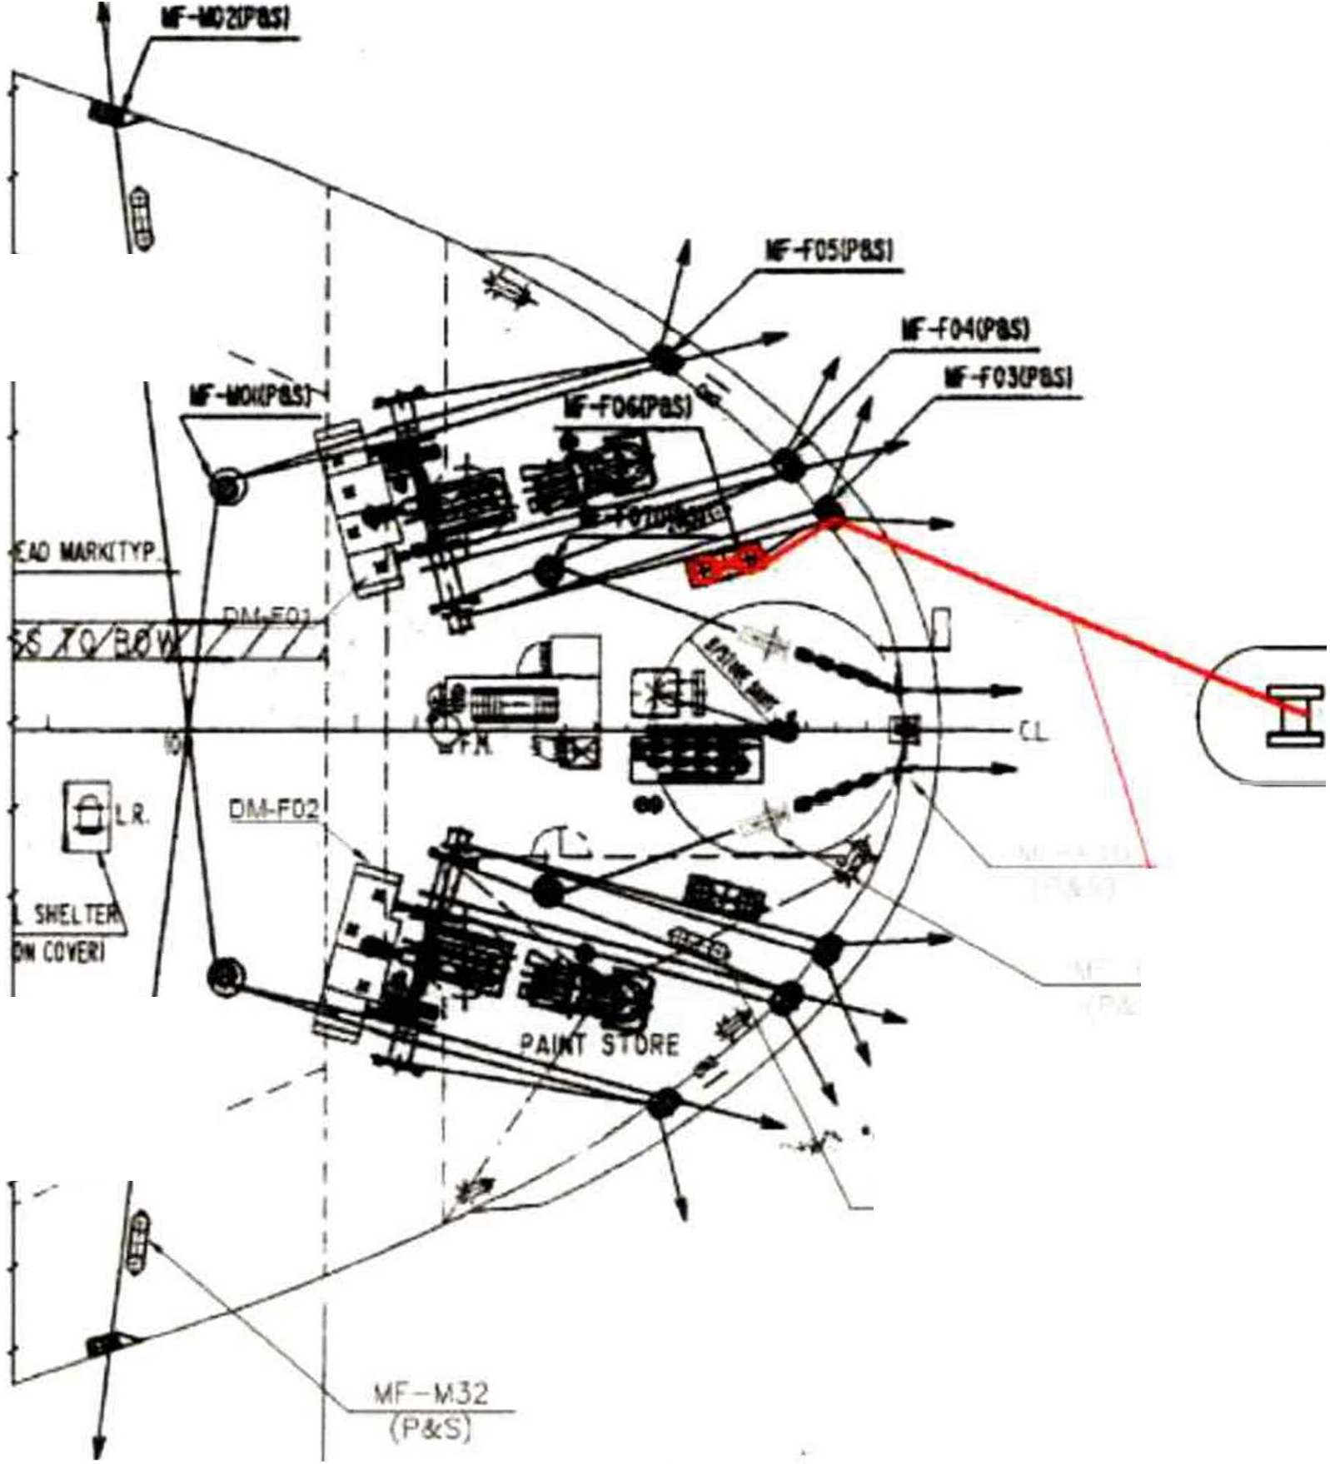

Note: The symmetrical arrangement (starboard side) may also be used.

MIT
EMERGENCY TOWING BOOKLET PAGE 30 OF 62

    - Mode 4-A (Towing from the Stern) Use tug's wire rope and a bollard.

TUG

1.--
W-IR-E�RO_P_E !

I

MF S20 ,.,
I
.....,(P&S)

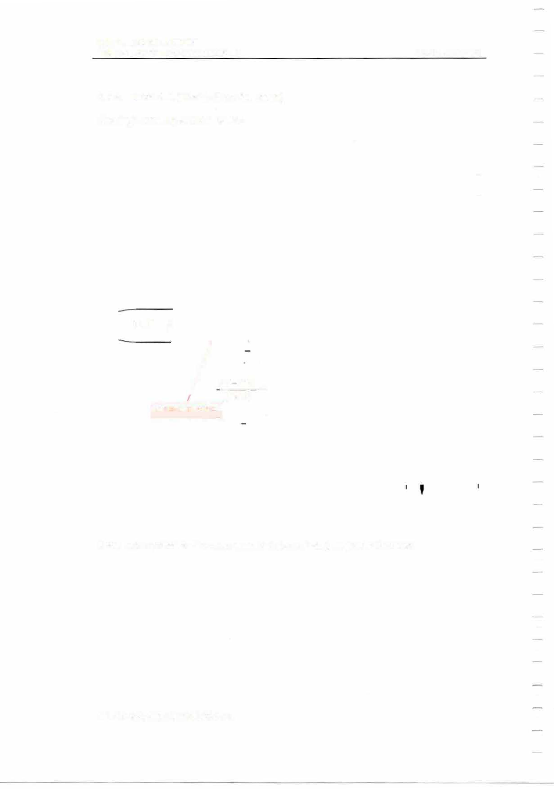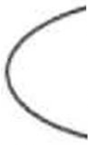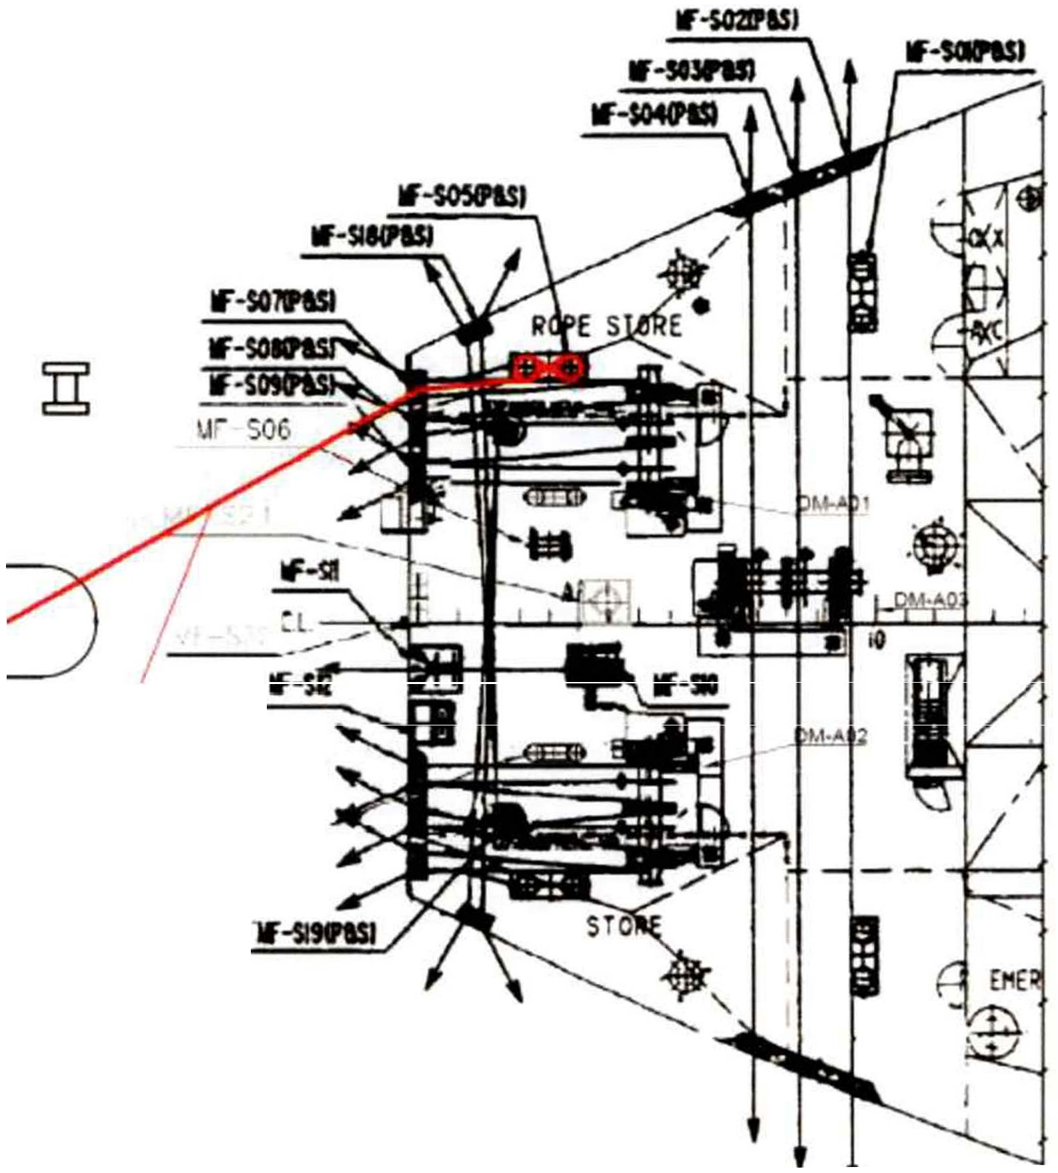

Note: The symmetrical arrangement (starboard side) may also be used.

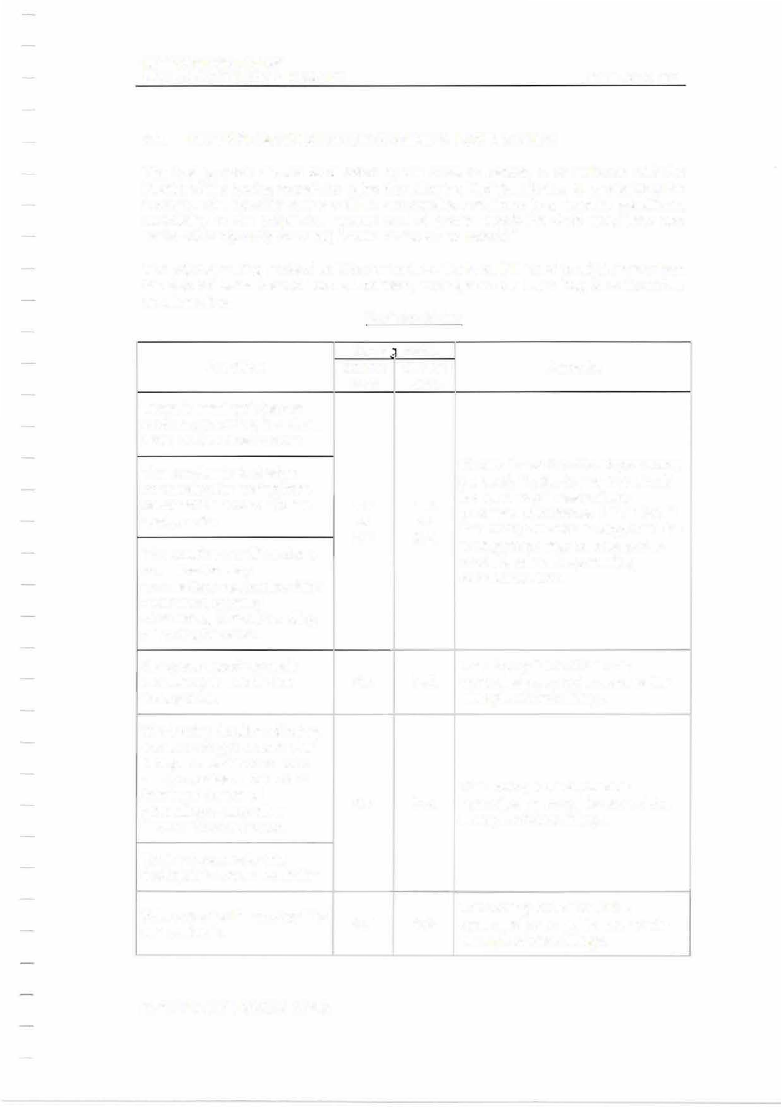MIT
EMERGENCY TOWING BOOKLET PAGE 31 OF 62

  - DECISION MATRIX FOR DETERMINING TOWING MODE

The towing mode should be decided by the vessel's Master, in consultation with the Master of the towing vessel, by using the following Decision Matrix. In considering the towing mode, the ship status and the surrounding conditions (e.g. weather conditions, availability of the propulsion system and of power supply for deck machinery and imminent danger of grounding) should be taken into account.

The primary towing mode should be to tow from the bow. If it is not possible to tow from the bow for some reason such as collision, towing from the stern may be selected as an alternative.
Decision Matrix

Condition  There is imminent danger such as grounding in a short time; i.e. less than 1 hour.  The weather is bad when connecting the towing lines between the towed and the towing ship.  The weather condition does not allow for easy  connection; e.g. towing ship's manoeuvring being obstructed, difficult handling of towing hawsers.  No power supply to deck machinery to handle the towing lines. | Towin1 mode |  | Remarks  Modes 1-F or 1-A should preferably be used. Modes 2-F or 2-A should be used only in case of any problems with modes 1-F or 1-A. If the towing duration is long, then the towing mode may be changed to mode 3, when the prevailing conditions allow.
 | f/m the bow  1-F  or 2-F  2-F | f/m the stern  1-A  or  2-A
 | f/m the bow  1-F  or 2-F  2-F | 2-A | The towing force should be controlled so as not to exceed the strength of deck fittings.
The towing duration of being towed is long; i.e. more than 1 day. Weather conditions are favourable. There is no imminent danger of grounding or any other unfavourable condition. |  | 3-A | The towing force should be controlled so as not to exceed the strength of deck fittings.
Towing hawsers by the towing ship are not available. |  | 3-A
Wire ropes by the towing ship are available. | 4-F |  | The towing force should be controlled so as not to exceed the strength of deck fittings.

EMMITERGENCY TOWING BOOKLET
PAGE 32 OF 62

  - ORGANIZATION OF DECK CREW
The towing operation should be conducted in accordance with the following organization chart:

r·-·-·-·-·-·-·-·-·-·-·-·-·-·-·-·-·-·-·1
j Bridge --�
Master ---------------,------
---13rd officer

- I •
I ·----- - - �--·-·-·-·-·-·-·-·-·-·-·-·--'

••.__-(Onboard wireless radio)

---

--+jTowing ship I
=
(VHFch.16)

.!-·-·-·-·-1,-·-·-·-·-·-·-·-·-·-·-·-·-·-O·-n·-up·p-e·r-d·e-c·k-a·-t b·-ow·-(·o-n·-up·-pe·-r d·-ec·k-a·-t s·-te·r-n)·1i
iI -Ch-ief..L...offi-cer-1---------.�2-nd-off-ice----,r l
.___--!2nd engineer
Bosun
--+tSeaman A (handling mooring winch)

seaman D
'---- ....iseaman E
Cwirreewleasnsdrabdoios.un carry portable

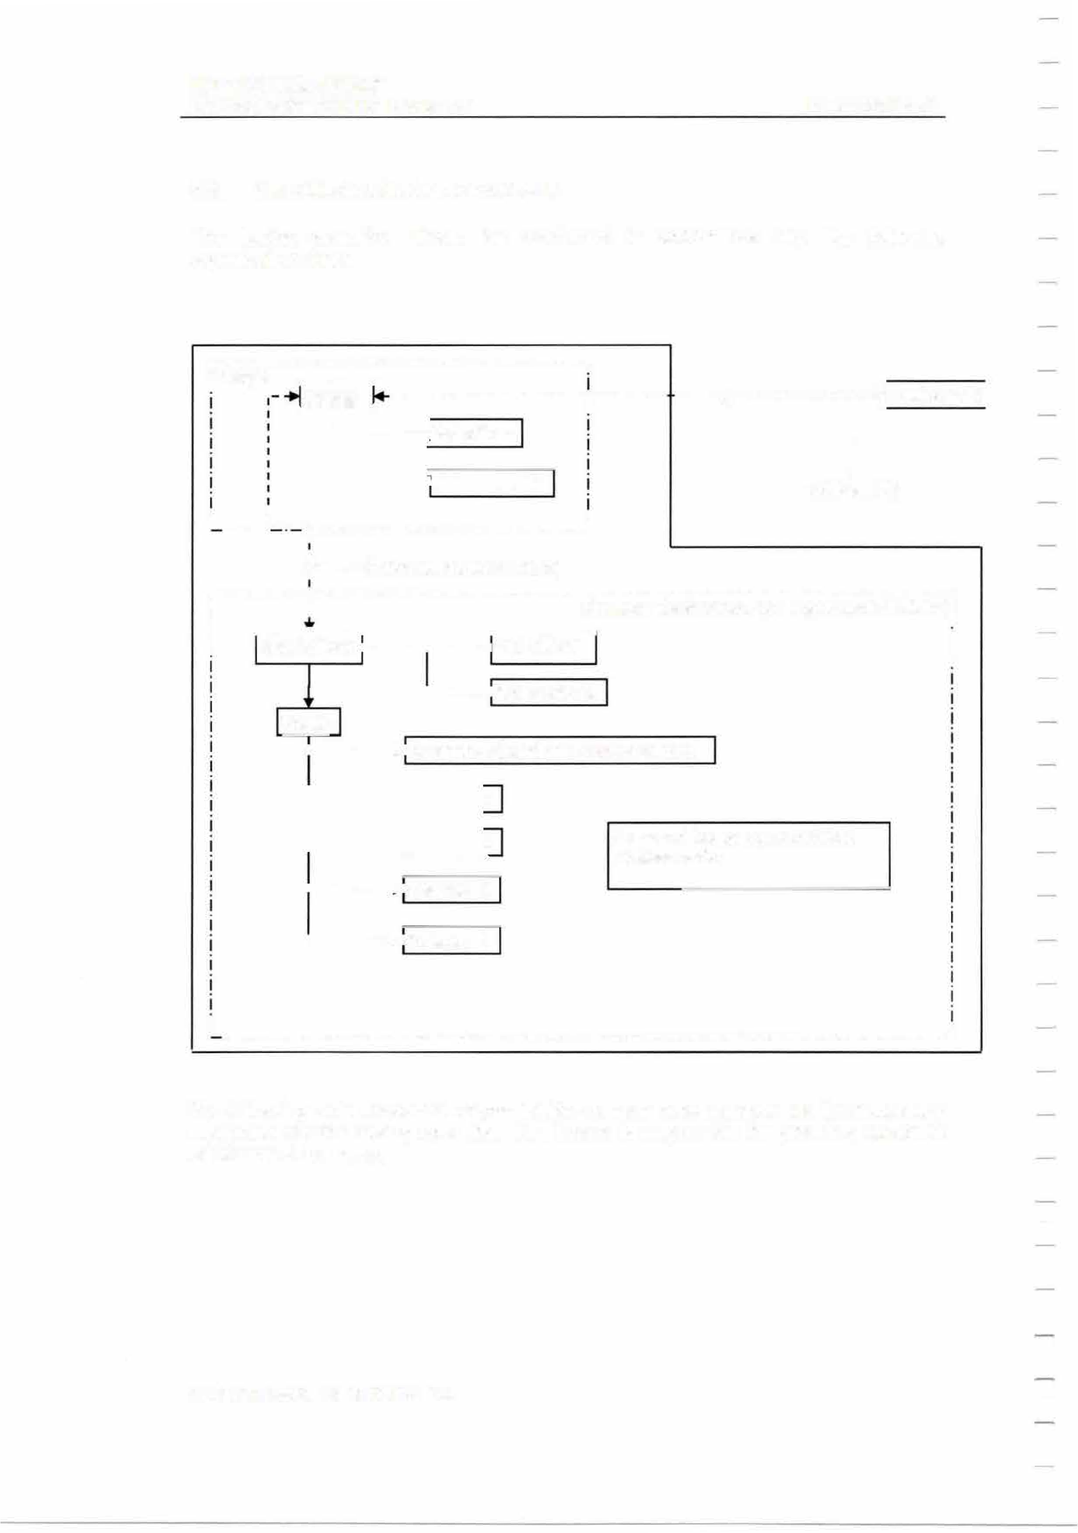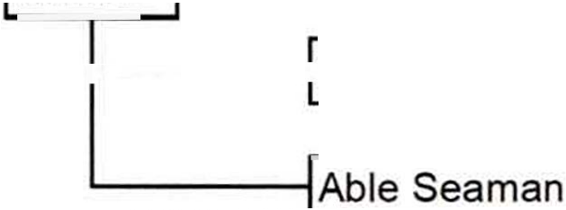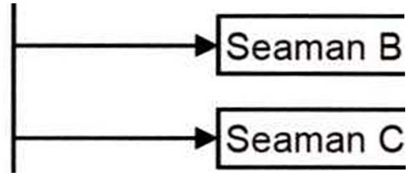

I .
. ·-·-·-·-·-·-·-·-·-·-·-·-·-·-·-·-·-·-·-·-·-·-·-·-·-·-·-·-·-·-·-·-·-·-·-·-·J

The following table shows the responsibilities of each crew member and the necessary equipment for the towing operation. The bosun is responsible for providing sufficient deck tools to the crew.

MIT
EMERGENCY TOWING BOOKLET

Crew Responsibilities

PAGE 33 OF 62

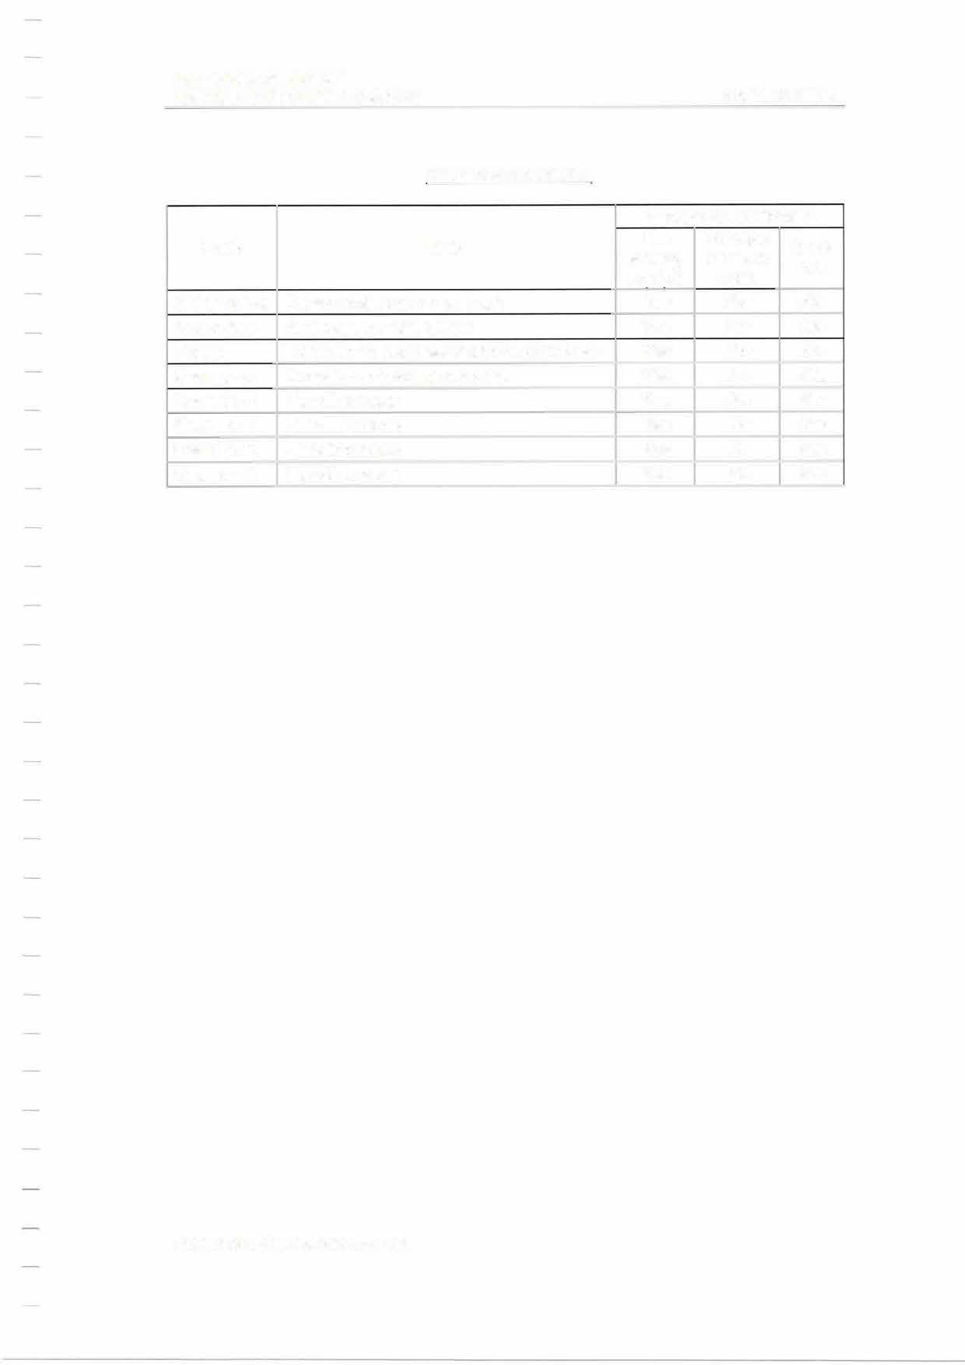
Rank  Chief Officer 2nd officer Bosun Seaman A  Seaman B | Duty  Responsible person on deck Assistant to Chief Officer  Foreman on deck assigning work to crew | Necessary equipment
Rank  Chief Officer 2nd officer Bosun Seaman A  Seaman B |  | Life saving  eauio't | Portable wireless  radio  Yes | Deck tool  No
Rank  Chief Officer 2nd officer Bosun Seaman A  Seaman B |  | Yes | Portable wireless  radio  Yes | Deck tool  No
Rank  Chief Officer 2nd officer Bosun Seaman A  Seaman B |  | Yes  Yes | Yes  Yes | No  No
Rank  Chief Officer 2nd officer Bosun Seaman A  Seaman B | Operator of mooring winches | Yes | No | Yes
Rank  Chief Officer 2nd officer Bosun Seaman A  Seaman B | Handling ropes | Yes | No | Yes
Seaman C | Handling ropes | Yes | No | Yes
Seaman D | Handling ropes | Yes | No | Yes
Seaman E | Handling ropes | Yes | No | Yes

MIT
EMERGENCY TOWING BOOKLET

PAGE 34 OF 62

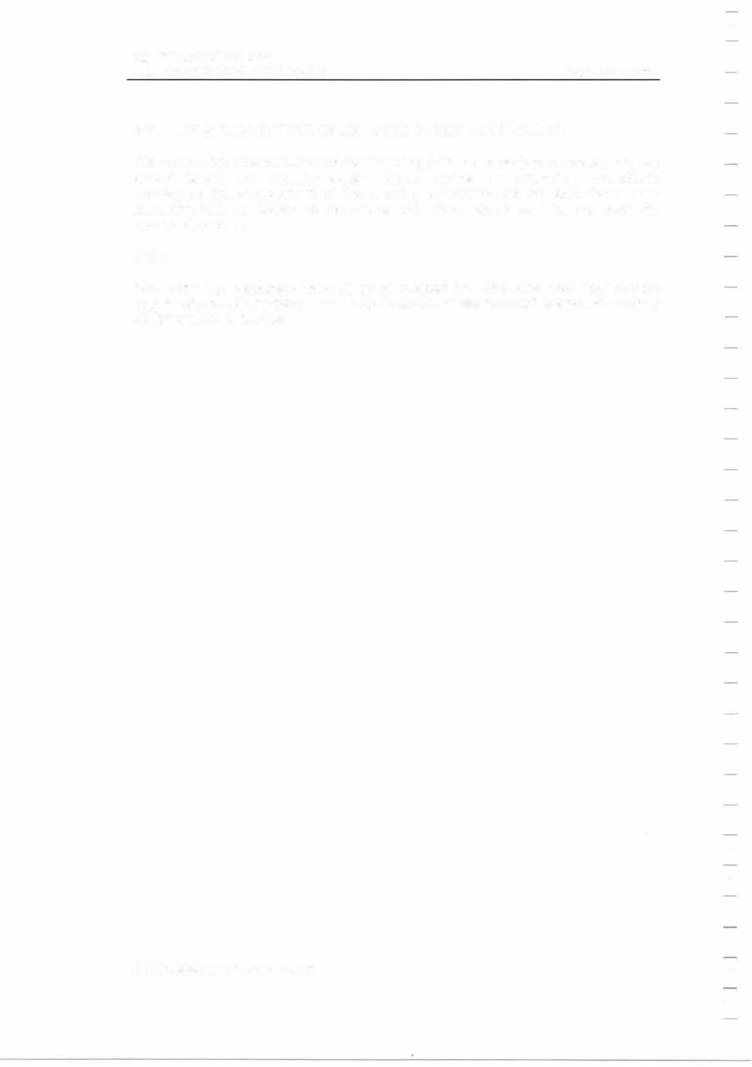

  - EXAMPLES OF TOWING LINE CONNECTING PROCEDURES

The connecting procedures for the basic towing patterns, described in Section 3.4, are shown below. The vessel's Master should decide the connecting procedures considering the arrangement of the mooring equipment and the ship status after consulting with the Master of the towing ship. Crew should be informed about the chosen procedure.

Note:
The following examples have been developed for this ship and may not be applicable to other ships, especially to those of design and equipment largely different from this ship.

MIT
EMERGENCY TOWING BOOKLET

    - Mode 1-F: Using ship's chain.

PAGE 35 OF 62

      - Ensure that all personnel involved in the emergency towing operation are clear of any snap-back areas.
      - Ensure that proper communication with bridge and towing ship is established.

MESSENGER ROPE

TUG

CHAIN
IWIREROPE

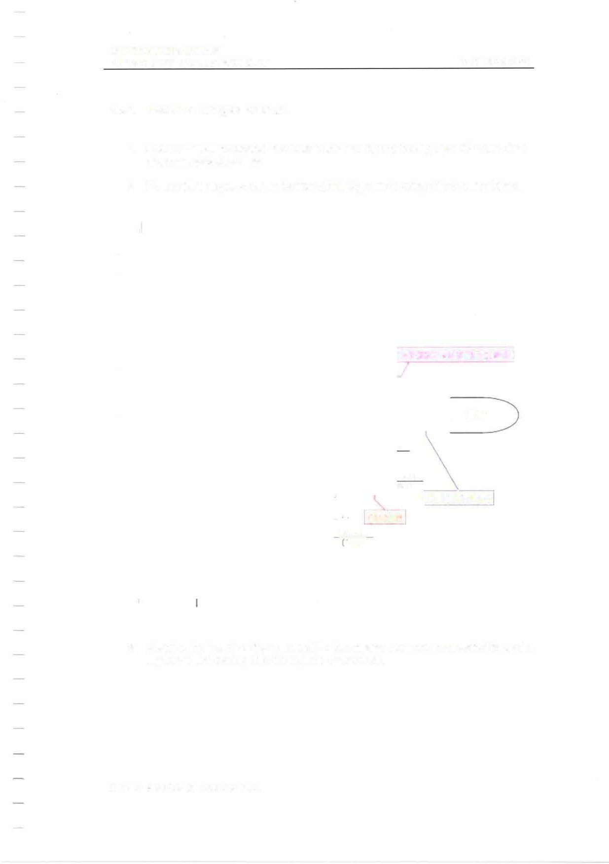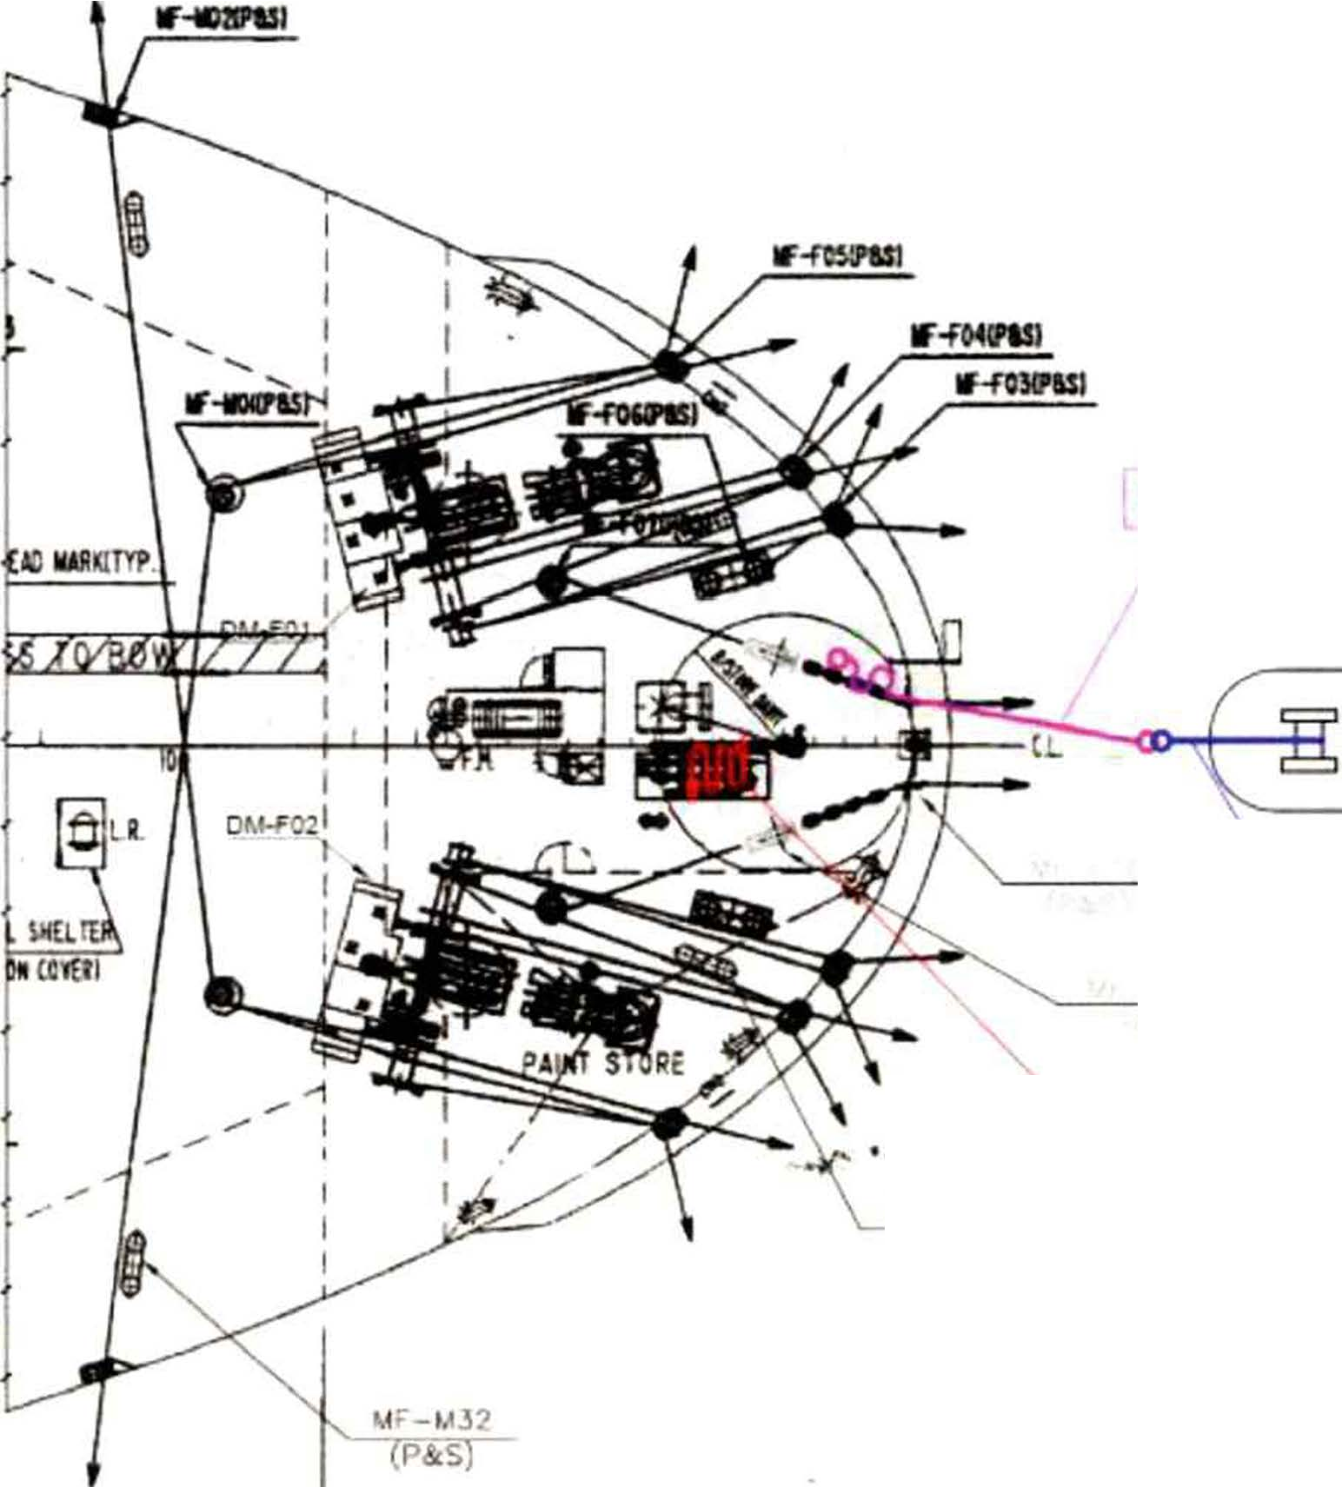
11r-ro9

      - Receive the heaving line followed by the messenger rope connected to a wire rope from the towing ship through the bow chock.

MIT
EMERGENCY TOWING BOOKLET

c:..

PAGE 36 OF 62

WIRE ROPEj
/

TUG

.,.r-r09 (P&S)
CHAIN

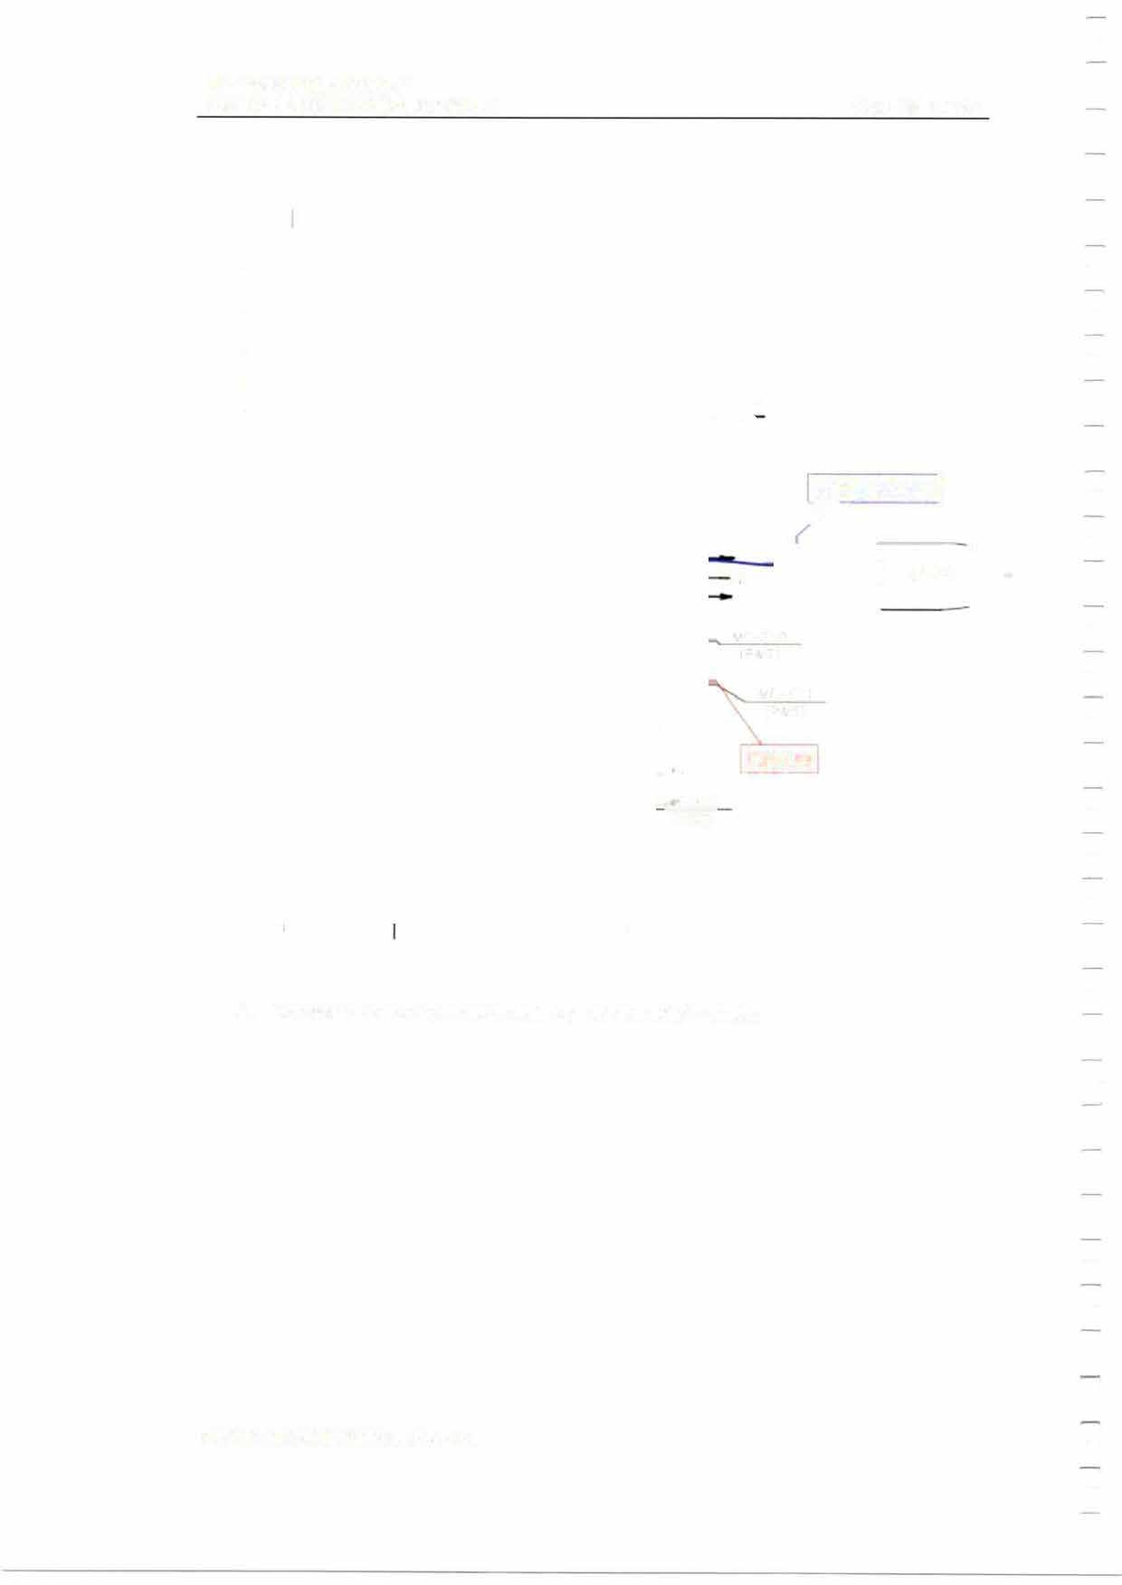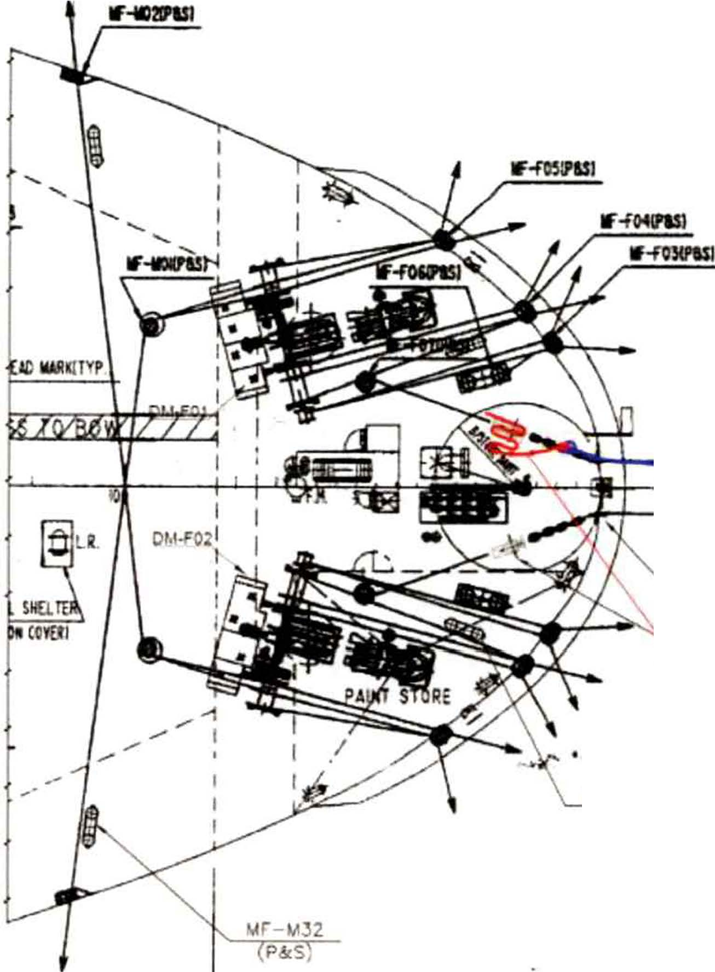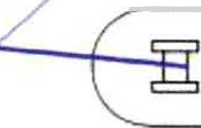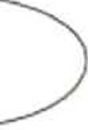

      - Connect the towing ship's wire rope to the ship's chain.

MIT
EMERGENCY TOWING BOOKLET

\If -LIJ2 (P&S)

PAGE 37 OF 62

TUG

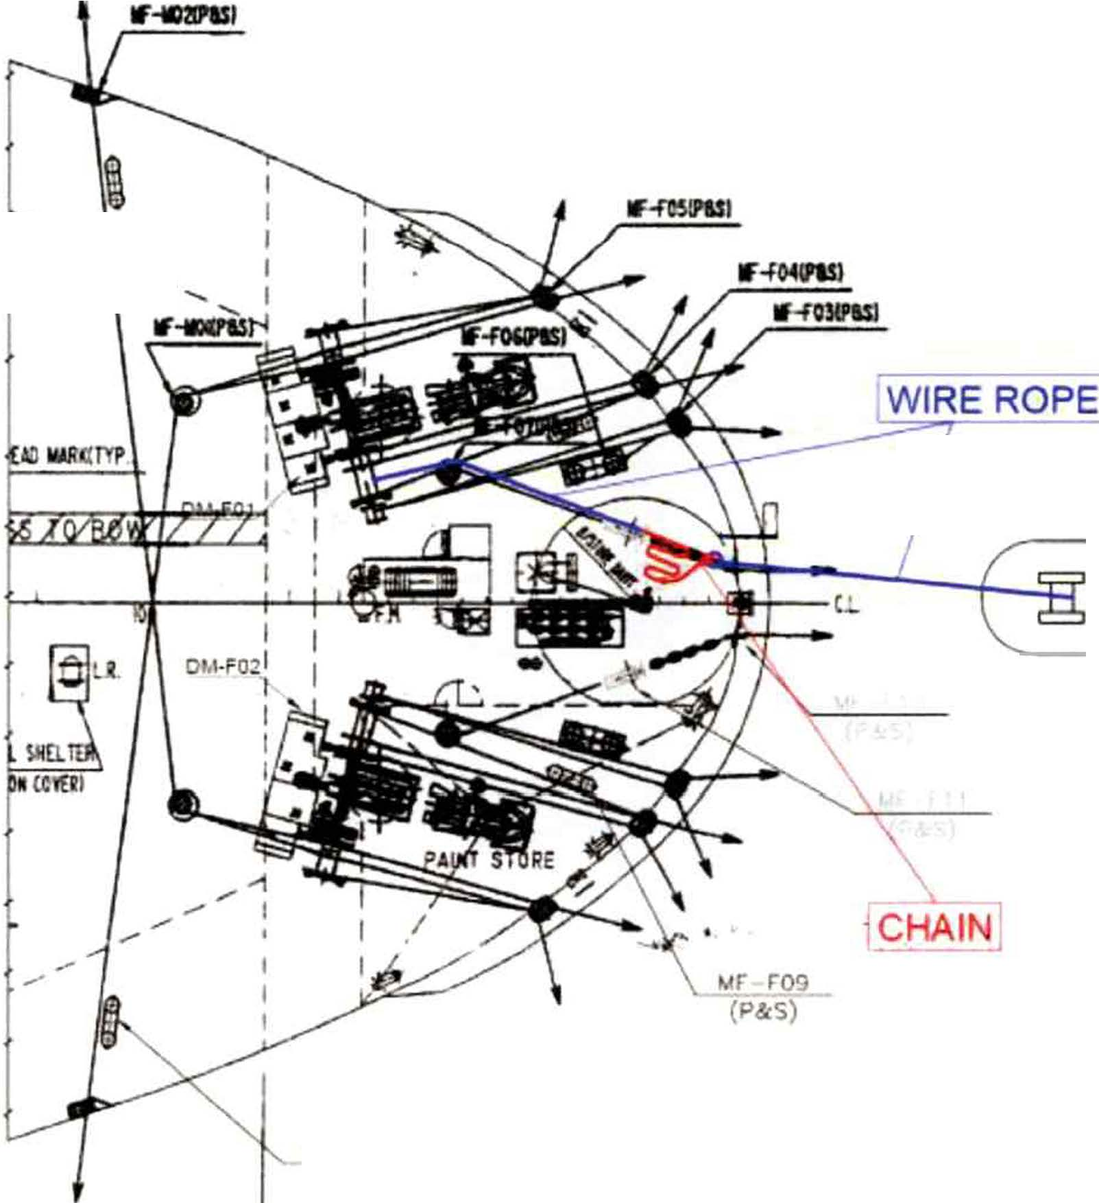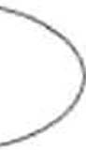

      - Secure the chain to the chain stopper by connecting a wire rope to the free end of the chain, passing it through the chain stopper and the stand roller and winding it on the mooring drum of the port side mooring winch.
      - When the chain reaches the chain stopper, lock the chain on it.

MIT
EMERGENCY TOWING BOOKLET

PAGE 38 OF 62

1,tF-r09 (P&S)

\

\
CHAIN
TUG

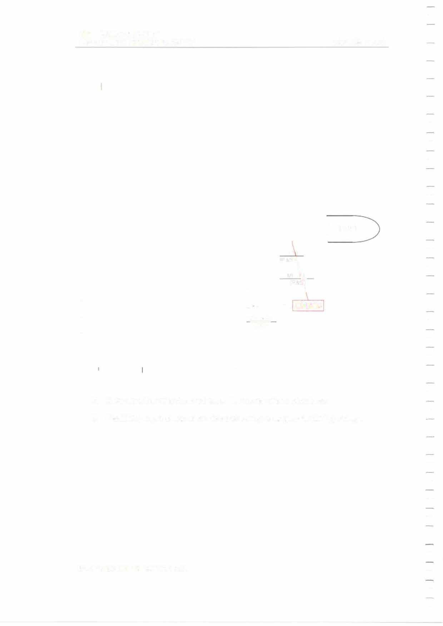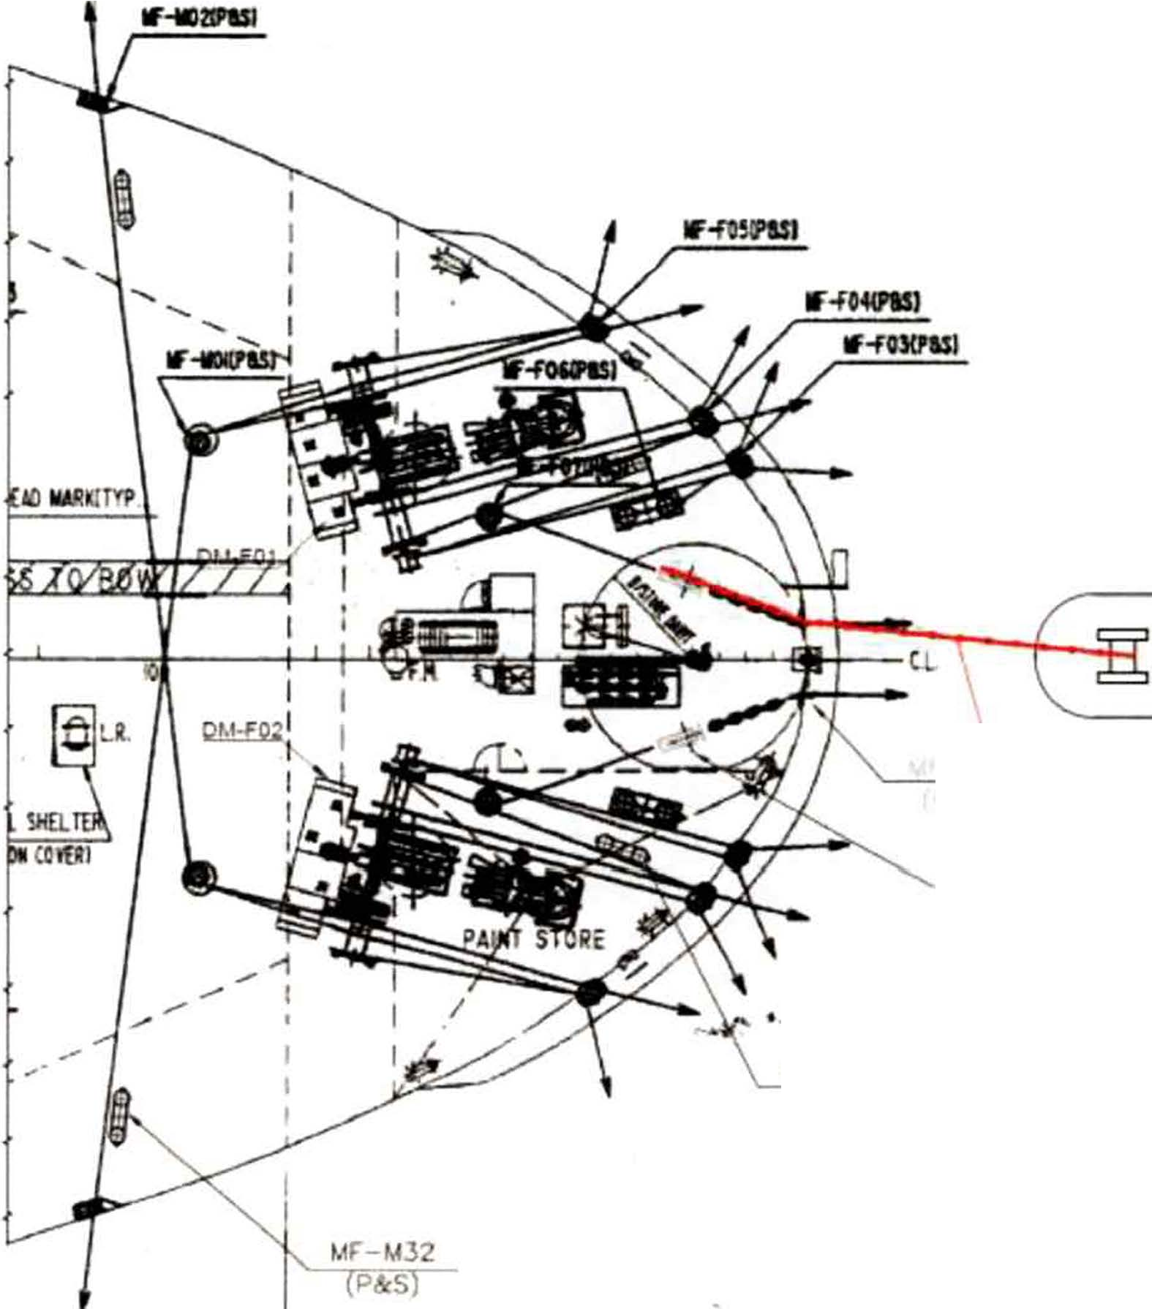

      - Make sure the wire does not touch the corner of any structures.
      - Establish proper watch to monitor the towing arrangement during towage.

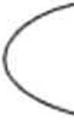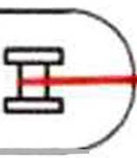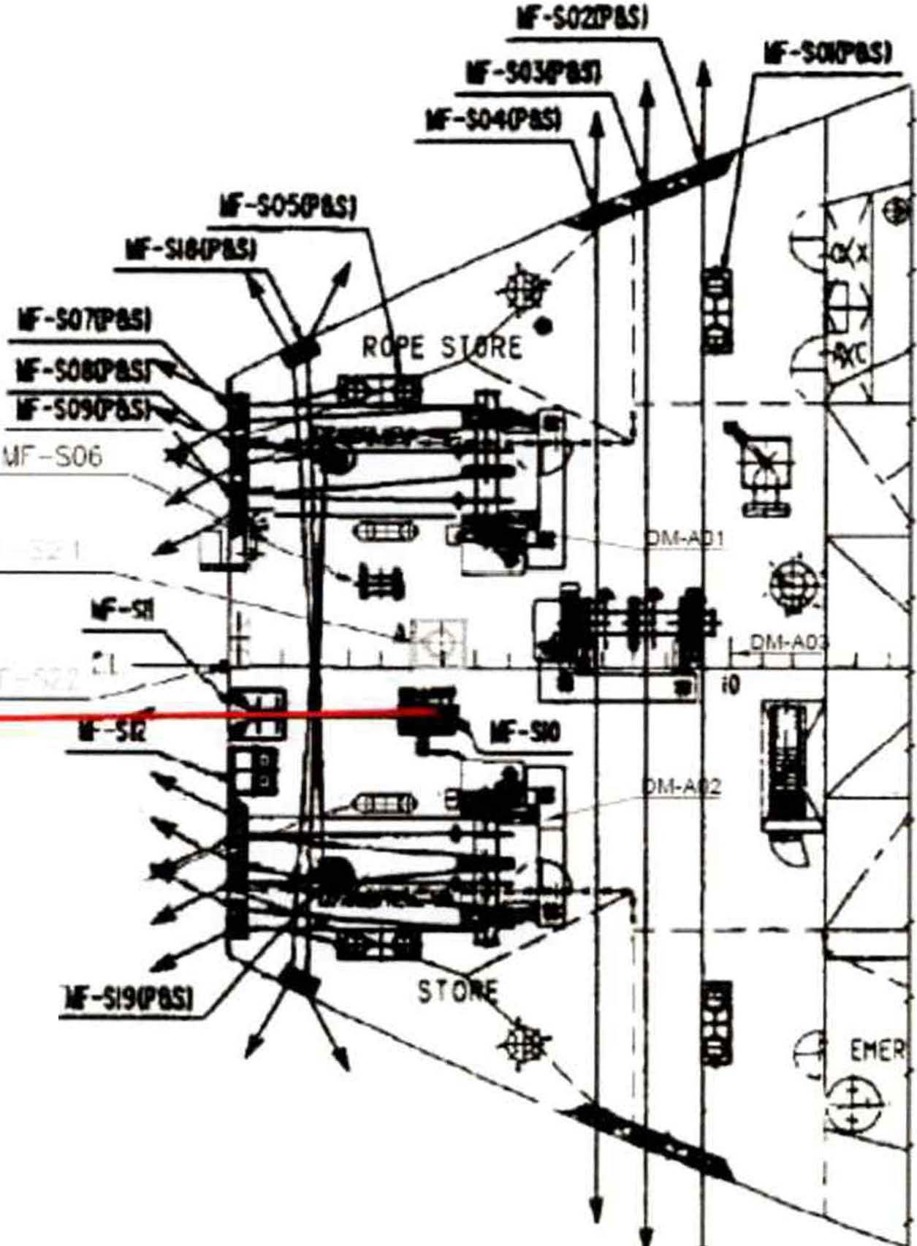MIT
EMERGENCY TOWING BOOKLET PAGE 39 OF 62

    - Mode 1-A: Using ship's emergency towing arrangement

      - Ensure that all personnel involved in the emergency towing operation are clear of any snap-back areas.

      - Ensure that proper communication with bridge and towing ship is established.

TUG
I

MF-S20 ,,,.
(P&:S)
!WIRE ROPEI

      - Follow relevant instructions according to the emergency towing arrangement procedures.
      - Establish proper watch to monitor the towing arrangement during towage.

MIT
EMERGENCY TOWING BOOKLET PAGE 40 OF 62

    - Mode 2-F: Using ship's wire ropes.

      - Ensure that all personnel involved in the emergency towing operation are clear of any snap-back areas.
      - Ensure that proper communication with bridge and towing ship is established.

IF-fUISI WIREBOPfl
lf.f044PISI

..,, ..,,
,�

,,.r-roq
(P&S)

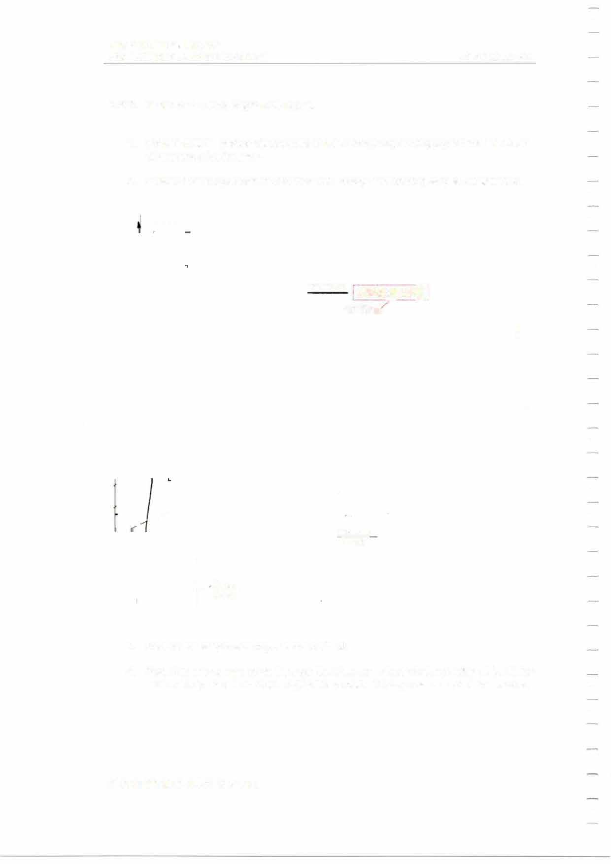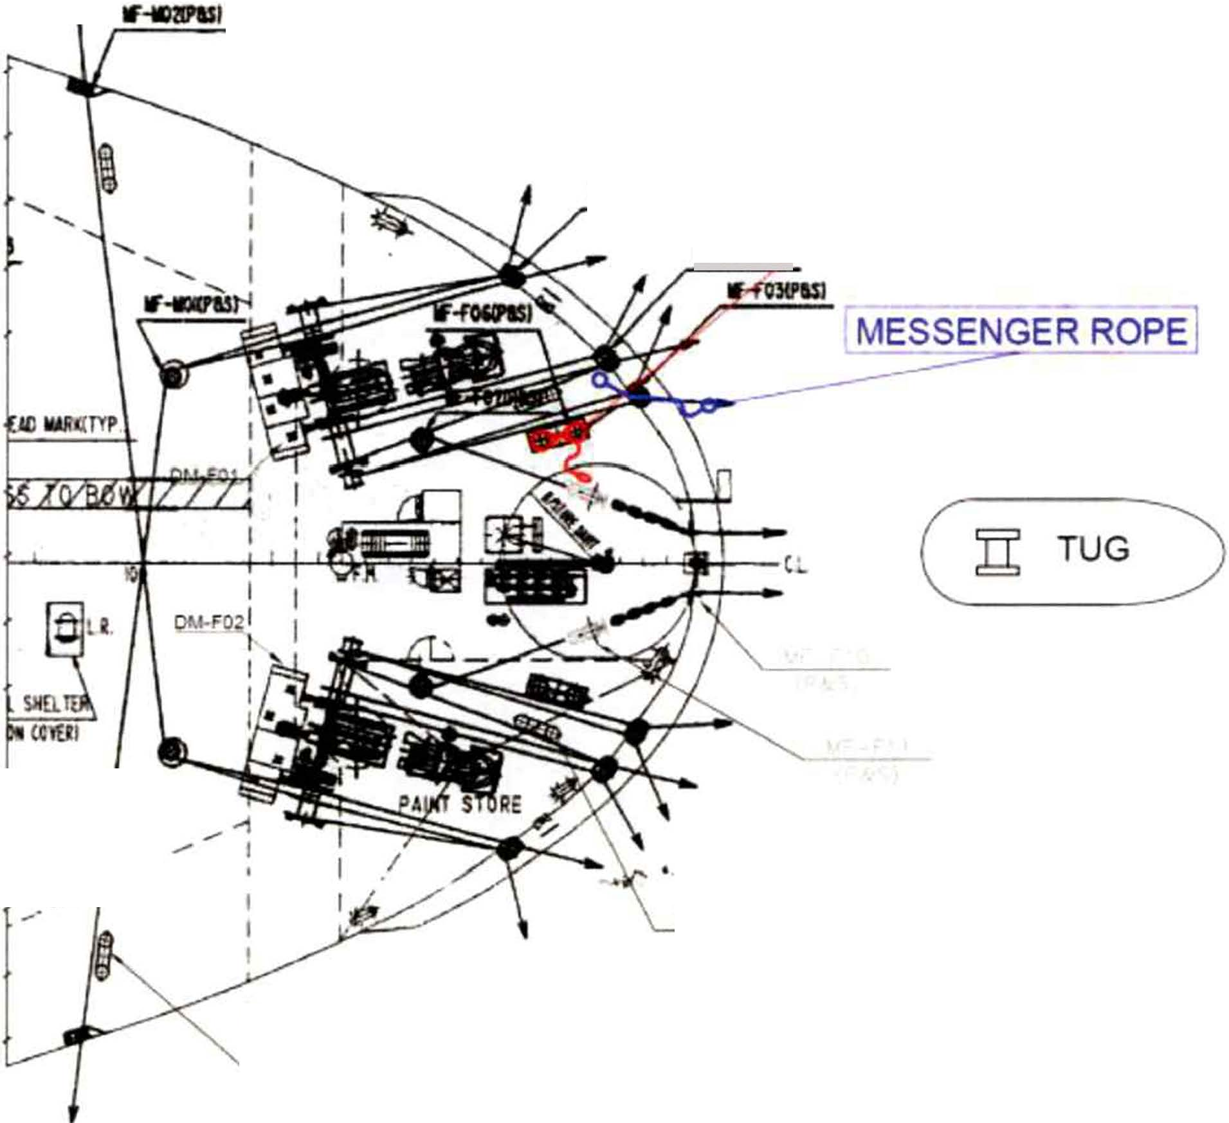l '-IF-UJ2

Secure the ship's wire rope to the bollard.
- Pass the messenger rope through the Panama chock to the towing ship. Make sure the rope does not chafe against the bulwark stay near the Panama chock.

MIT
EMERGENCY TOWING BOOKLET

PAGE 41 OF 62

WIRE ROPE

'­ '-

TUG

.,,.

MESSENGER ROPE

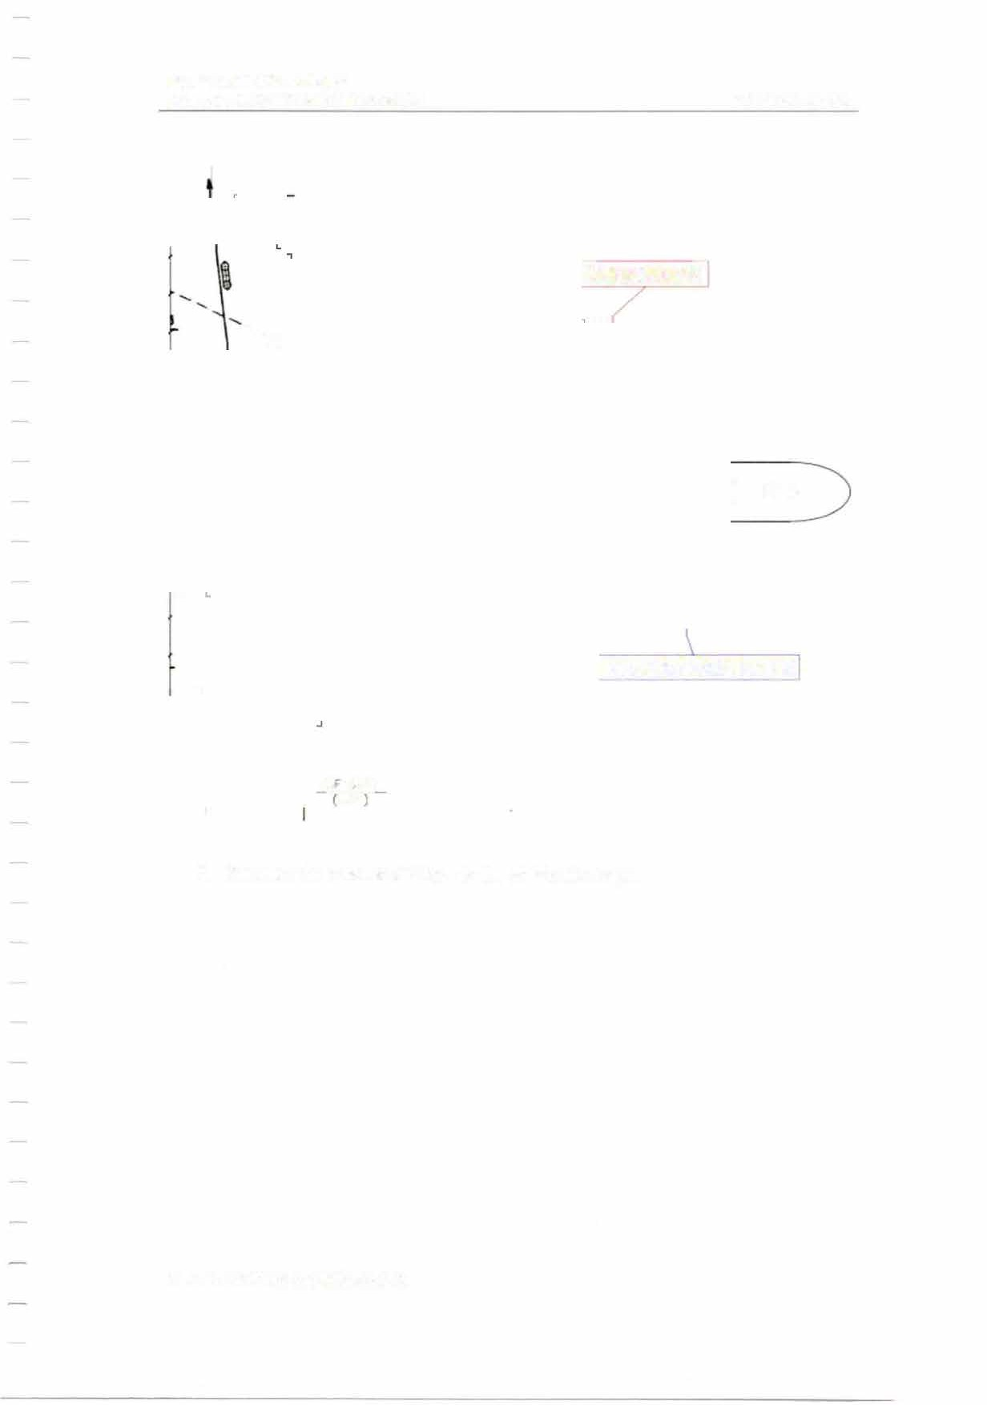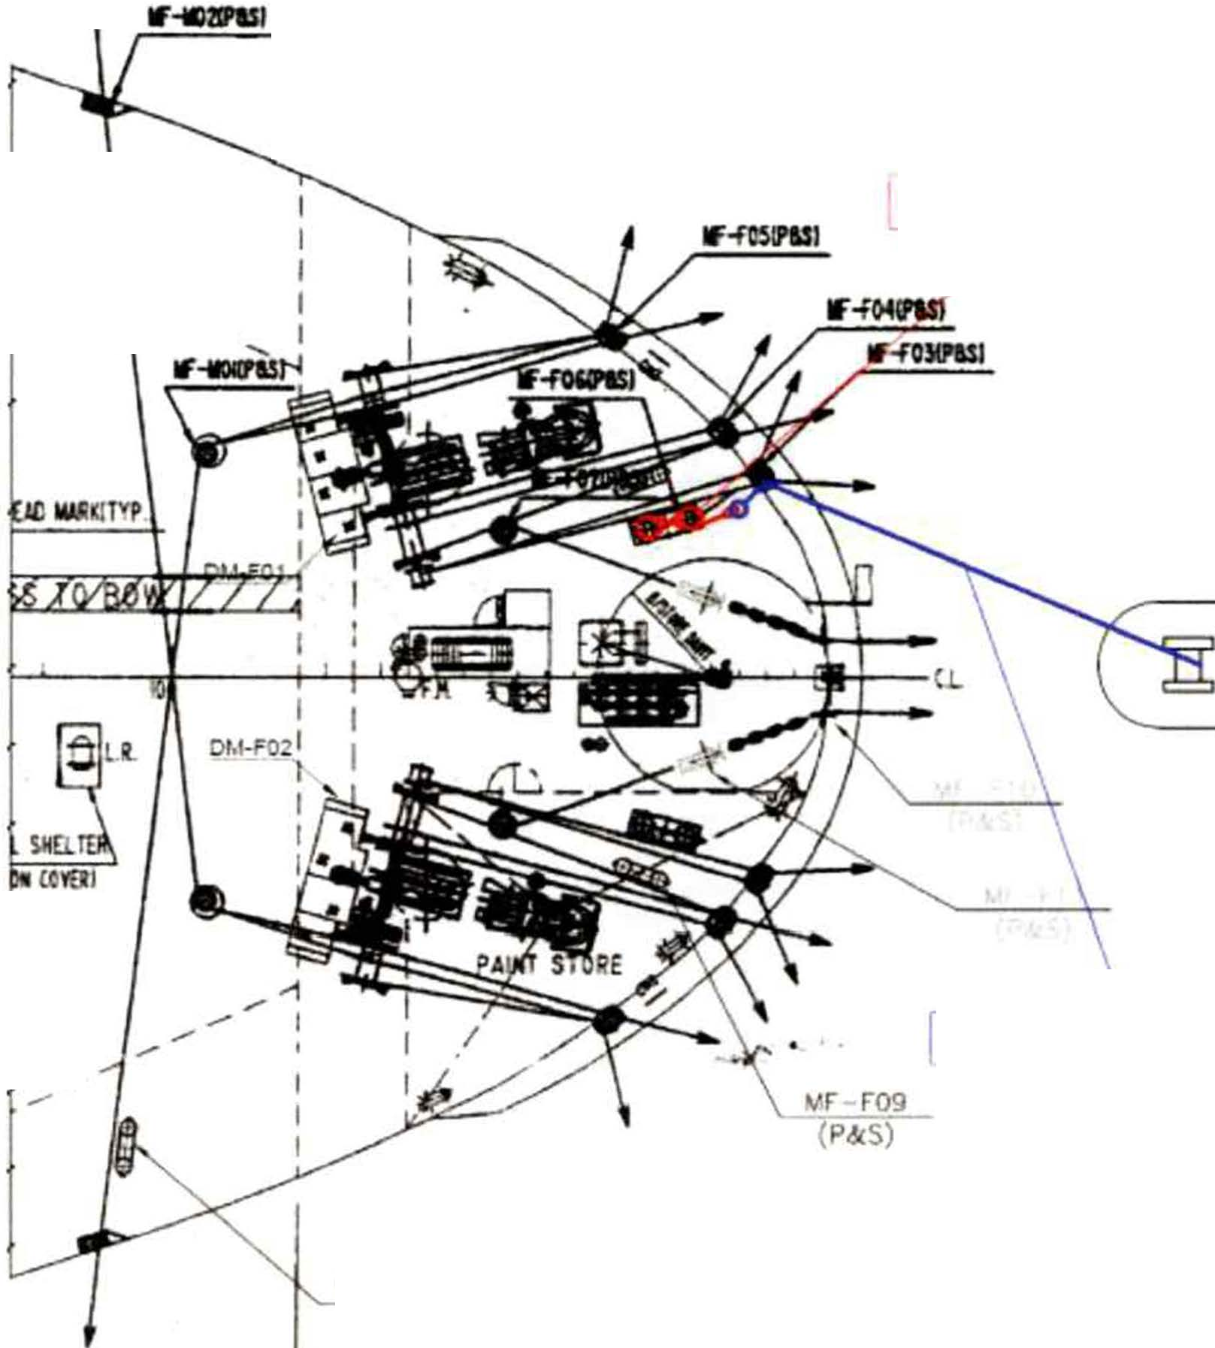

M -VJ2
P&S

- Connect the messenger rope to the ship's wire rope.

MIT
EMERGENCY TOWING BOOKLET

PAGE 42 OF 62

TUG

. @}LR.

O!ICCYOI

wr-r09

rw1RE ROPE

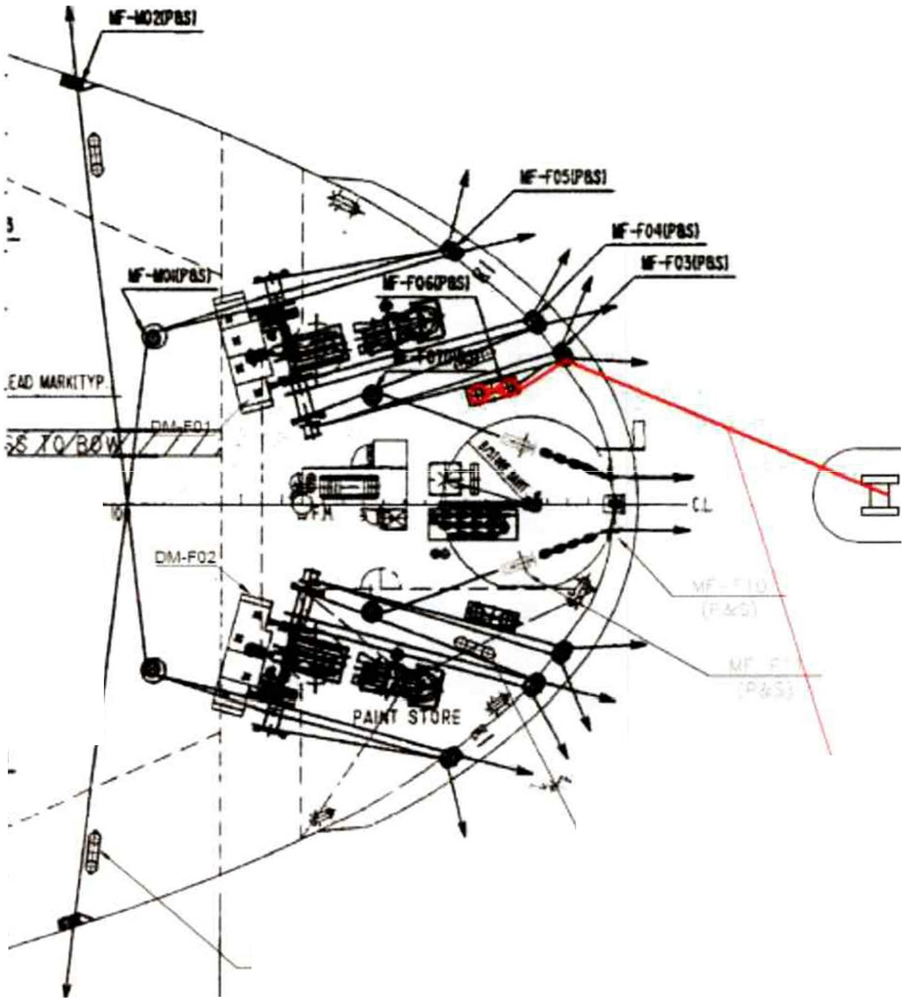
(P&S)

  - AF VJ2 P&S,

- Slack the messenger rope and wire rope gently.

- Lubricate the wire rope with grease where it rubs against the Panama chock and finish the connecting operation.
- Establish proper watch to monitor the towing arrangement during towage.

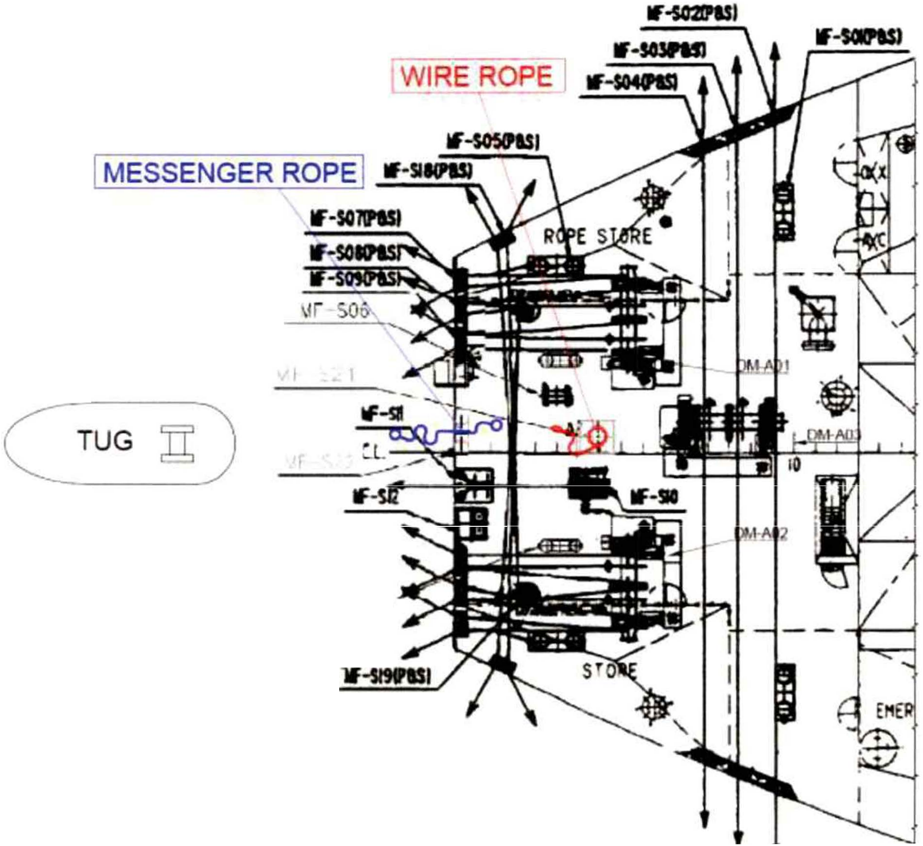MIT
EMERGENCY TOWING BOOKLET PAGE 43 OF 62

    - Mode 2-A: Using ship's wire ropes.

      - Ensure that all personnel involved in the emergency towing operation are clear of any snap-back areas.
      - Ensure that proper communication with bridge and towing ship is established.

YF-S20.,..,. (P&S)

      - Secure the ship's wire rope to the strong point.

MIT
EMERGENCY TOWING BOOKLET

PAGE 44 OF 62

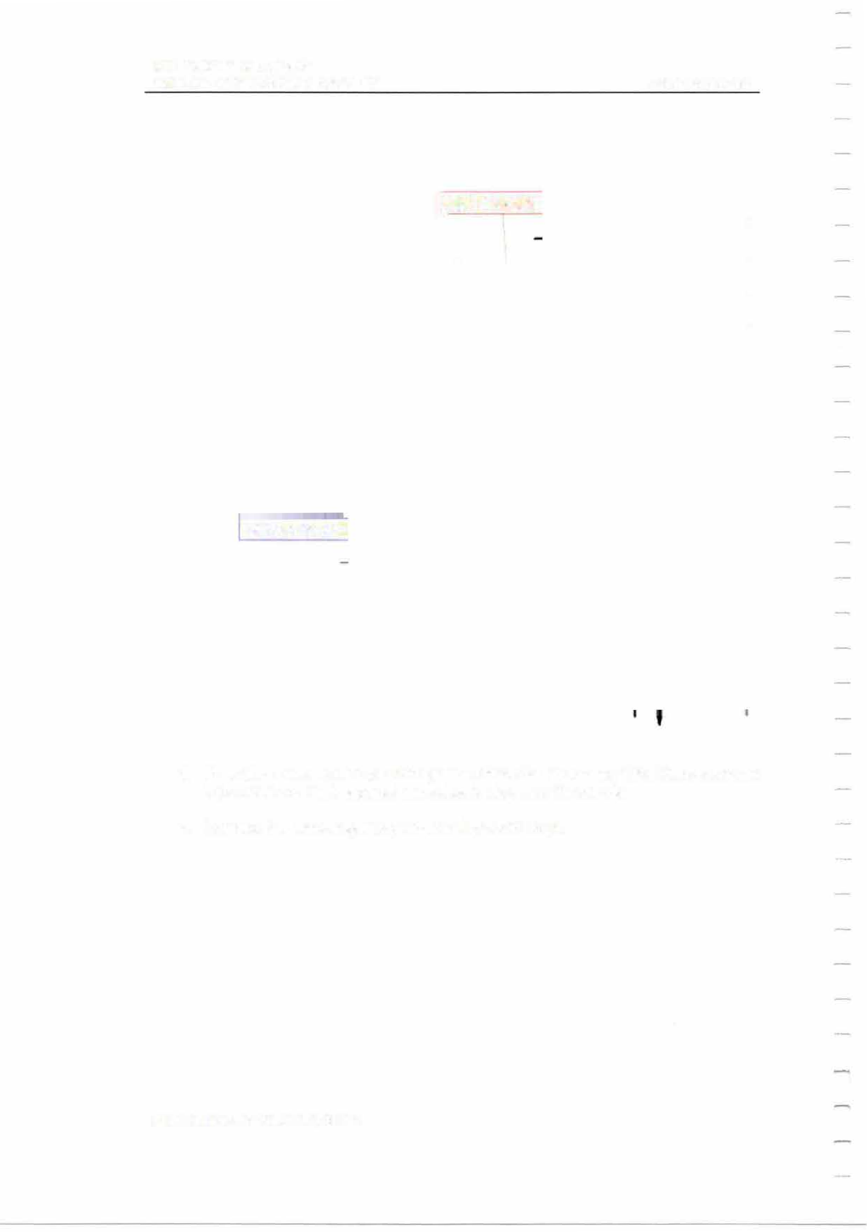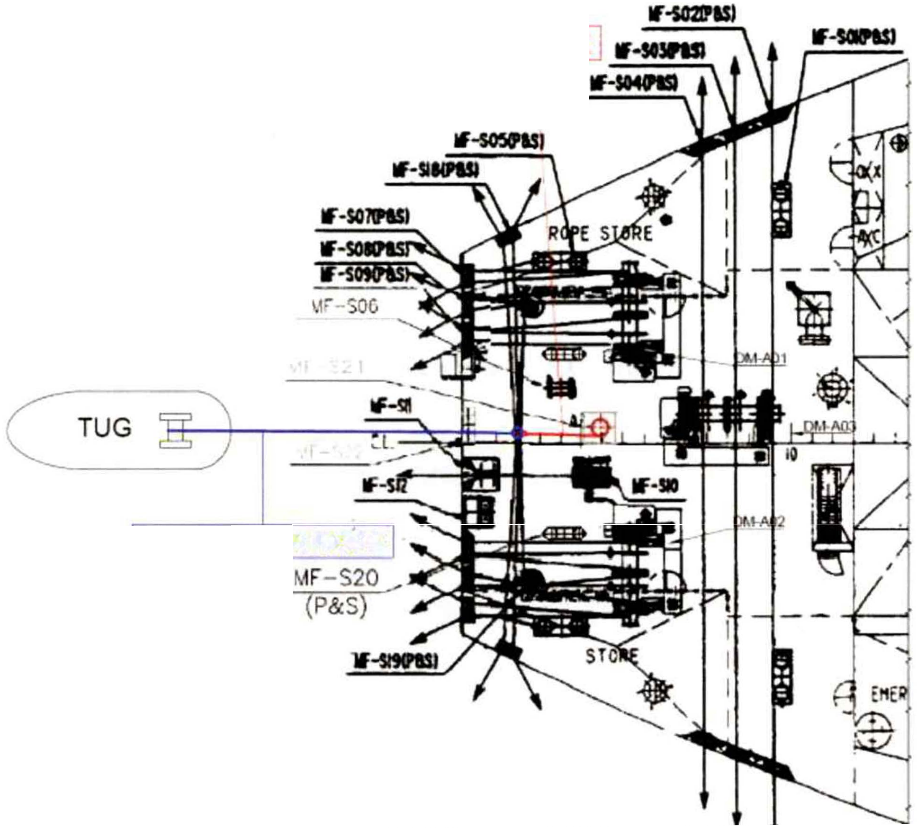

Lw1RE ROPE

MESSENGER ROPE

      - Pass the messenger rope through the chock to the towing ship. Make sure the rope does not chafe against the bulwark stay near the chock.
      - Connect the messenger rope to the ship's wire rope.

MIT
EMERGENCY TOWING BOOKLET

PAGE 45 OF 62

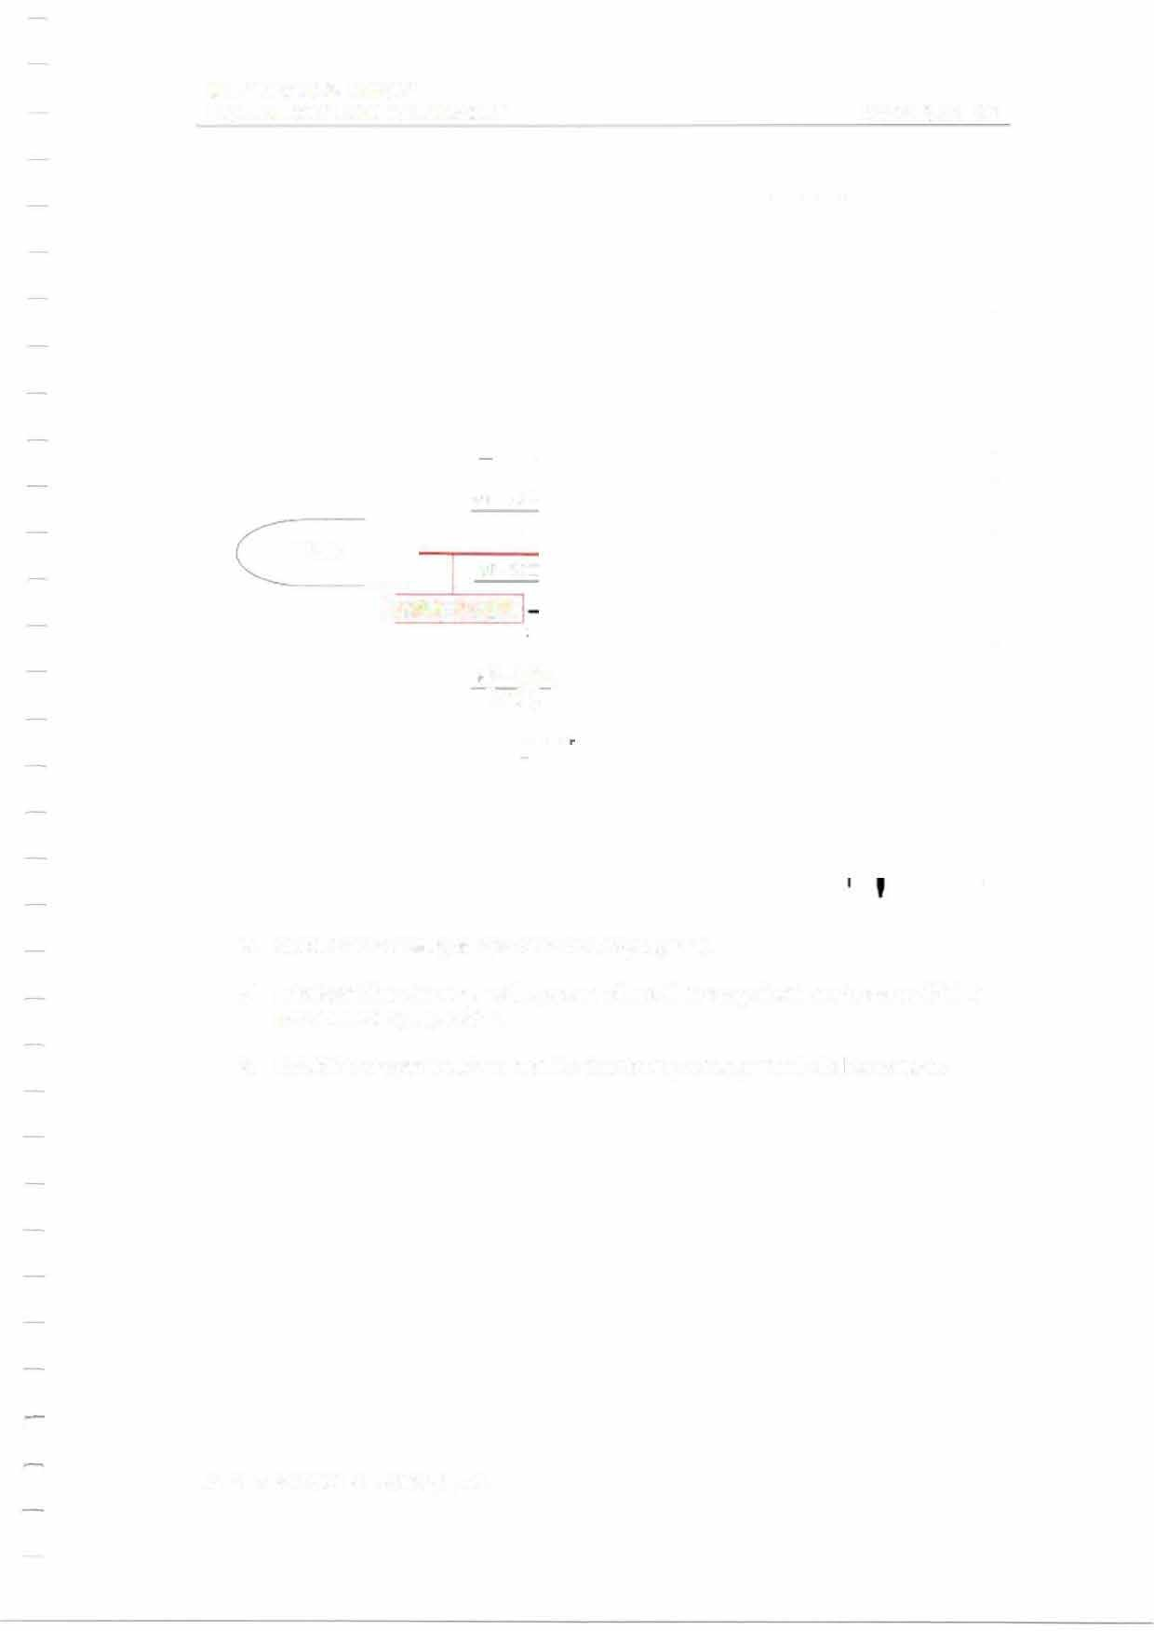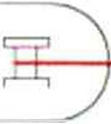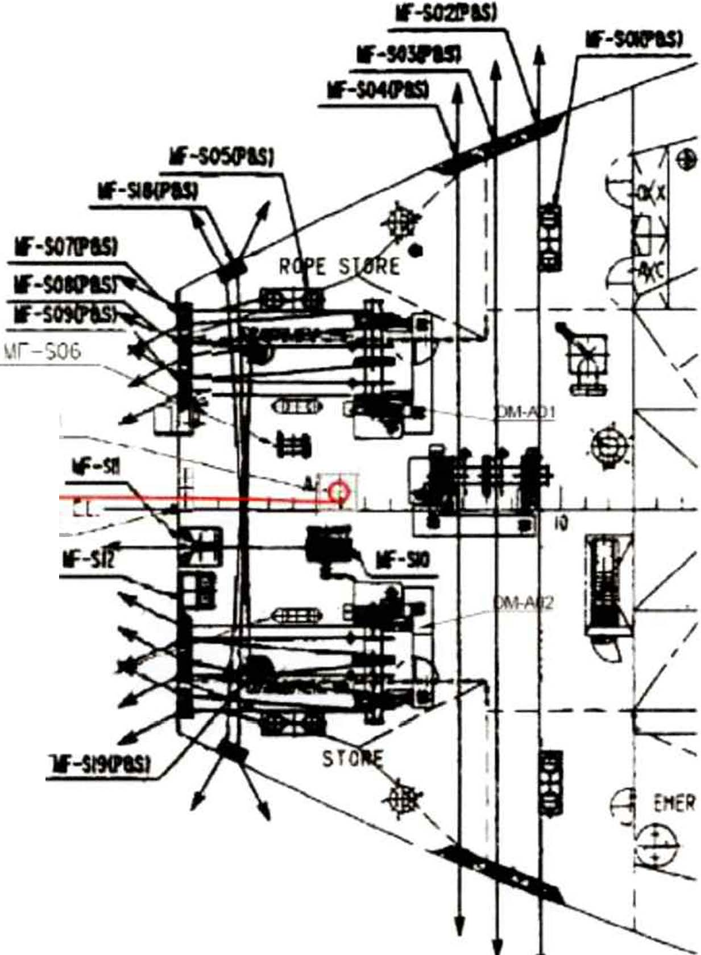

TUG
Lw1RE ROPE

'.-IF-S20 _,,. (P&SJ

      - Slack the messenger rope and wire rope gently.
      - Lubricate the wire rope with grease where it rubs against the chock and finish the connecting operation.

      - Establish proper watch to monitor the towing arrangement during towage.

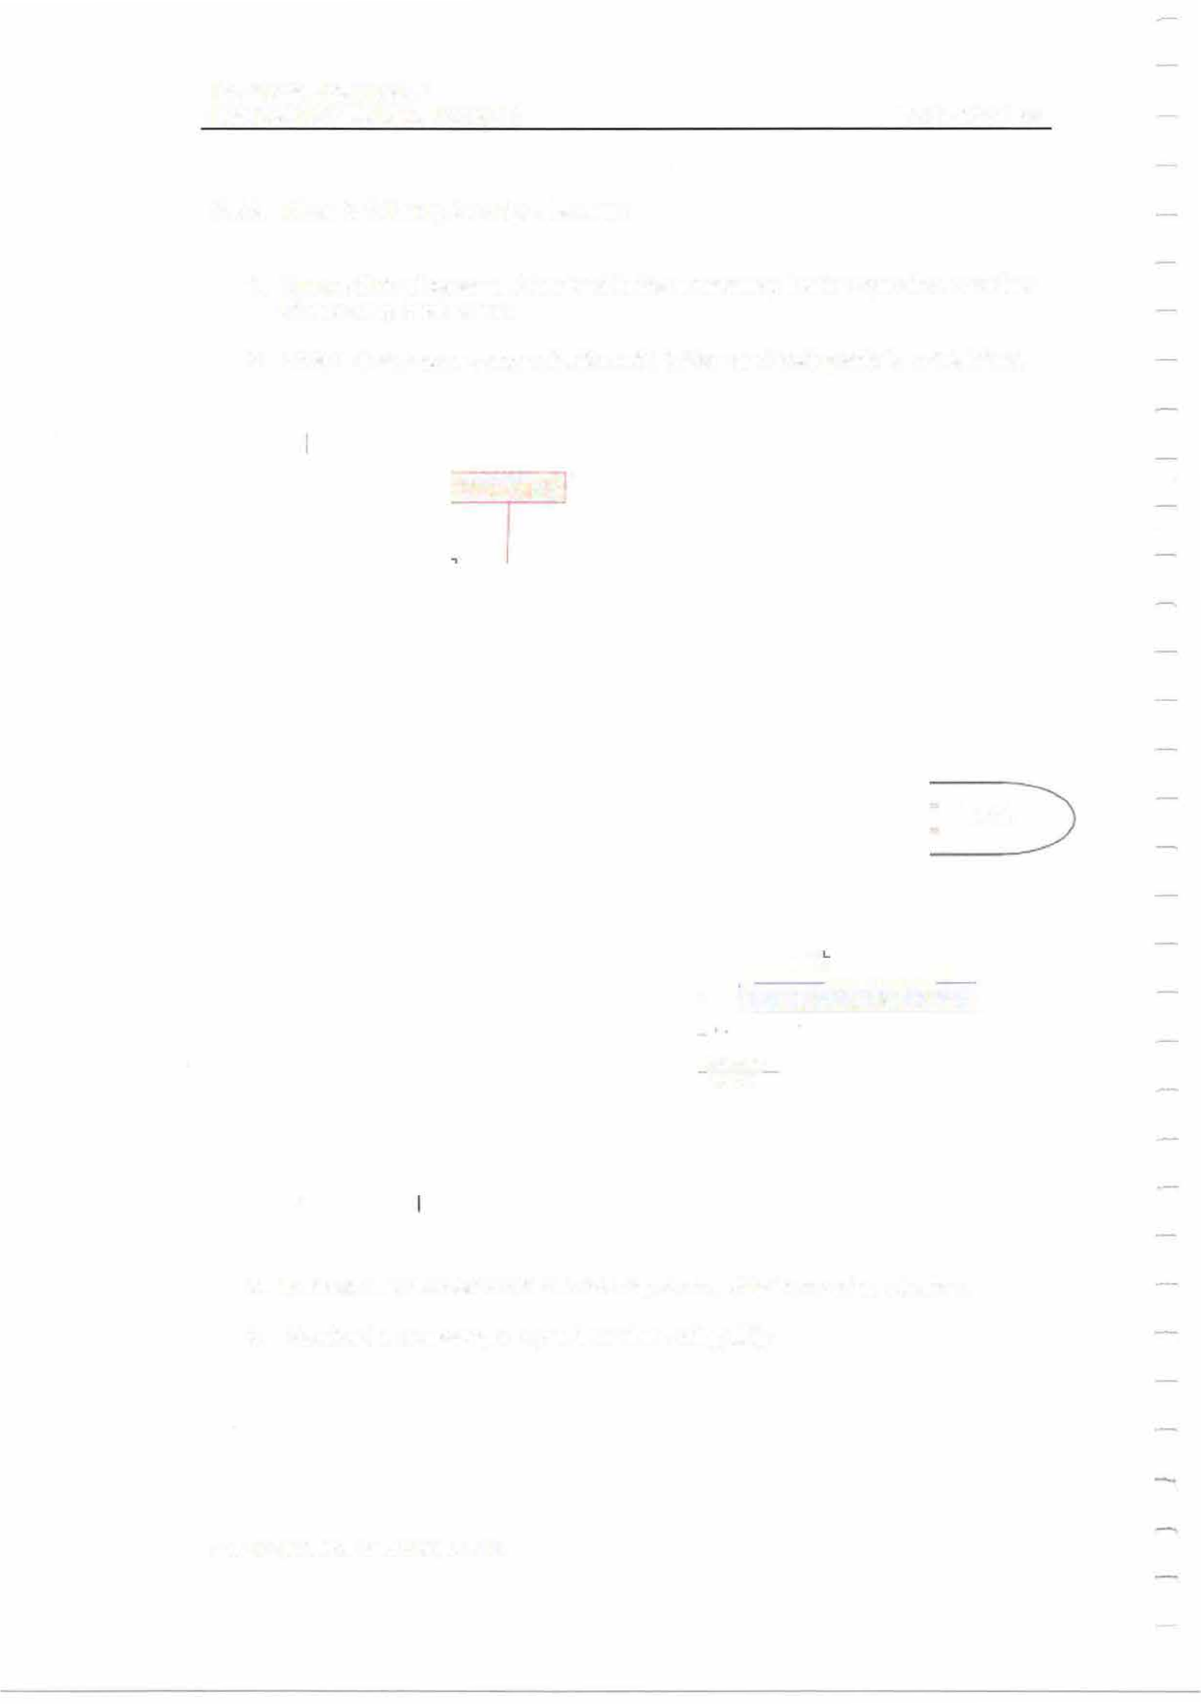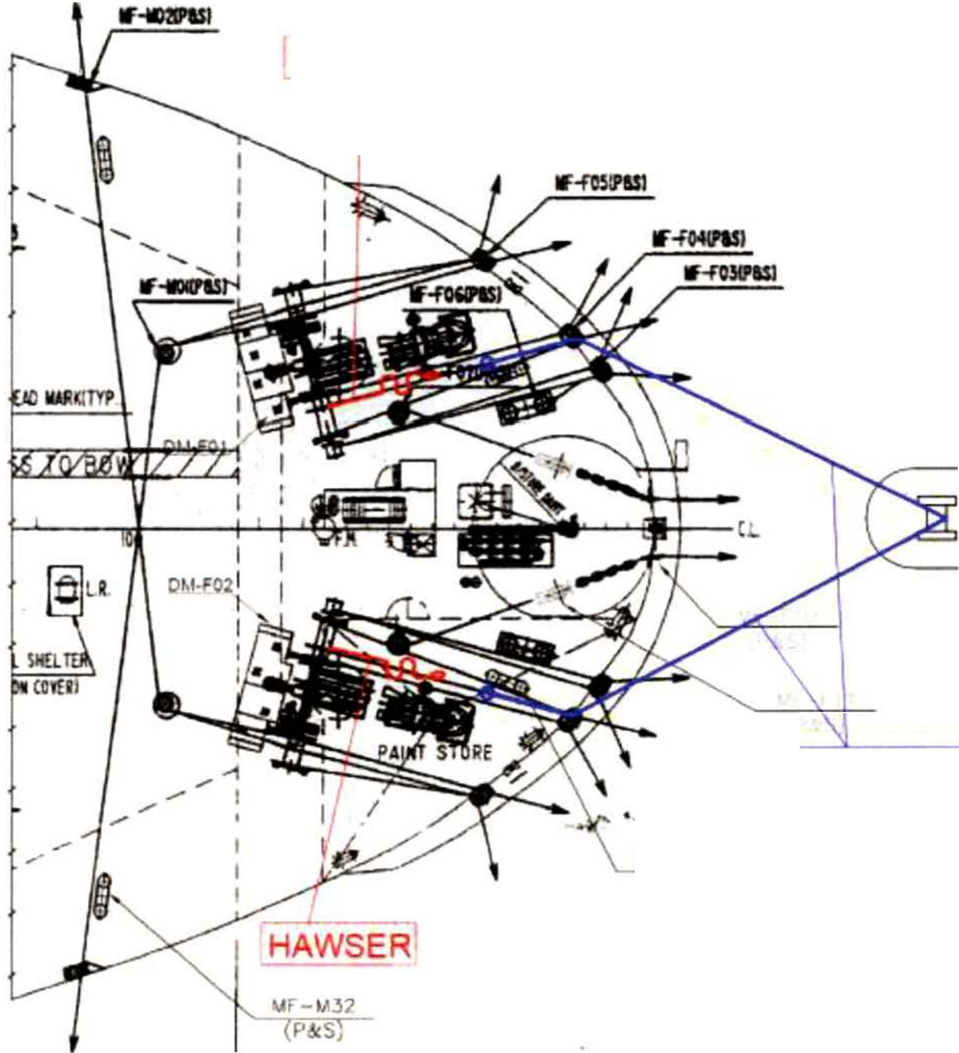MIT
EMERGENCY TOWING BOOKLET PAGE46 OF 62

    - Mode 3-F: Using the ship's hawsers.

1 . Ensure that all personnel involved in the emergency towing operation are clear of any snap-back areas.
- Ensure that proper communication with bridge and towing ship is established.

HAWSER

TUG

[MESSENGER ROPEI

vr-r09 (P&S)

- Wind off the hawsers from the mooring drums of both mooring winches.
- Receive the messenger ropes from the towing ship.

MIT
EMERGENCY TOWING BOOKLET

PAGE 47 OF 62

HAWSER
i

TUG

--

HAWSER
MF t,,J2 P&S₁

I MESSENGER ROP�

wr-rog (P&S)

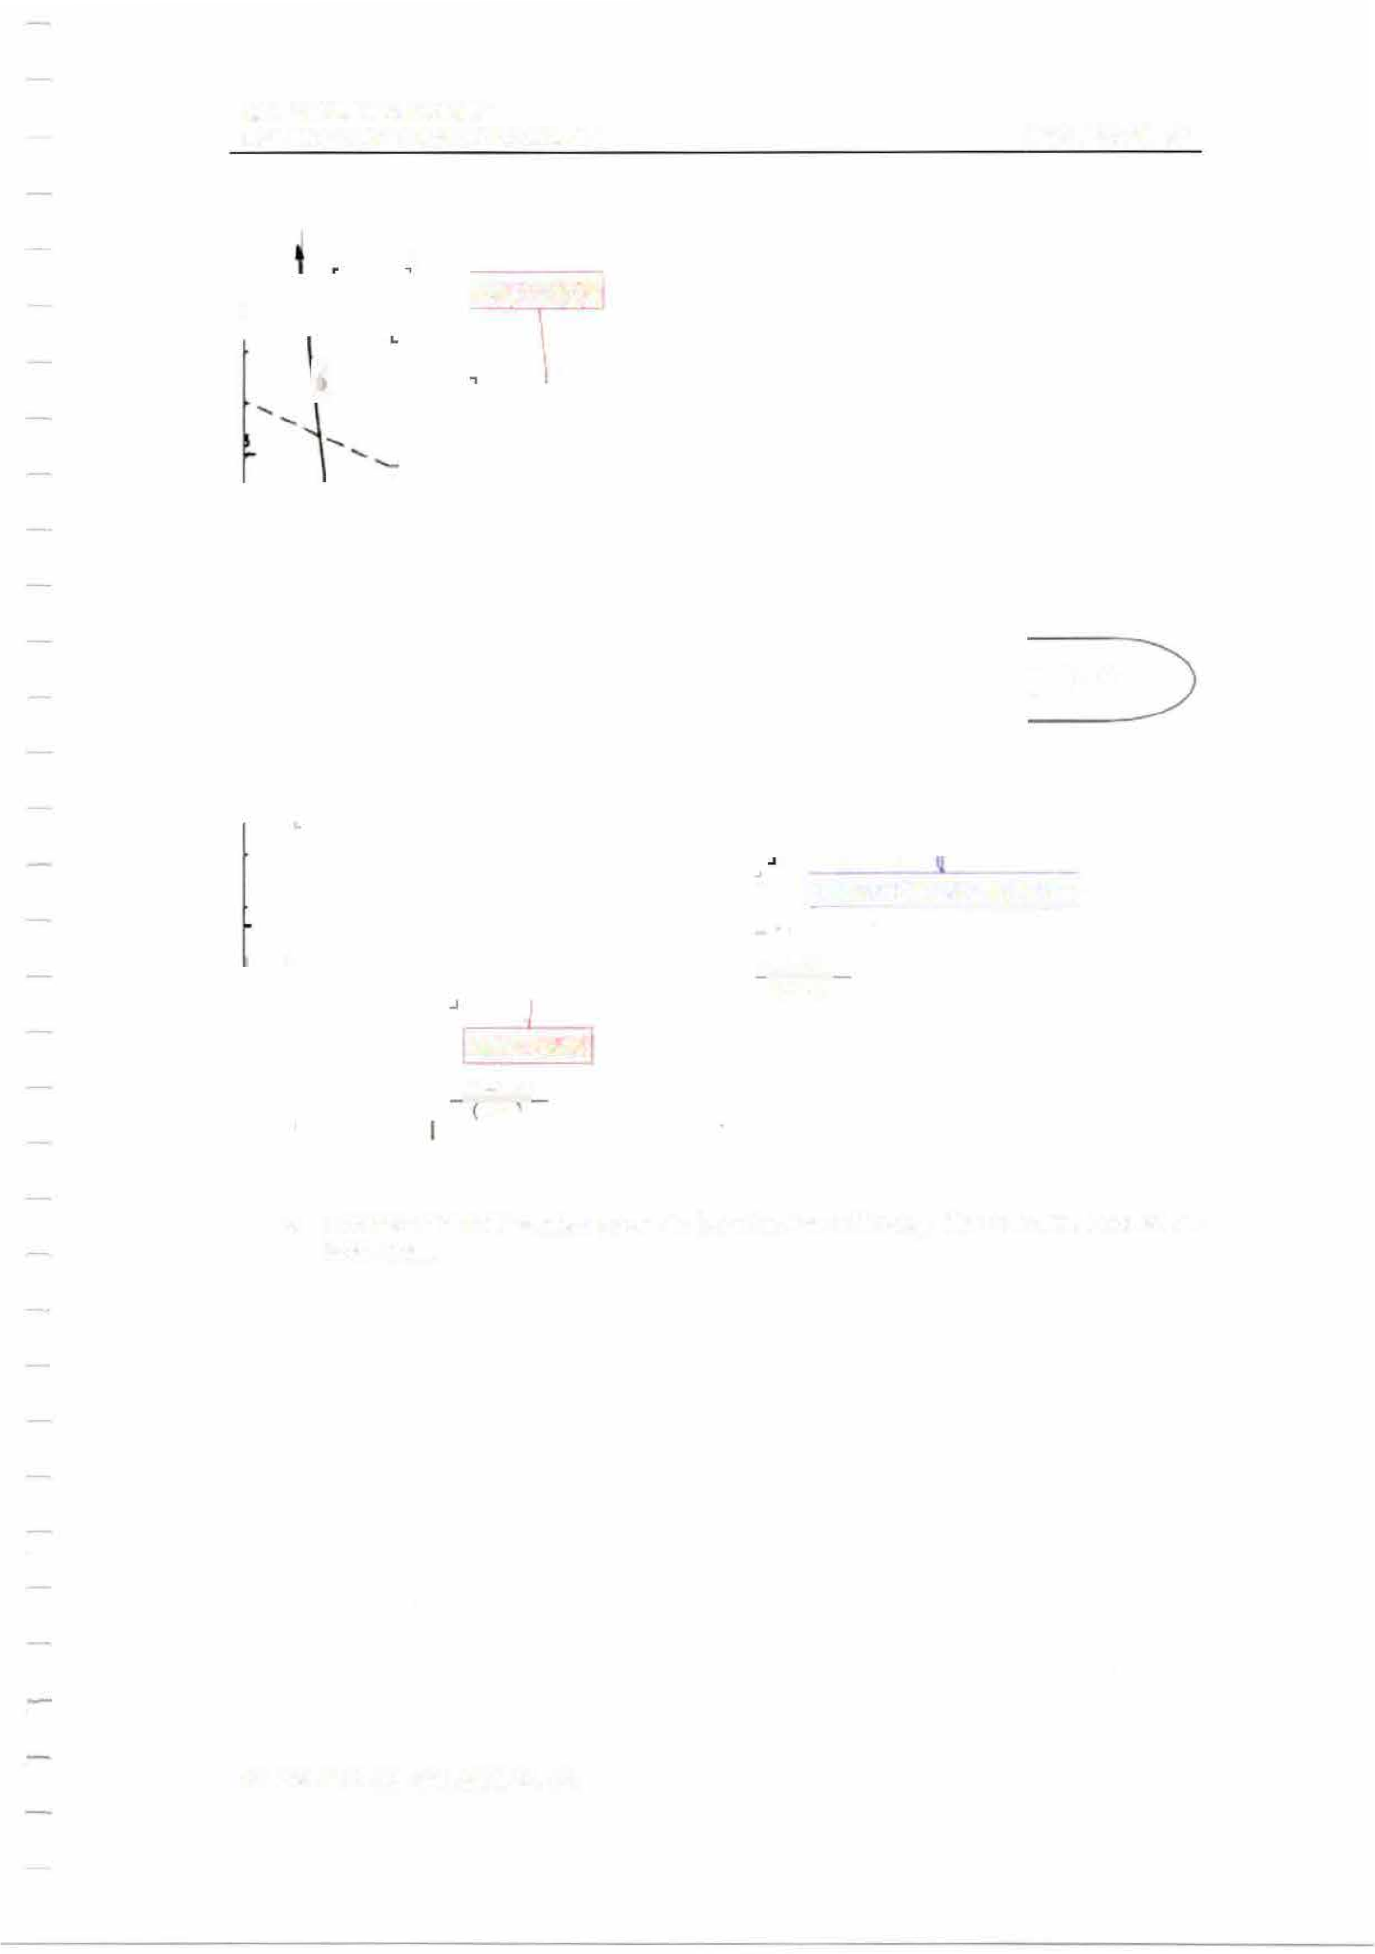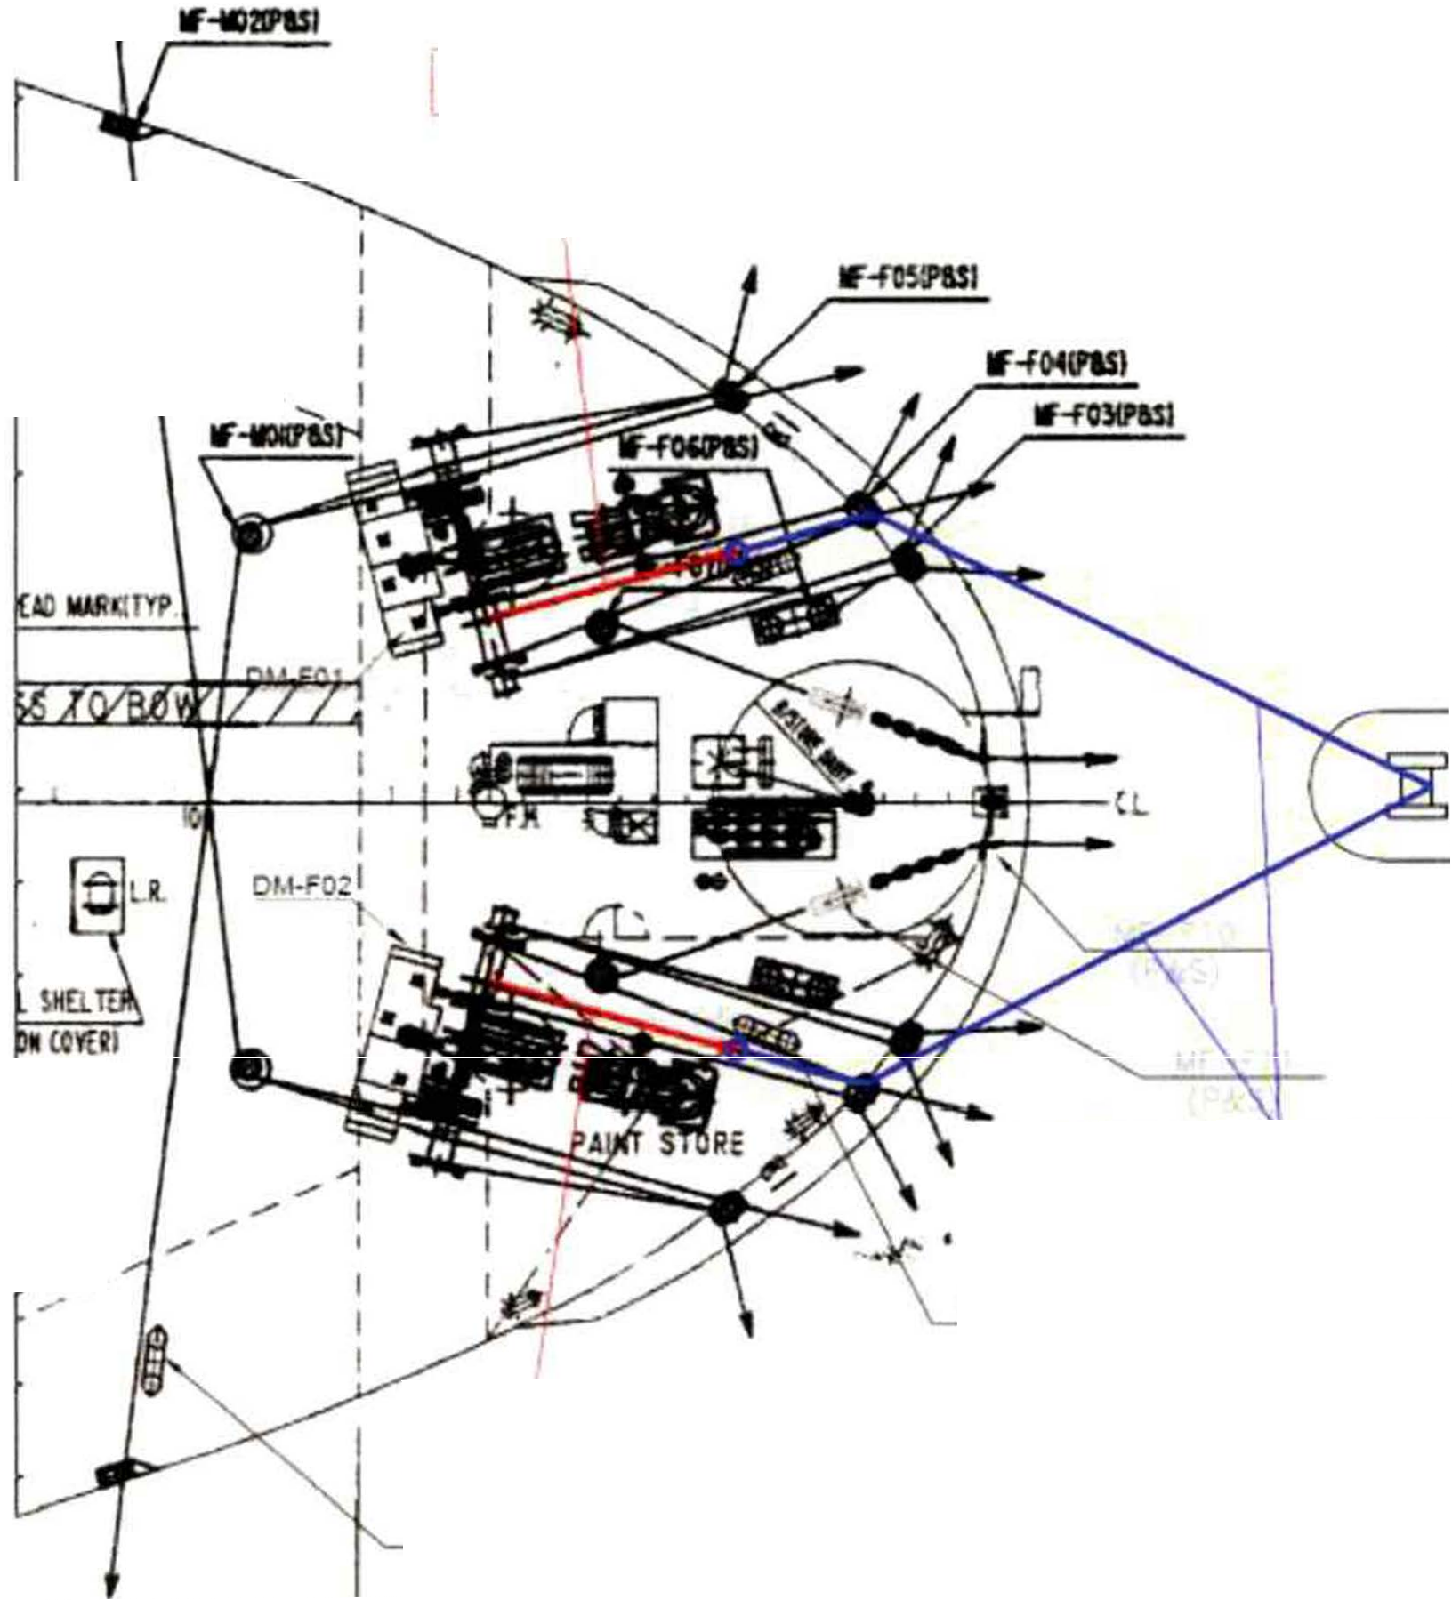

- Connect the messenger ropes to both hawsers through the panama chocks on both sides.

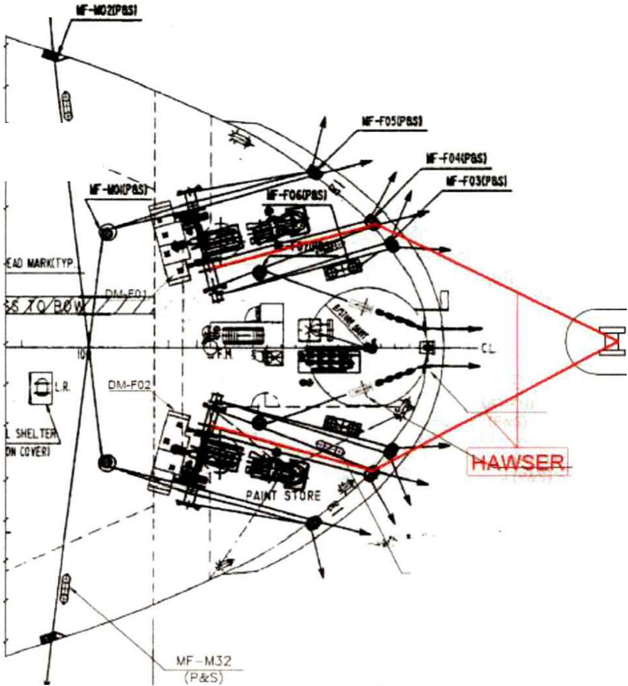MIT
EMERGENCY TOWING BOOKLET PAGE 48 OF 62

TUG

vr rog (P&S) -

- Raise the wires connected with the messenger ropes to the towing ship through the panama chocks on both sides by winding off the mooring drums of the mooring winches, and stop the winches after the hawsers are fixed to the towing ship.
- Adjust winches so that the tension of both hawsers is approximately the same and make sure that the hawsers do not chafe against the corners of any structures.
- Disengage the clutches, apply the brakes of the winches and finish the connecting operation.
- Establish proper watch to monitor the towing arrangement during towage

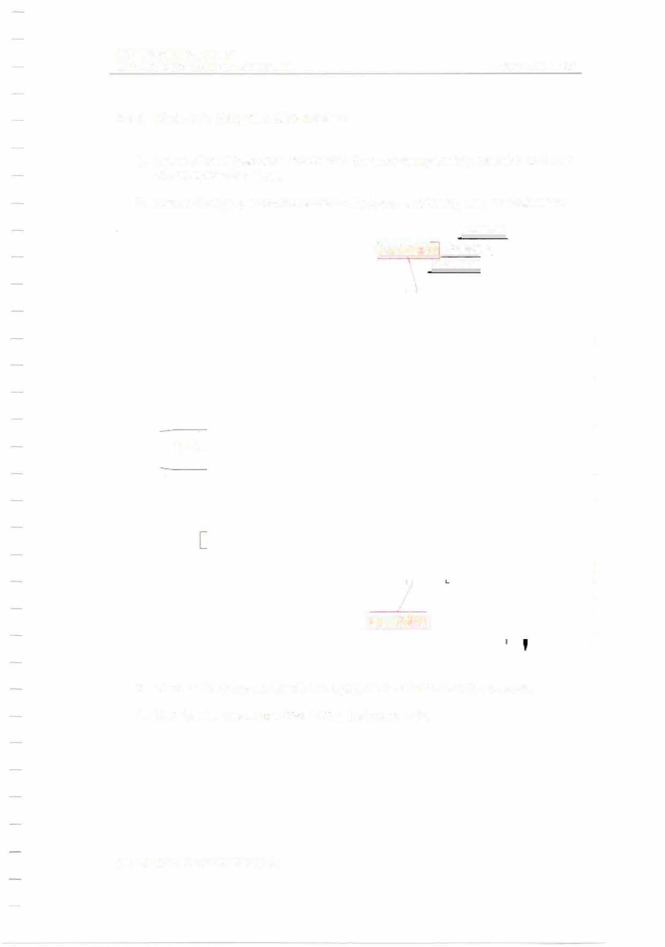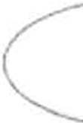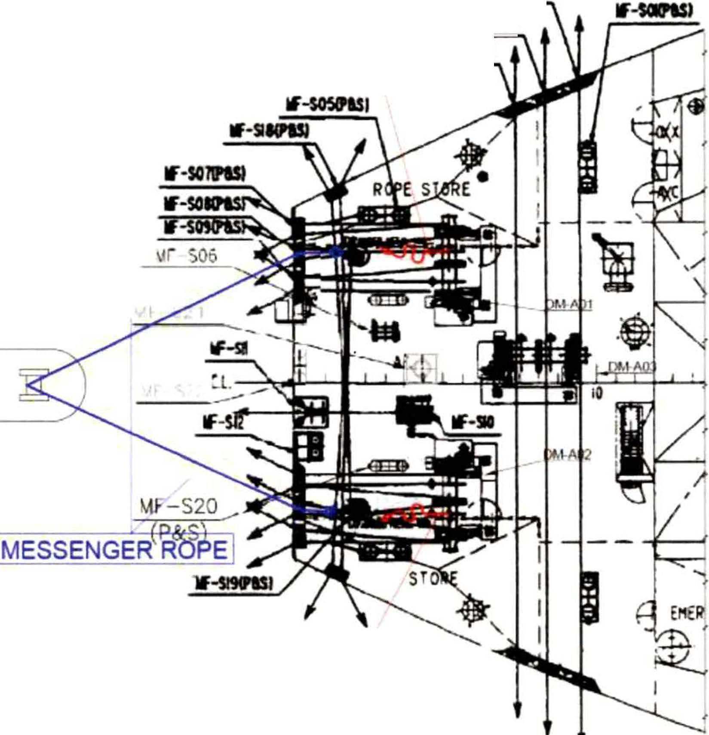MIT
EMERGENCY TOWING BOOKLET PAGE49 OF 62

    - Mode 3-A: Using the ship's hawsers.

      - Ensure that all personnel involved in the emergency towing operation are clear of any snap-back areas.
      - Ensure that proper communication with bridge and towing ship is established.

lf-i02IPISI
HAWSER lf·SOJftD

lf�SMN

TUG

!HAWSER!

      - Wind off the hawsers from the warping heads of both mooring winches.

      - Receive the messenger ropes from the towing ship.

MIT
EMERGENCY TOWING BOOKLET

' MESSENGER ROPEI

If-so2IPISJ

[HAWSER lf·SIK'II
.......

PAGE 50 OF 62

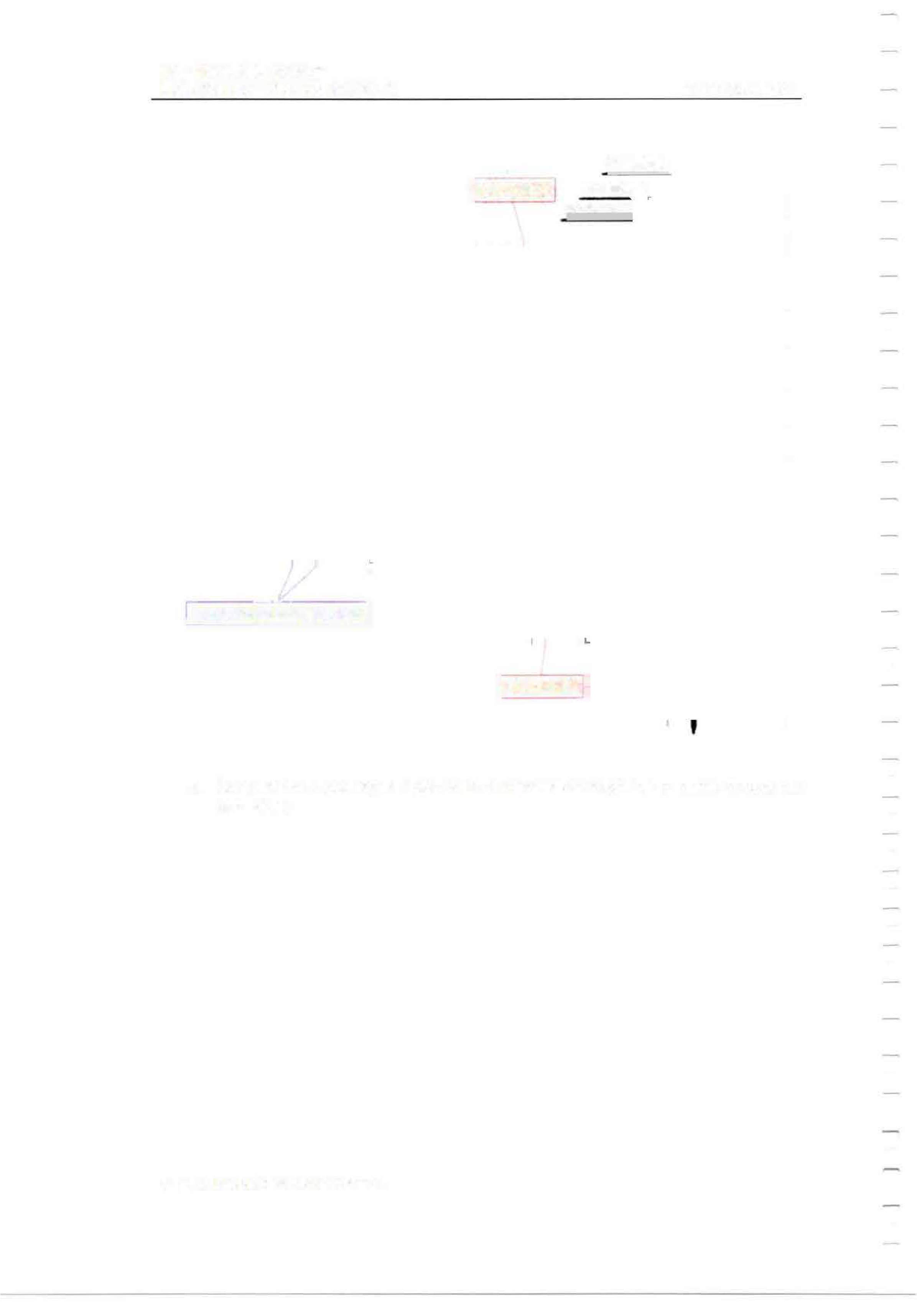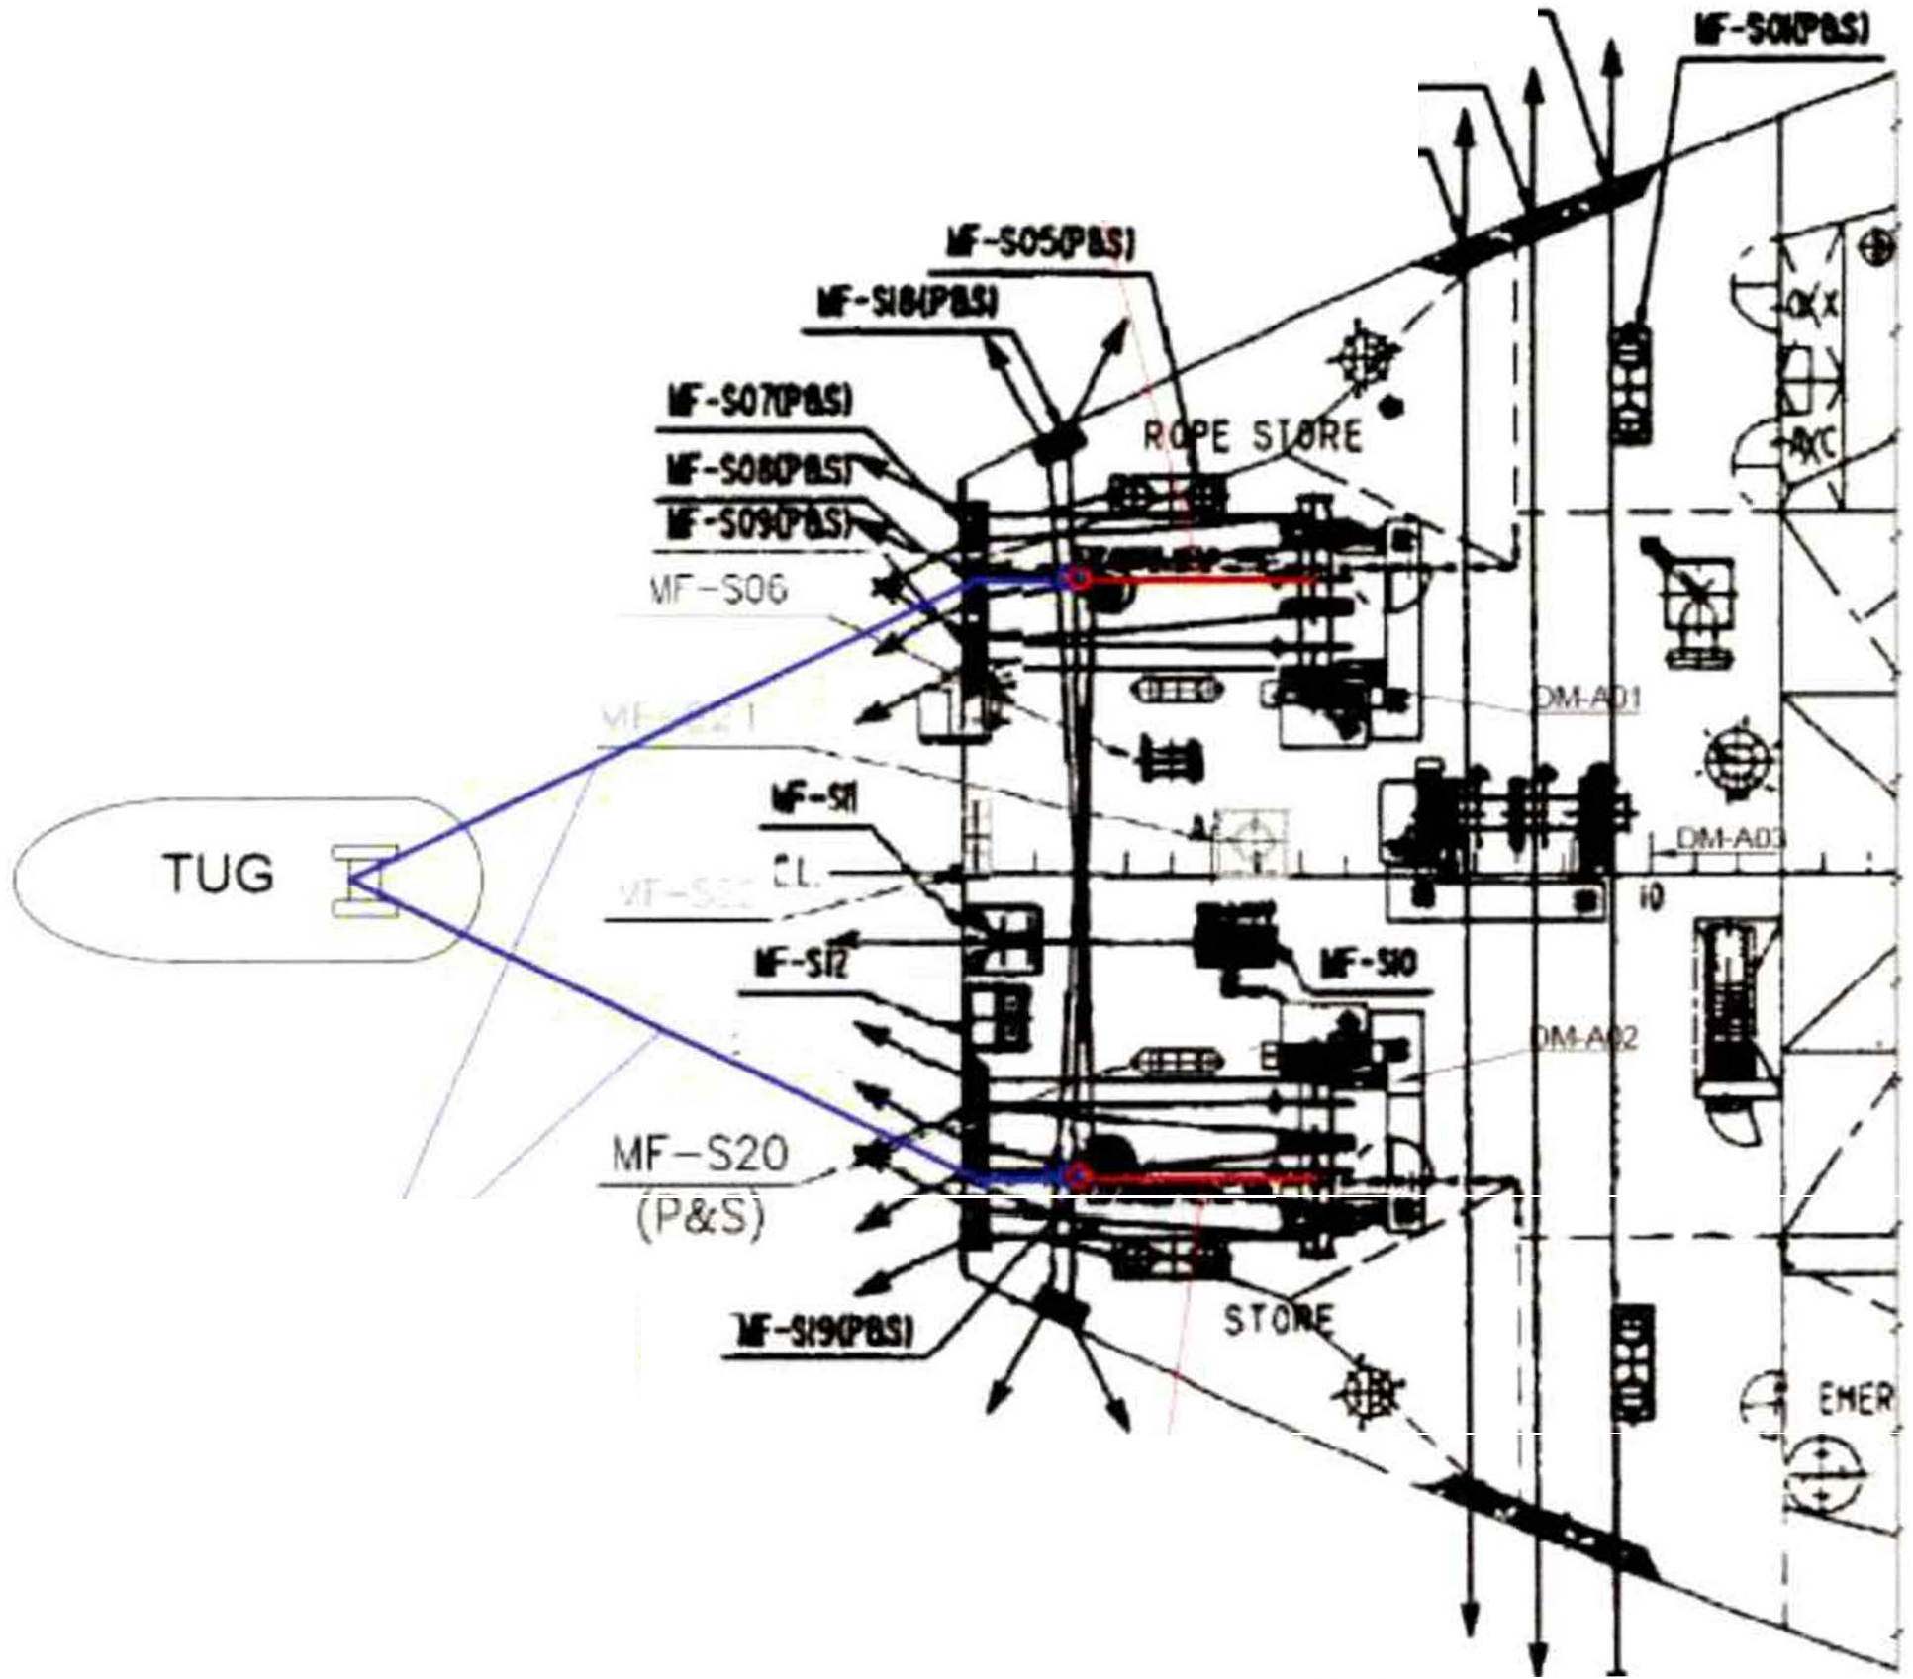

jHAWSER

      - Connect the messenger ropes to both hawsers through the panama chocks on both sides.

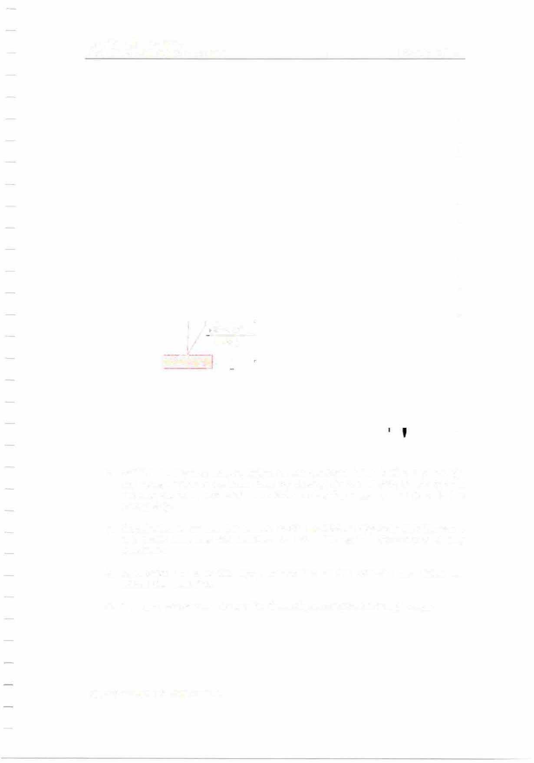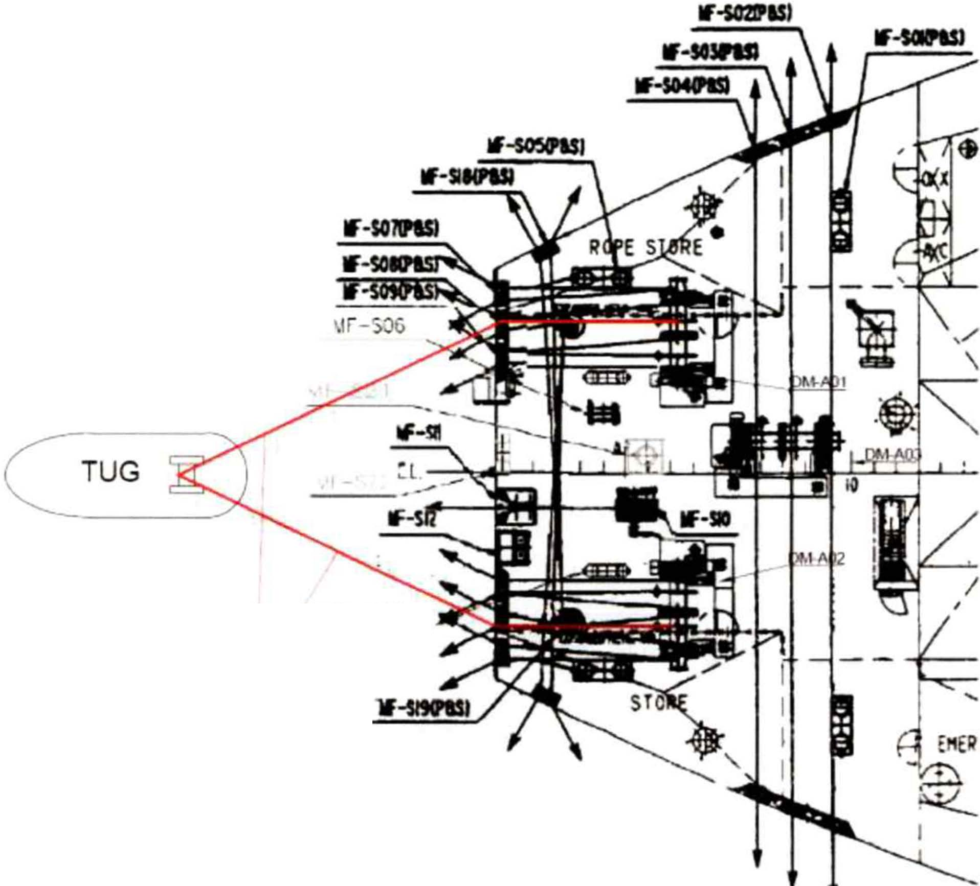MIT
EMERGENCY TOWING BOOKLET PAGE 51 OF 62

\ff-S20 .,
(P&S)
!HAWSER

      - Raise the wires connected with the messenger ropes to the towing ship through the panama chocks on both sides by winding off the warping heads of both mooring winches, and stop the winches after the hawsers are fixed to the towing ship.
      - Adjust winches so that the tension of both hawsers is approximately the same and make sure that the hawsers do not chafe against the corners of any structures.
      - Disengage the clutches, apply the brakes of the winches and finish the connecting operation.
      - Establish proper watch to monitor the towing arrangement during towage.

MIT
EMERGENCY TOWING BOOKLET PAGE 52 OF 62

    - Mode 4-F: Using tug's wire rope.

      - Ensure that all personnel involved in the emergency towing operation are clear of any snap-back areas.

      - Ensure that proper communication with bridge and towing ship is established.

TUG

.,,,.

vr r09 (P&S)

(wlRE ROPE

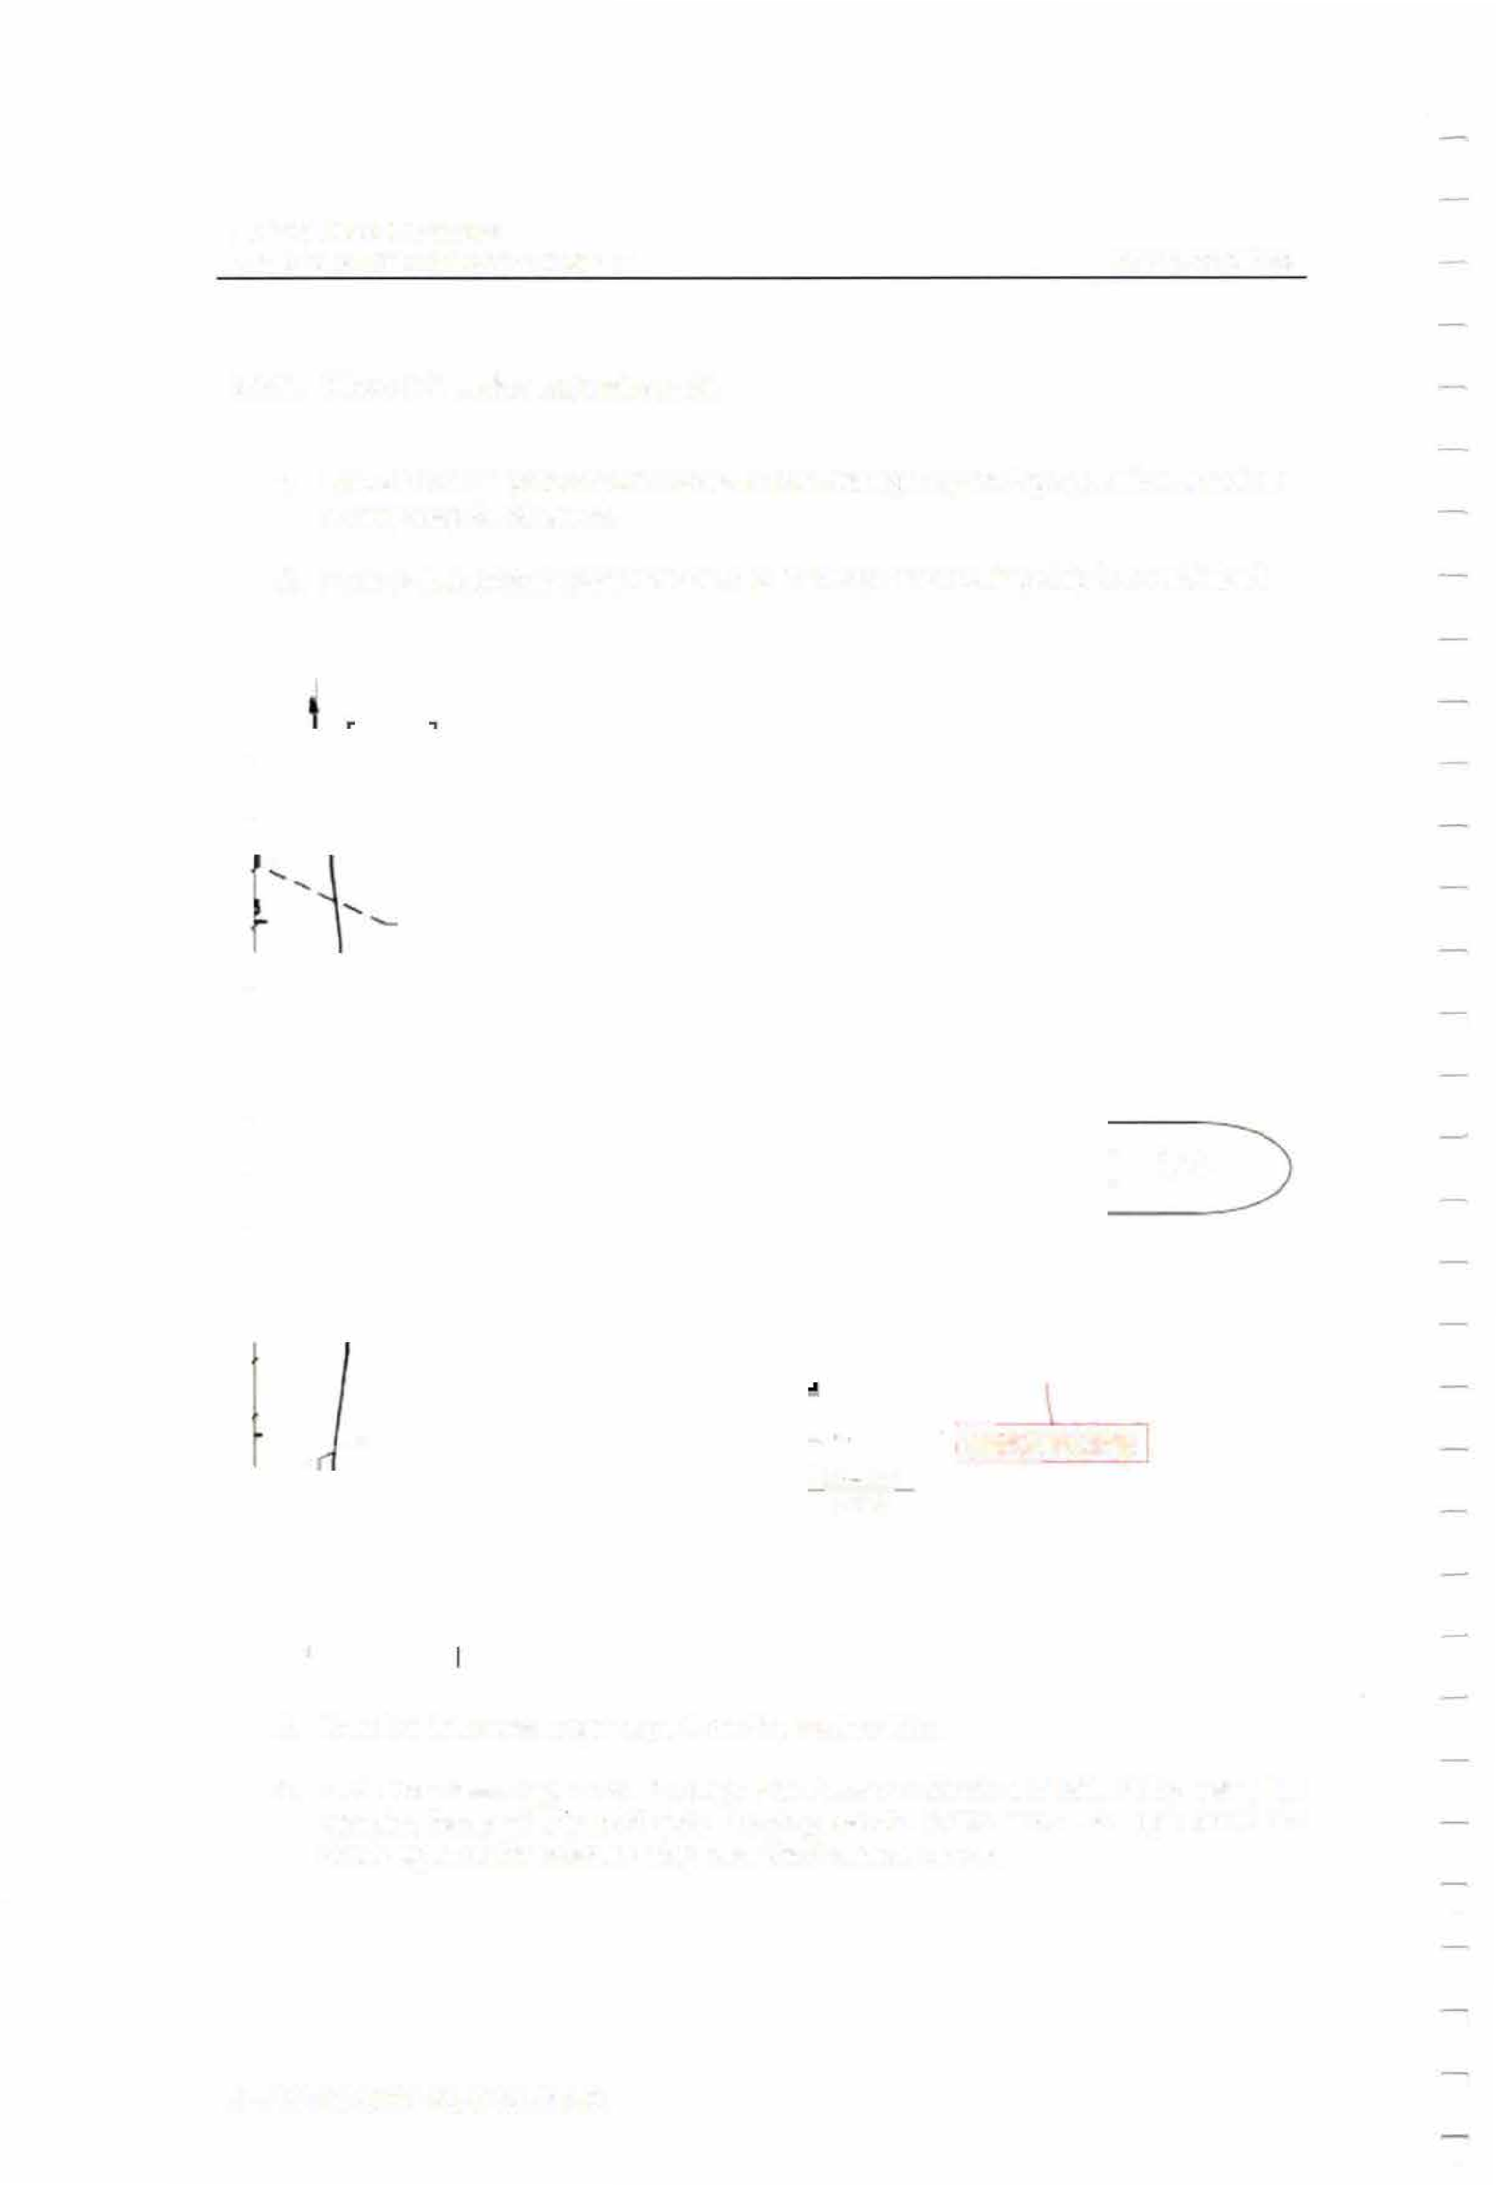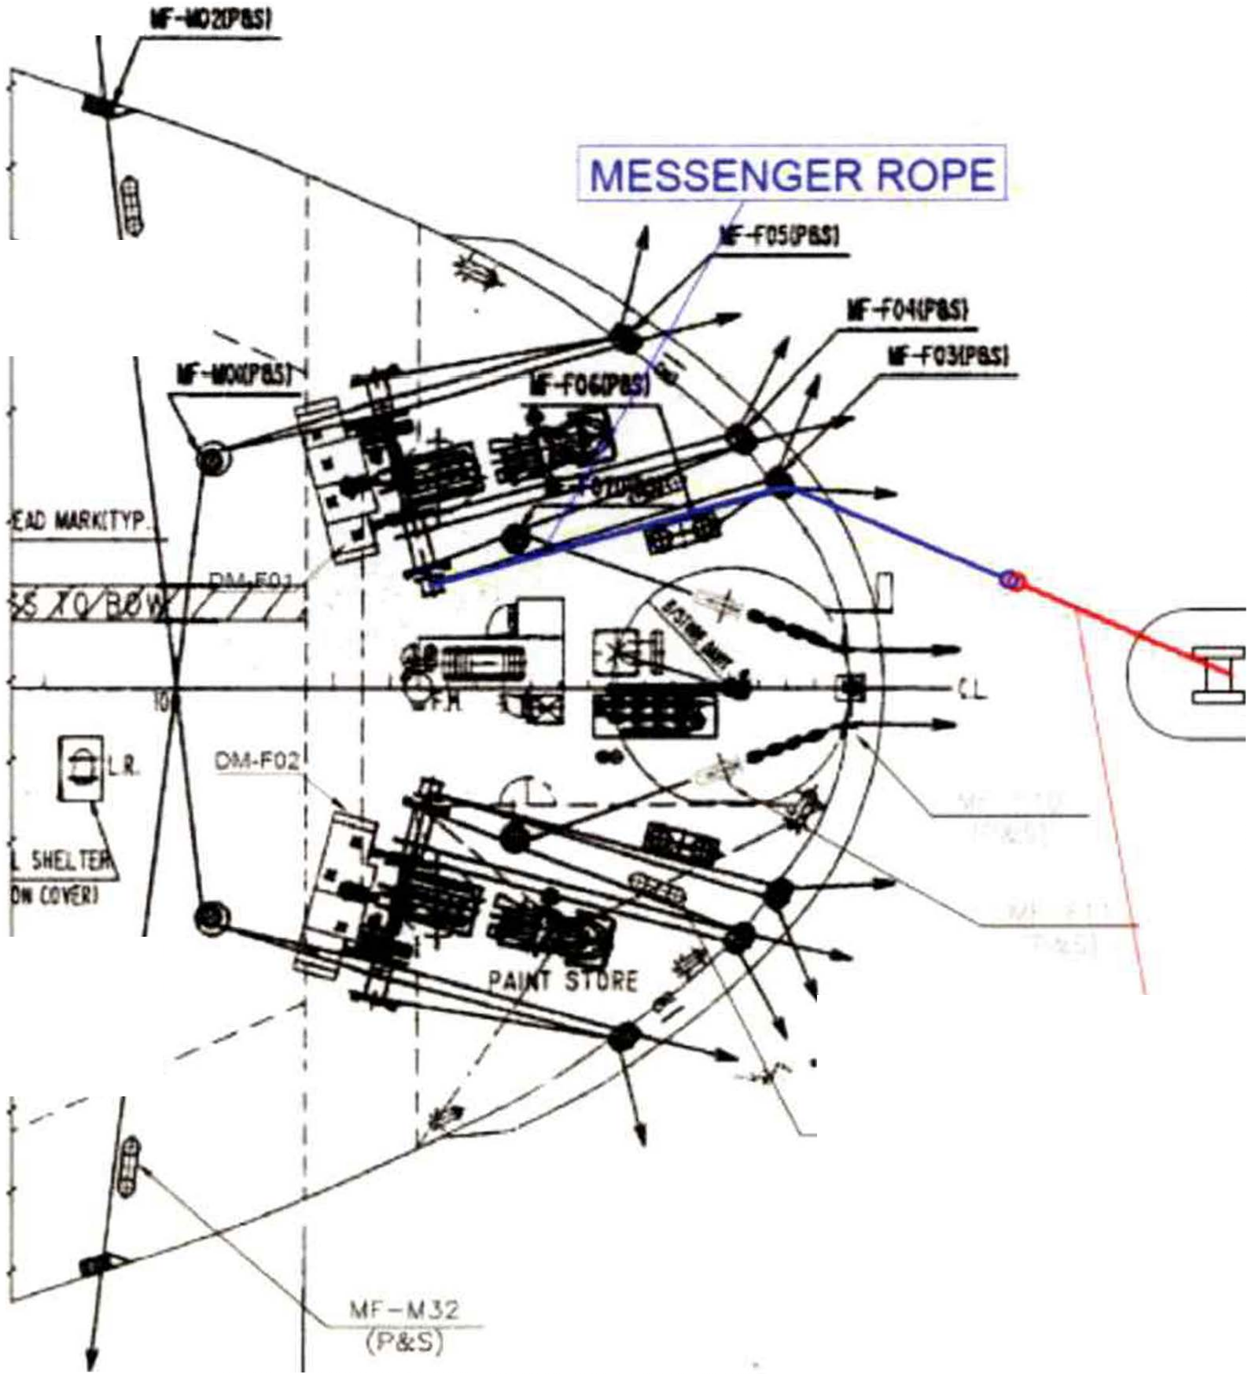

      - Receive the messenger rope from the towing ship.
      - Pass the messenger rope through the Panama chock and raise it by using the warping head of the port side mooring winch. Make sure the rope does not chafe against the bulwark stay near the Panama chock.

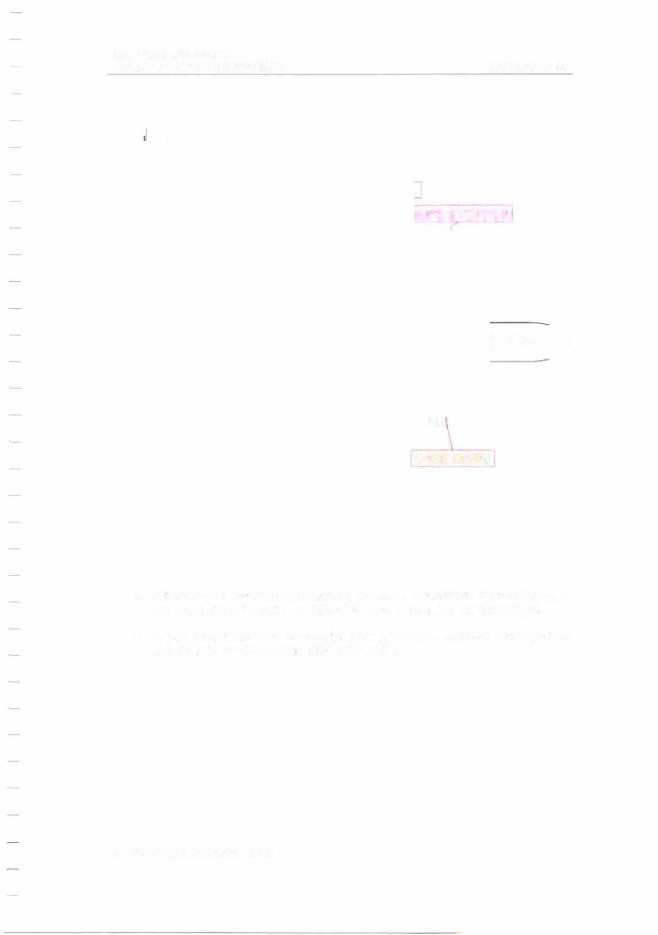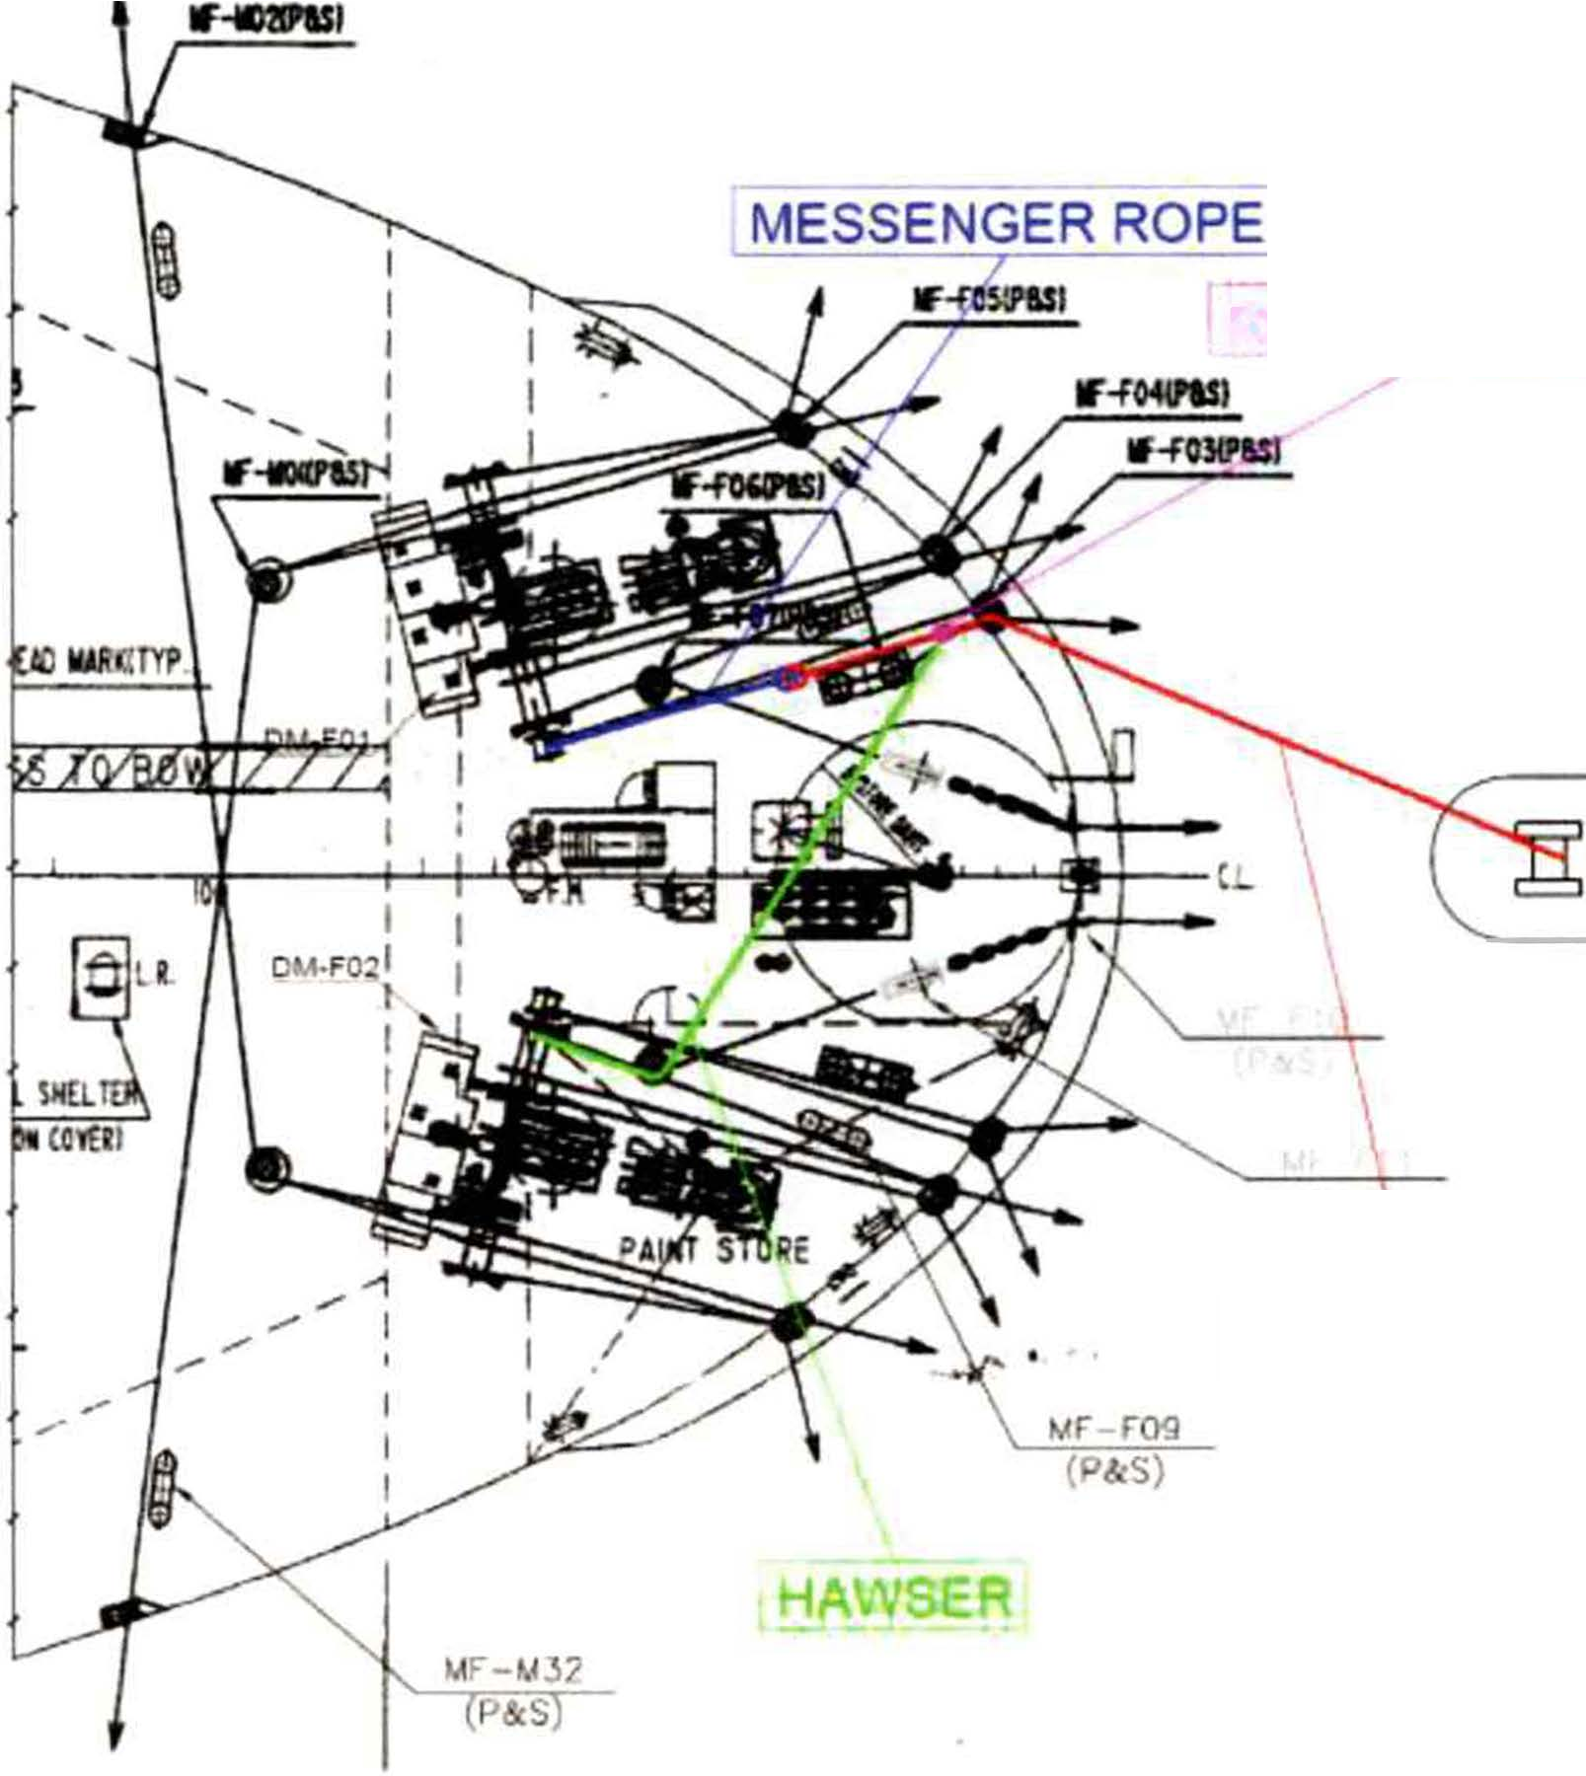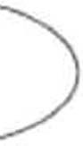MIT
EMERGENCY TOWING BOOKLET PAGE 53 OF 62

ROPE STOPPER

TUG

WIRE ROPE

      - Wind off the hawser from the mooring drum of the starboard side mooring winch and connect it to the wire through the deck roller by using the rope stopper.
      - Wind up the hawser on the mooring drum of the starboard side mooring winch and keep the tension on the middle of the wire.

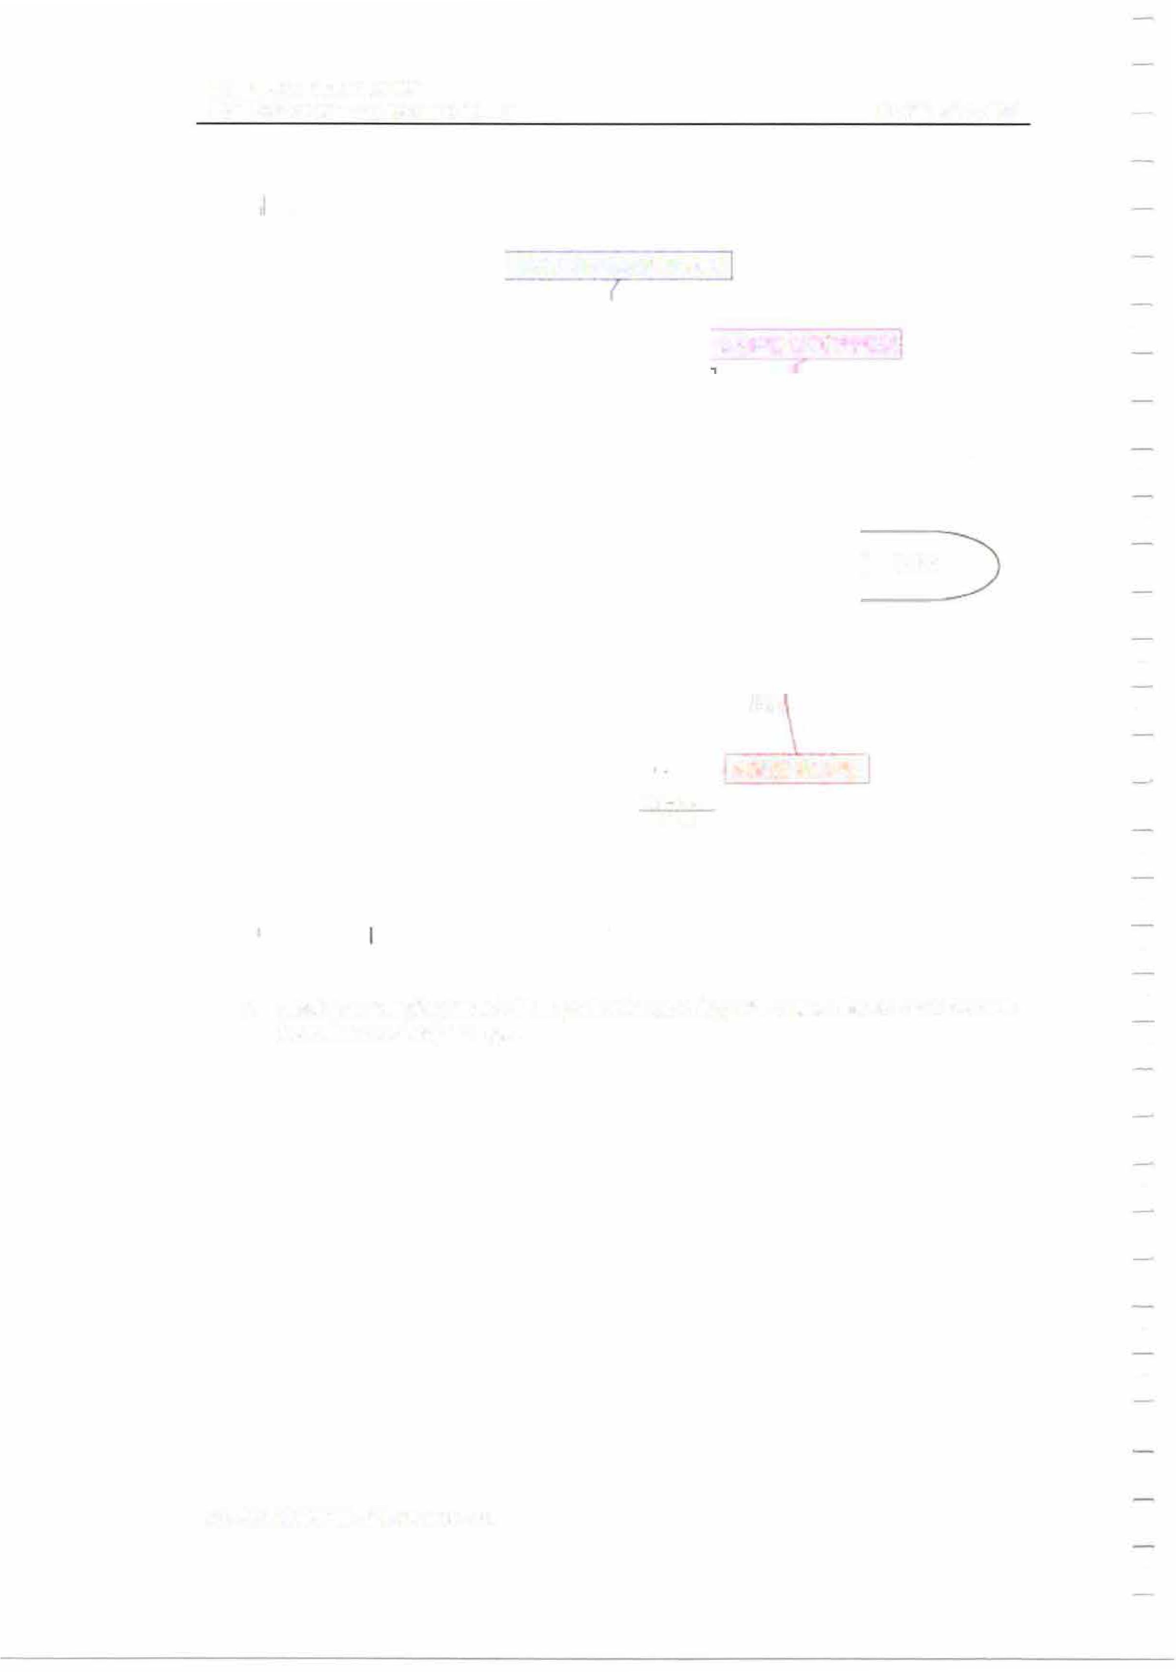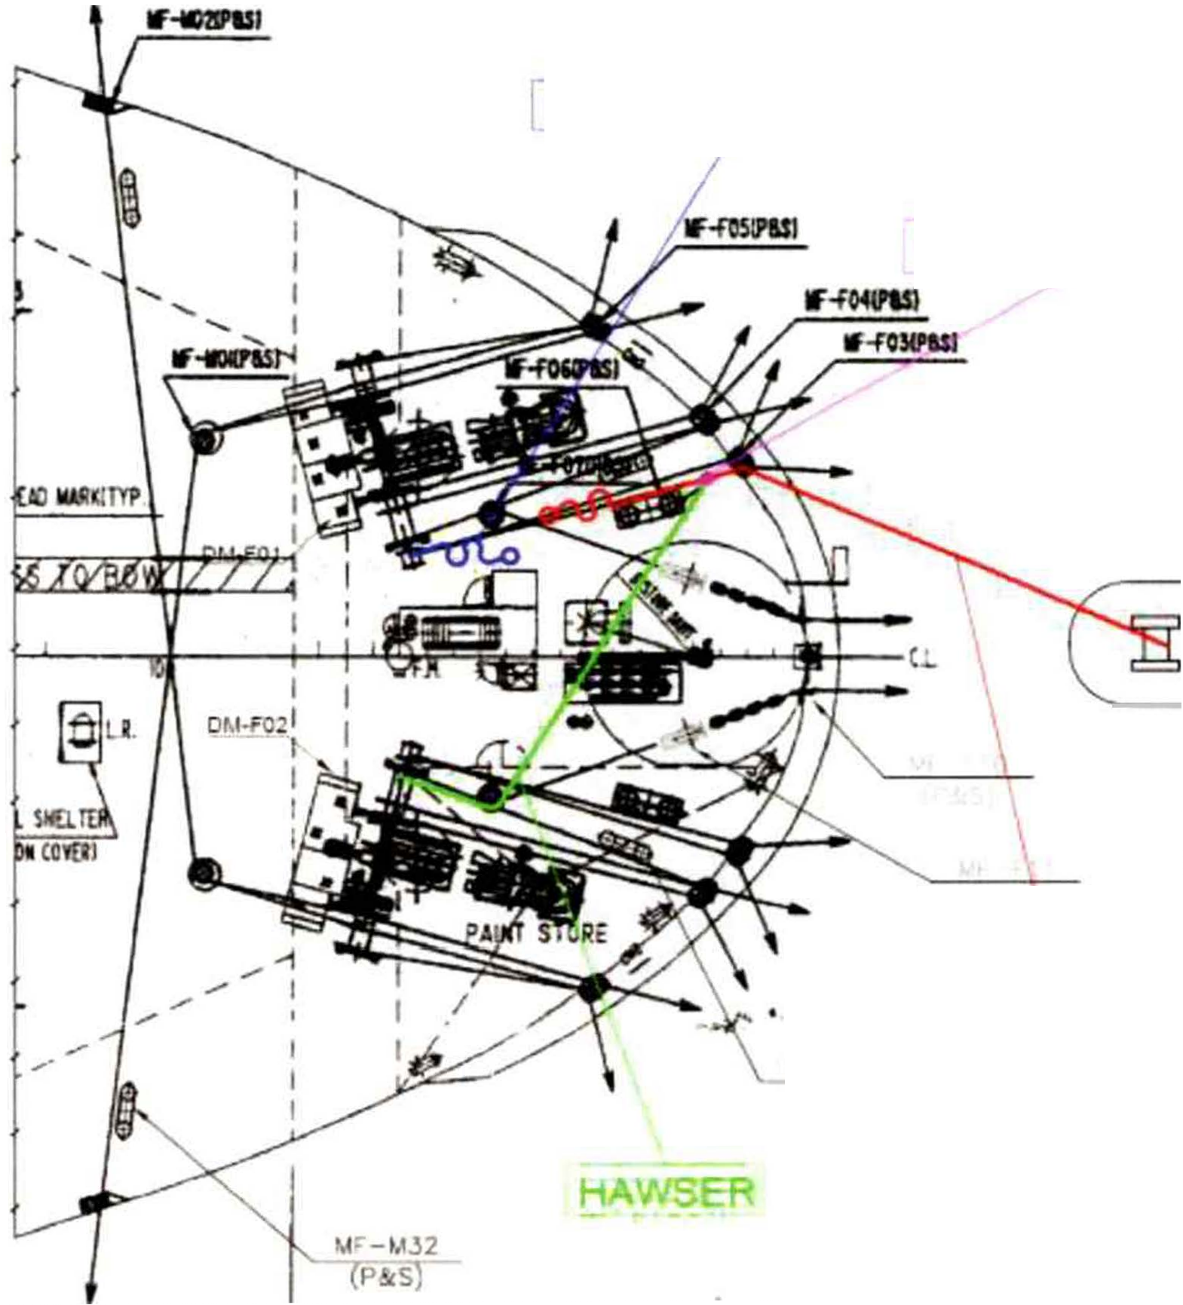MIT
EMERGENCY TOWING BOOKLET PAGE 54 OF 62

MESSENGER ROPE

ROPE STOPPER

TUG

WIRE ROPE
�� rog (PdcS)

      - Slack the warping head of the port side mooring winch and disconnect the wire from the messenger rope.

MIT
EMERGENCY TOWING BOOKLET

PAGE 55 OF 62

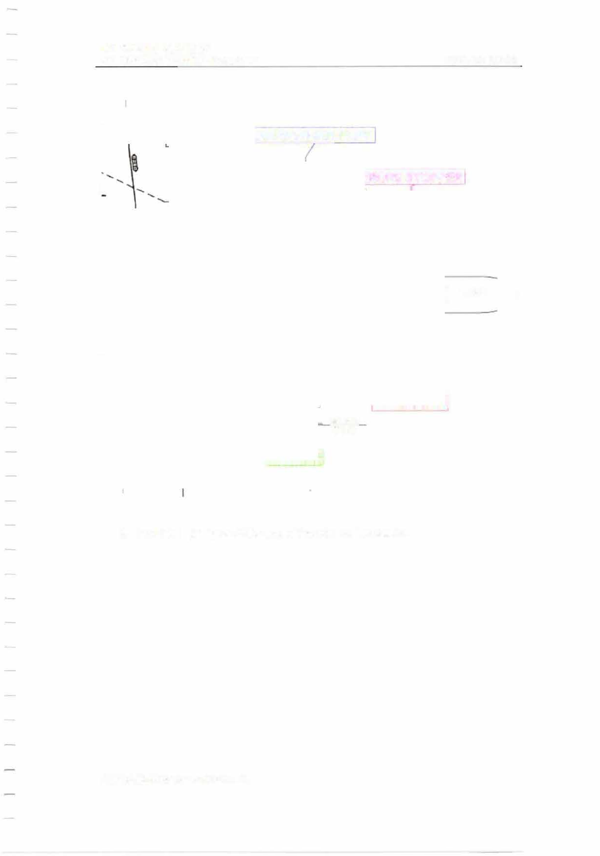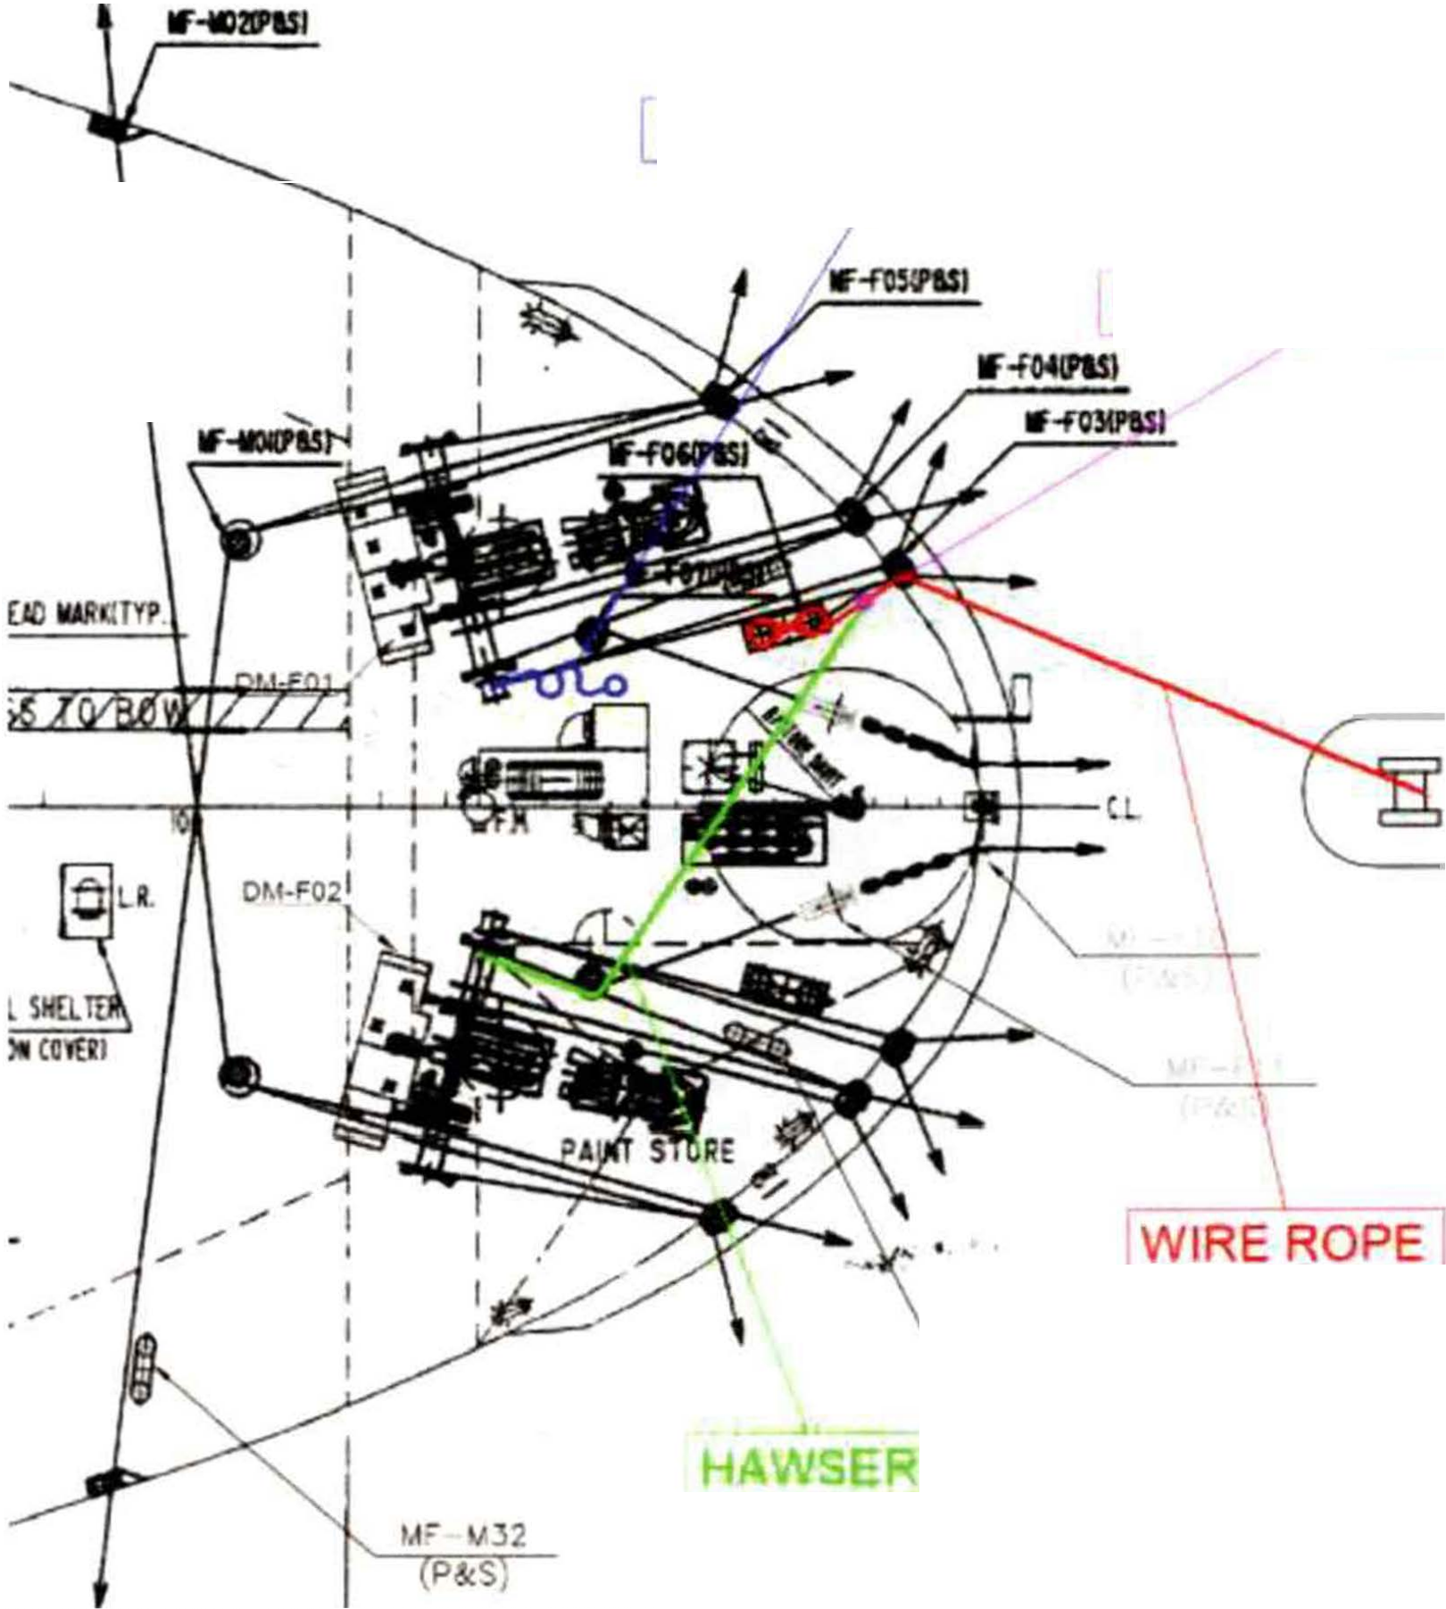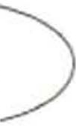

MESSENGER ROPE

ROPE STOPPER
I

TUG

,..r-r09
(Pd!S)

      - Hook the eye splice at the end of the wire on the bollard.

MIT
EMERGENCY TOWING BOOKLET

PAGE 56 OF 62

lfilD8'1Sl

I MESSENGER ROPE

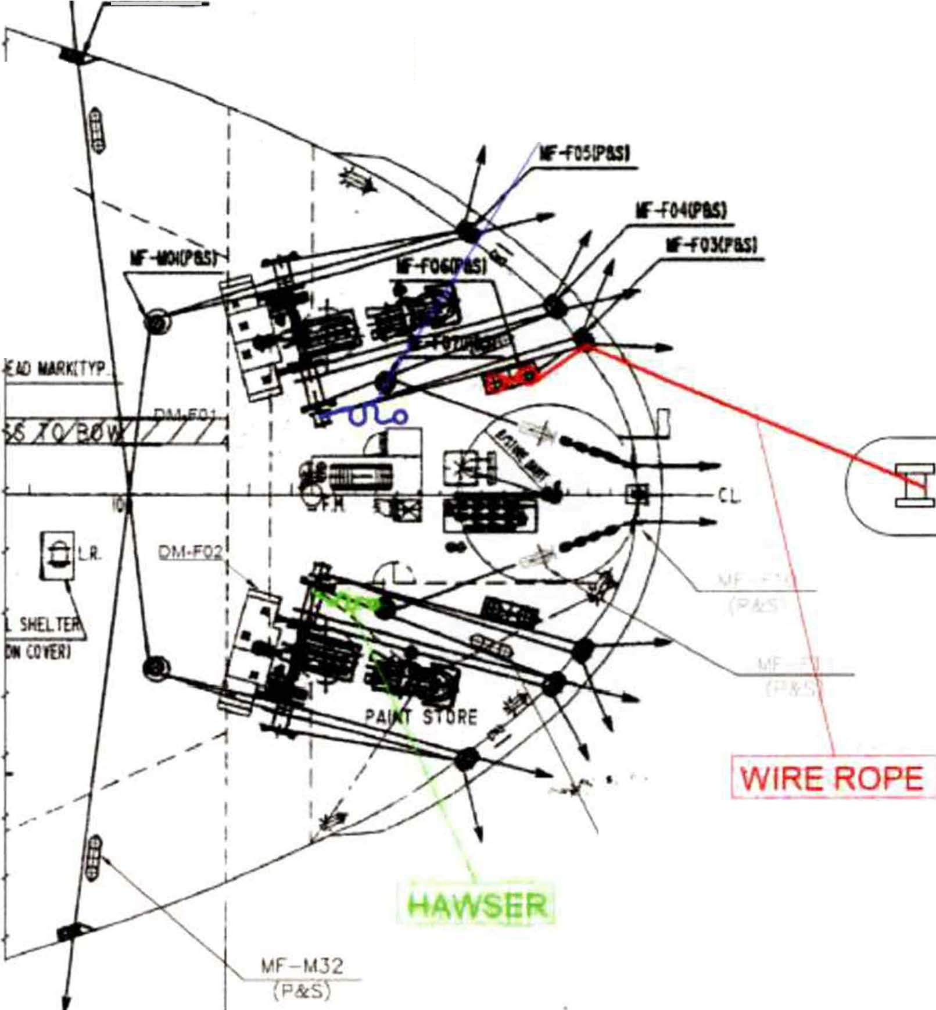

TUG

VF F09 P&S)

      - Wind off the mooring drum of the starboard side mooring winch and detach the rope stopper from the wire.
      - Make sure the wire does not touch the corner of any structures. Take in the slack by pounding with a sledgehammer, so that the wire in the bollard is lowered as much as possible.
      - Lubricate the wire with grease where it rubs against the Panama chock and finish the connecting operation.
      - Establish proper watch to monitor the towing arrangement during towage.

MIT
EMERGENCY TOWING BOOKLET PAGE 57 OF 62

    - Mode 4-A: Using tug's wire rope.

      - Ensure that all personnel involved in the emergency towing operation are clear of any snap-back areas.

      - Ensure that proper communication with bridge and towing ship is established.
lf-soaPISI

MESSENGER ROPE

C TUG

WIRE ROPE
MF-S20 ..., (P&S)

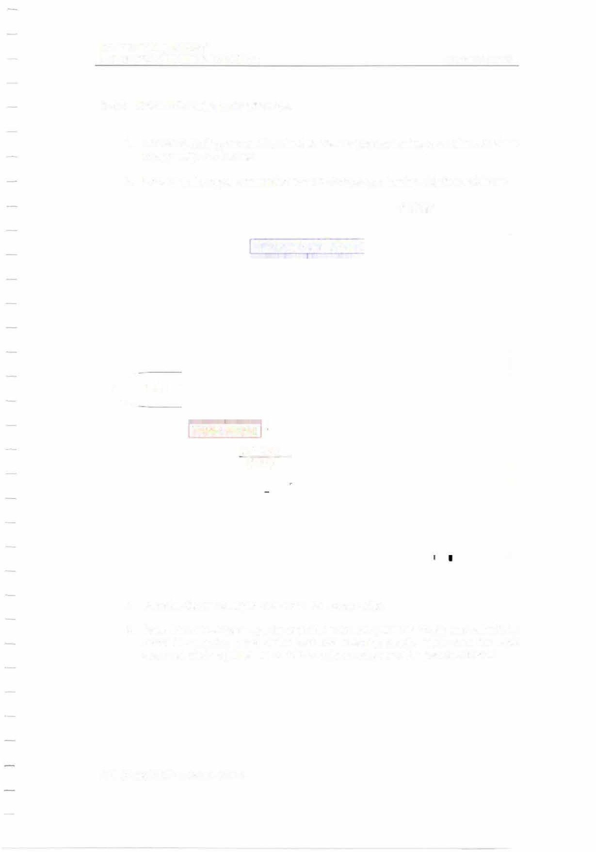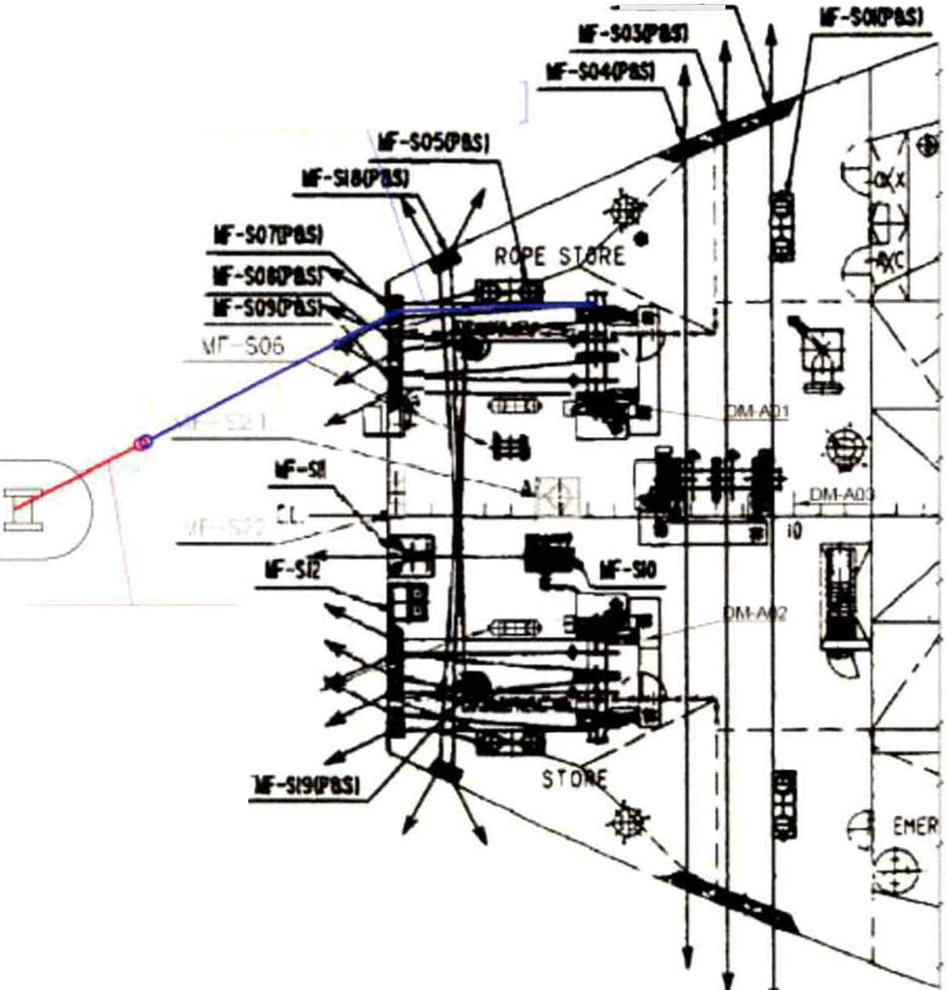

      - Receive the messenger rope from the towing ship.
      - Pass the messenger rope through the port side panama chock and raise it by using the warping head of the port side mooring winch. Make sure the rope does not chafe against the corner of bulwark stay near the panama chock.

MIT
EMERGENCY TOWING BOOKLET
I MESSENGER ROPE'

ROPE STOPPER

...
lf-mlPU,
...,
W-so5ft51
.............

PAGE 58 OF 62

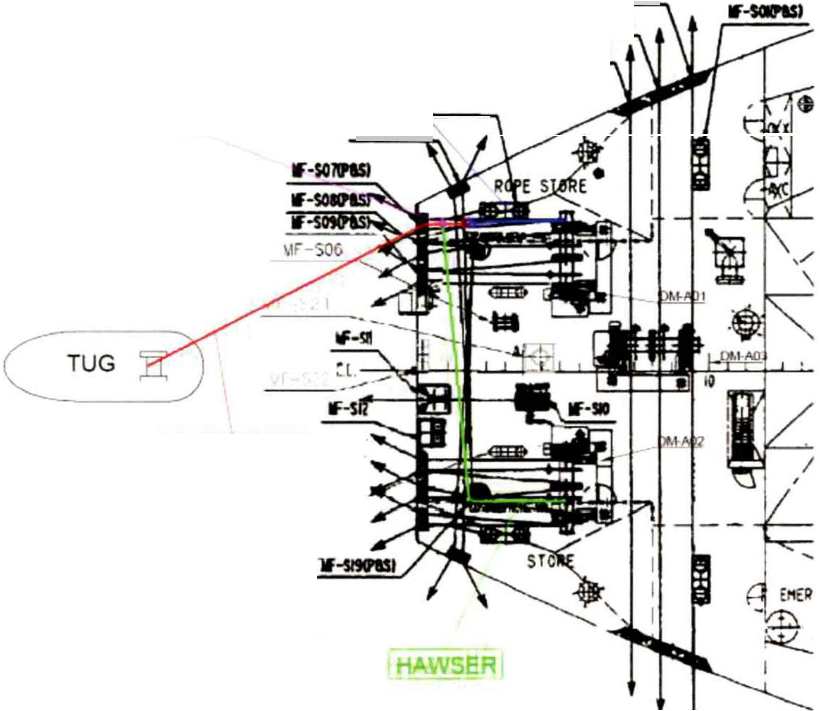

!WIRE ROPE 1
MF-S20 .,,

(P&S)

      - Wind off the hawser from the mooring drum of the port side mooring winch and connect it to the wire through the stand roller by using the rope stopper.

      - Wind up the hawser on the mooring drum of the port side mooring winch and keep the tension on the middle of the wire.

MIT
EMERGENCY TOWING BOOKLET PAGE 59 OF 62

MESSENqER ROPEl
ROPE STOPPER lf�J

WIRE ROPE7
MF-S20 ..,,.
(P&S)
lf-SMftl

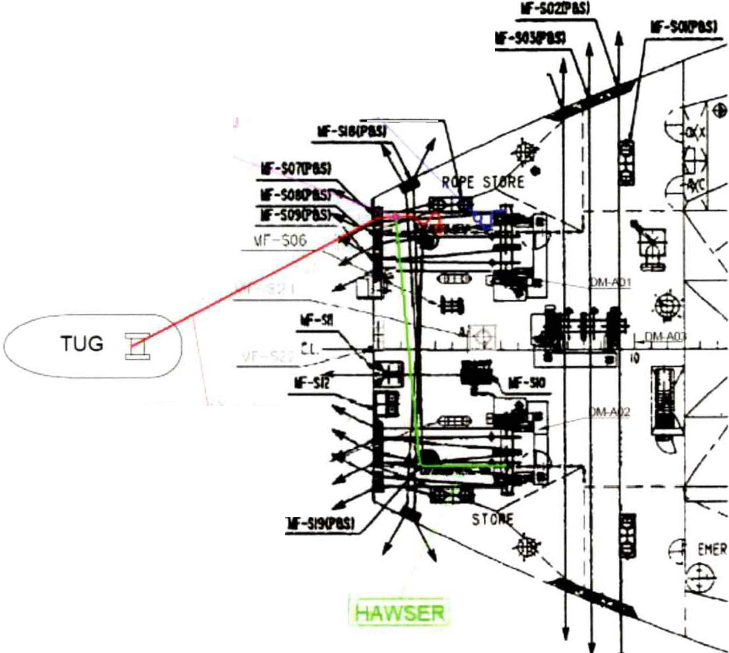

      - Slack the warping head of the port side mooring winch and disconnect the wire from the messenger rope.

MIT
EMERGENCY TOWING BOOKLET

MESSENQER ROPE]
ROPE STOPPER lf-SOWUI
lf·SI--

lf-so21PU1

lf-SMN
•---­

PAGE 60 OF 62

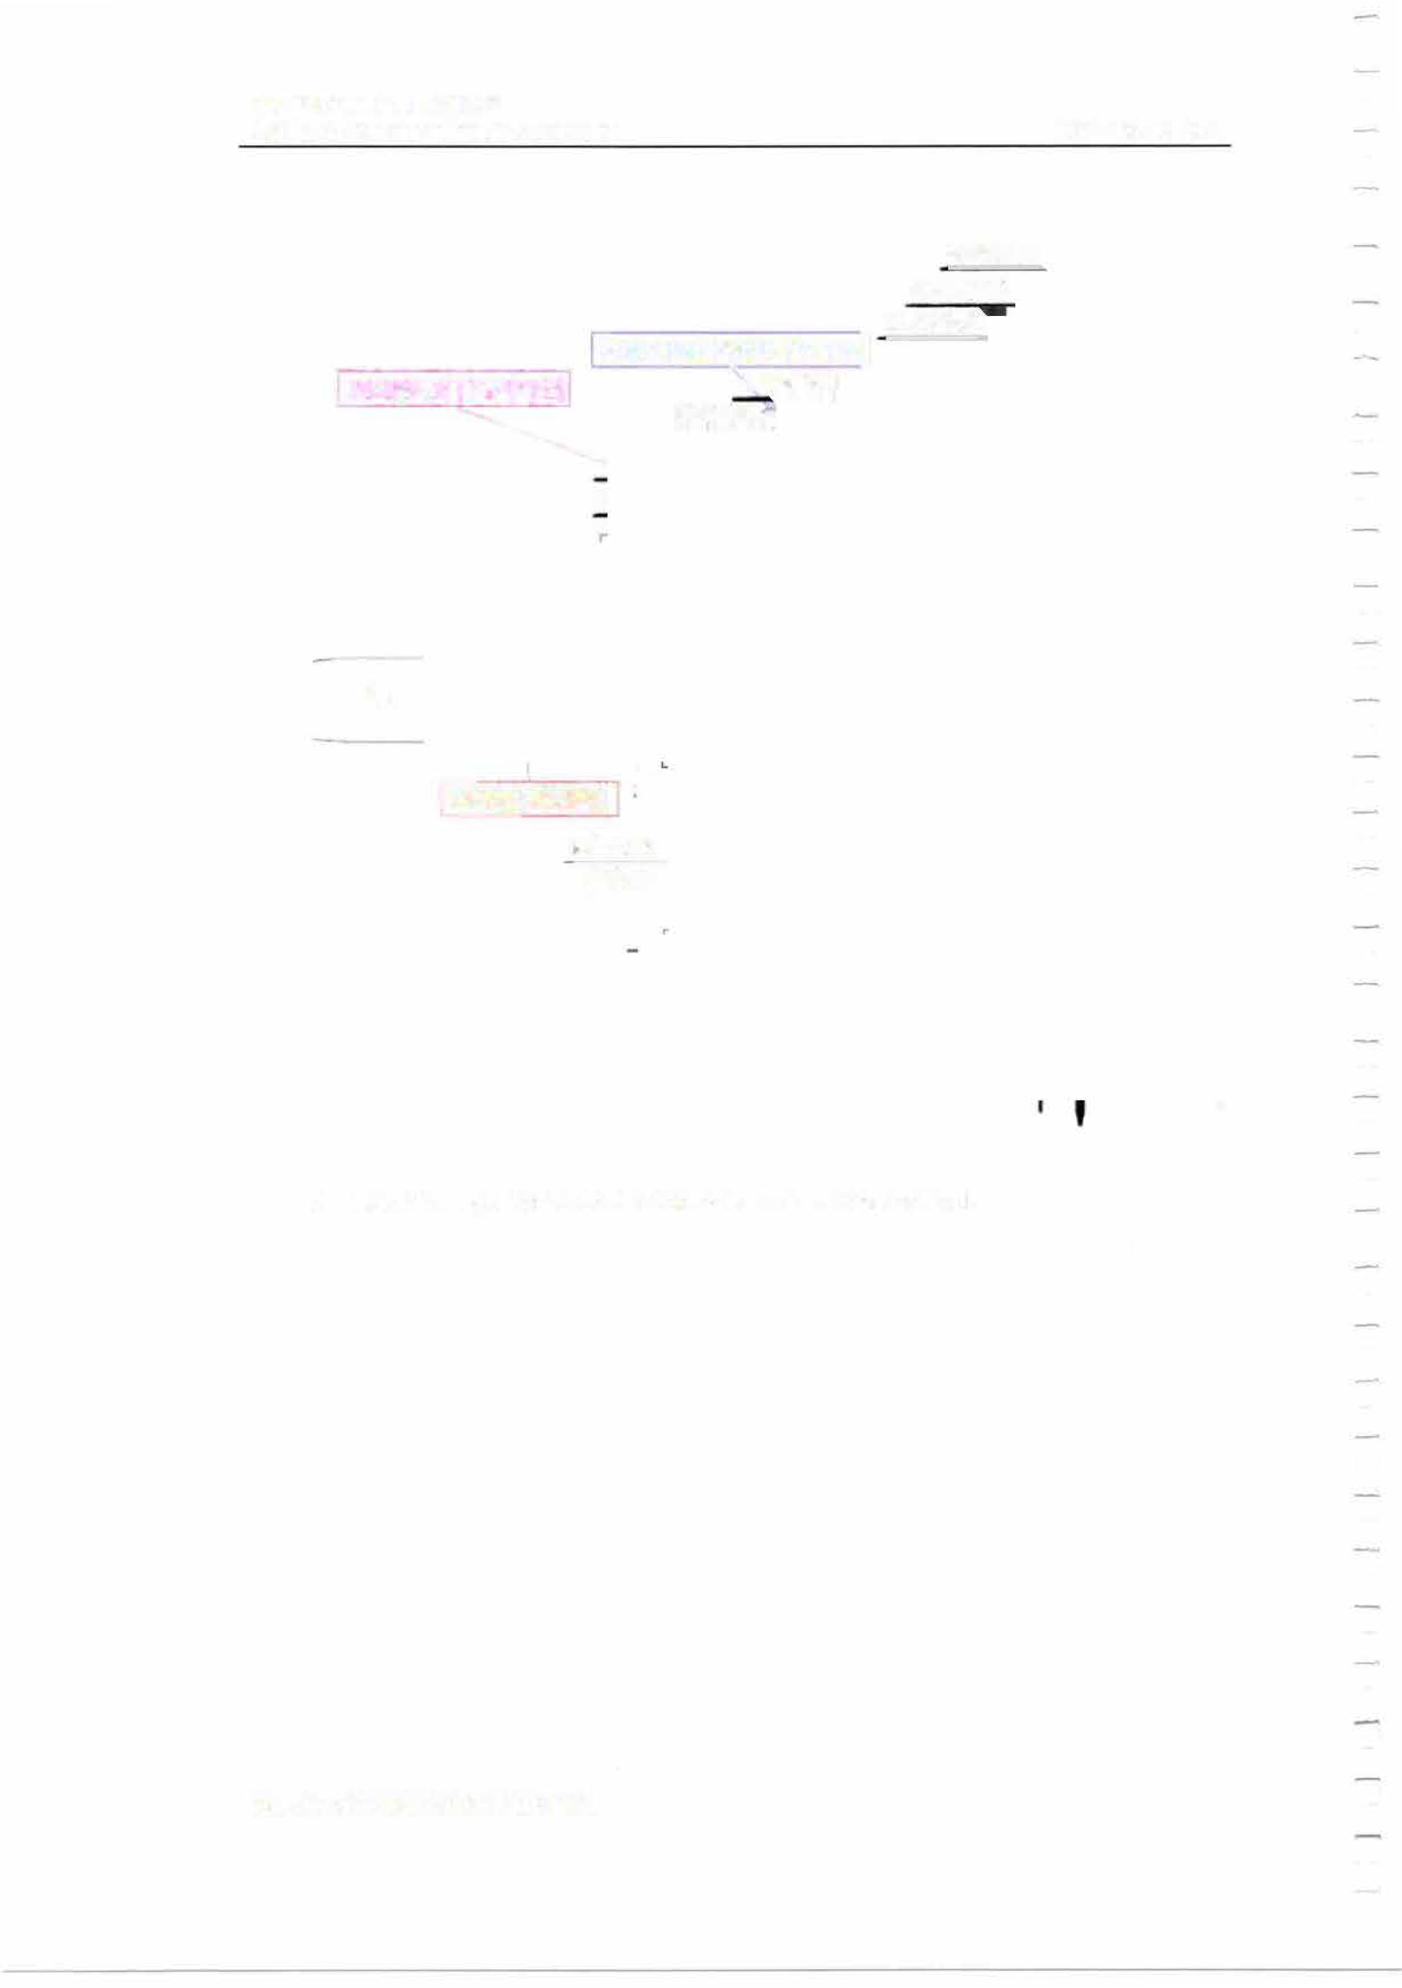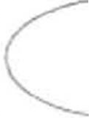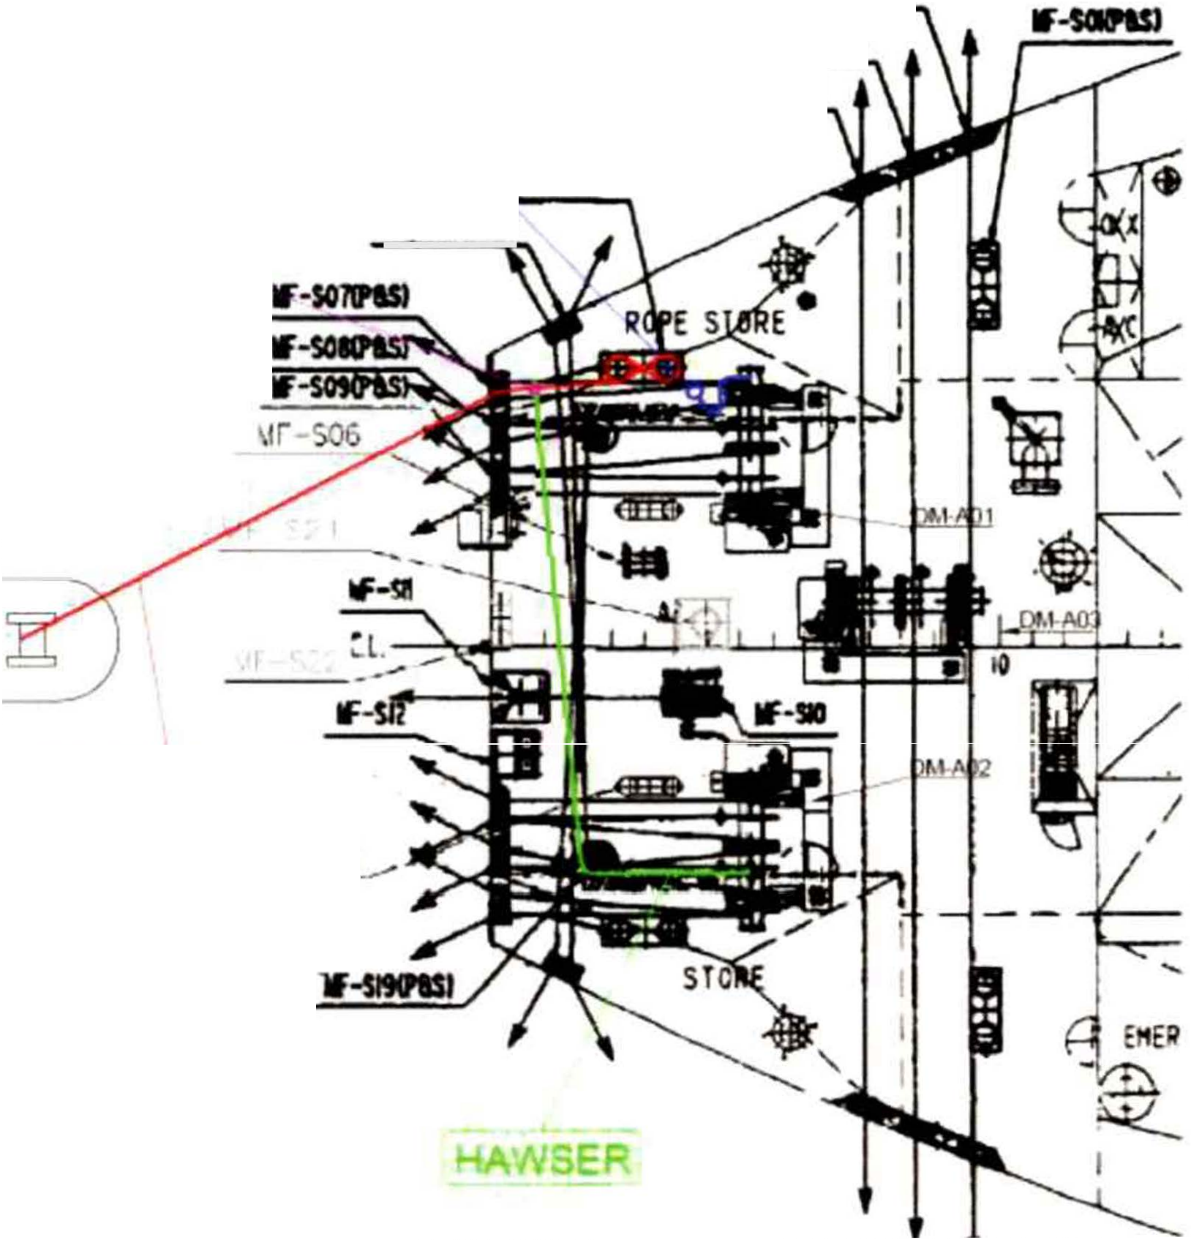

TUG

!WIRE ROPE
\.IF-S20
(P&S)

      - Hook the eye splice at the end of the wire at the bollard.

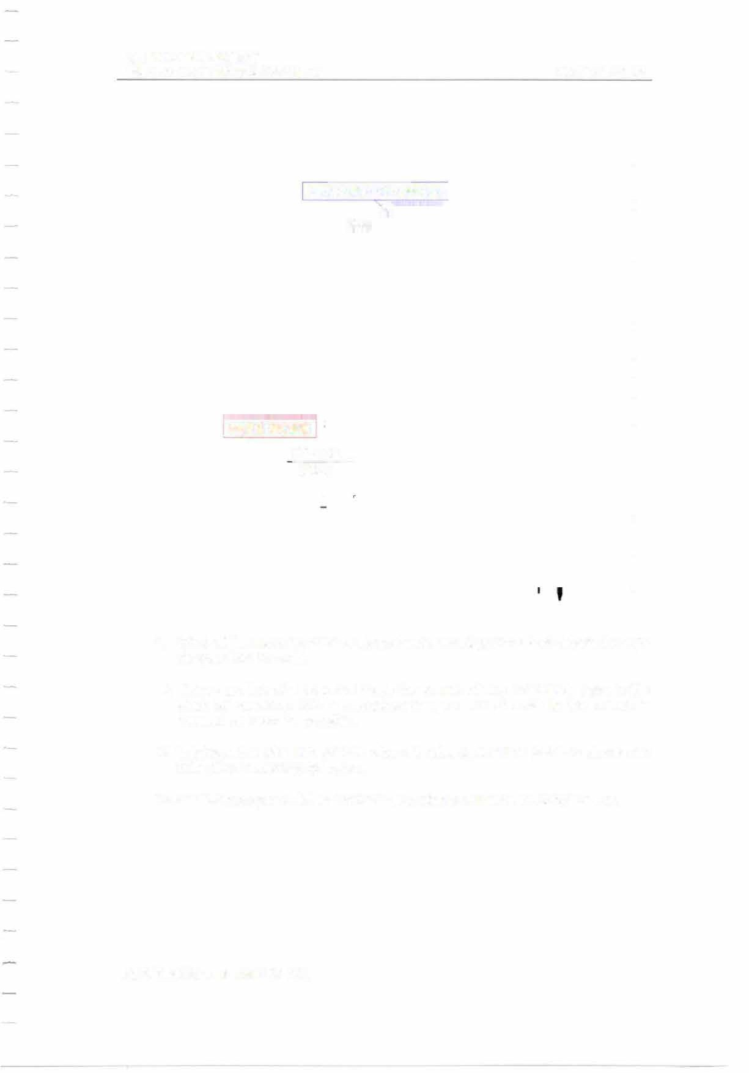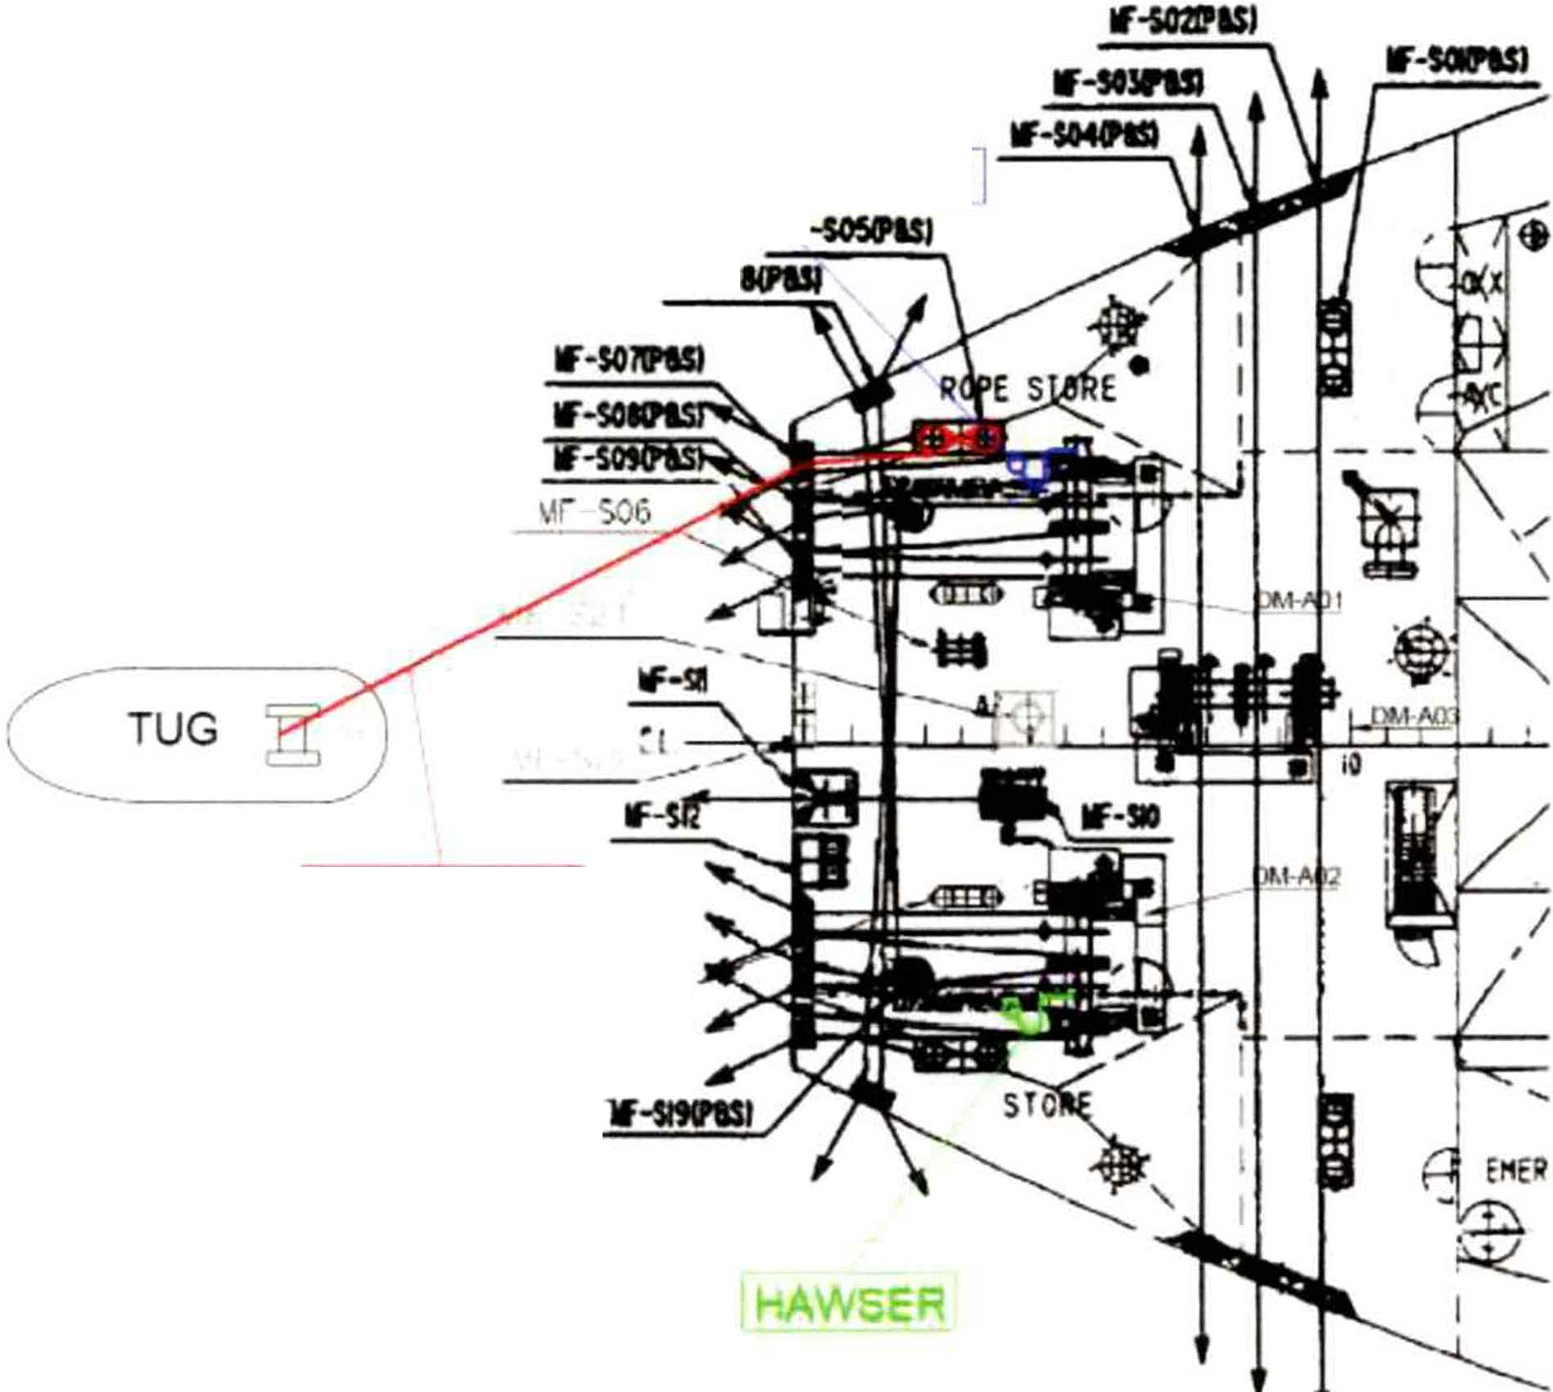MIT
EMERGENCY TOWING BOOKLET PAGE 61 OF 62

MESSENGER ROPE
w
If-I

WIRE ROPE
\1F-S20 .,, (P&S)

      - Wind off the mooring drum of the port side mooring winch and detach the rope stopper from the wire.

      - Make sure the wire does not touch the corner of any structures. Take in the slack by pounding with a sledgehammer, so that the wire in the bollard is lowered as much as possible.

      - Lubricate the wire with grease where it rubs against the panama chock and finish the connecting operation.
      - Establish proper watch to monitor the towing arrangement during towage.

MIT
EMERGENCY TOWING BOOKLET

4. REFERENCE DRAWINGS

PAGE 62 OF 62

No.

1.

General Arrangement
Title
Dwg. No.

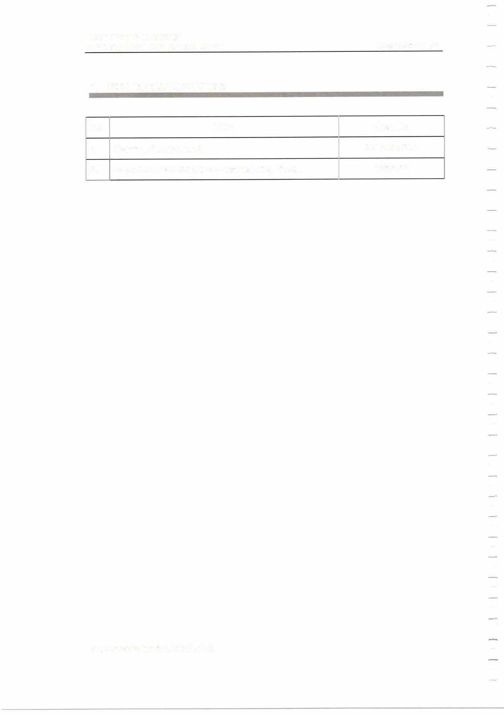
2. Layout of Deck Machinery and Mooring Fittings

